**Chapter 9 Transfer**

*In This Chapter:*

**9.1 New File Fund Transfer (Client’ A/C)**

**9.2 Manage File Fund Transfer**

**9.3 New Bank Fund Transfer (Client’ A/C)**

**9.4 New Bank Fund Transfer - Client’ A/C to Office’ A/C**

**9.5 New Bank Fund Transfer - Office’ A/C to Client’ A/C**

**9.6 Manage Bank Fund Transfer**

**9.7 New Trust Transfer (FD)**

**9.8 New FD (Direct Deposit)**

**9.9 Manage Trust Transfer**

**9.1 New File Fund Transfer (Client’ A/C)**

* To open New File Fund Transfer (Client’ A/C), on the **SmartLeg@l** navigation, click **Transfer** and go to **New File Fund Transfer (Client’ A/C)**.

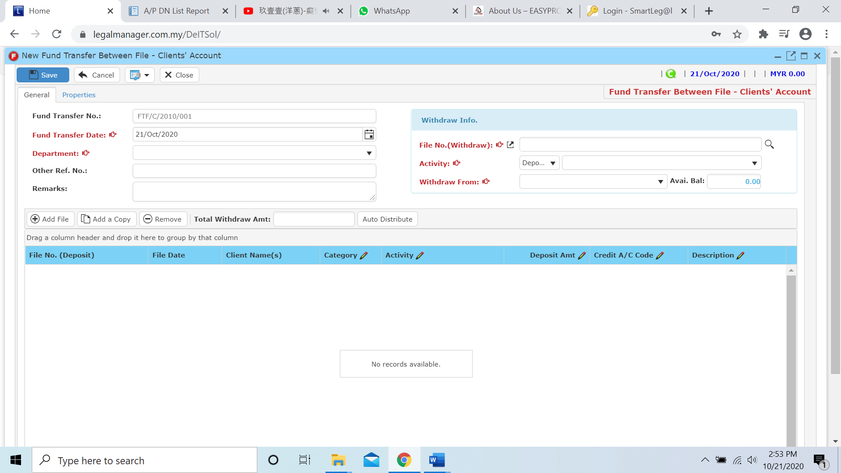

* Key in necessary information
* Fund Transfer No. is auto generated by the system
* Key in Fund Transfer Date and by default the date is auto generated with the date you click to New File Fund Transfer (Client’ A/C)
* Select a department from combo box

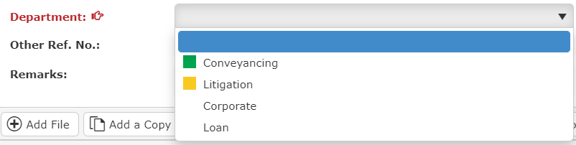

* In the withdraw info section, you can search File No. (withdraw) by clicking the browse icon , and it will pop-up a Search File Master Tool then click once to search all files

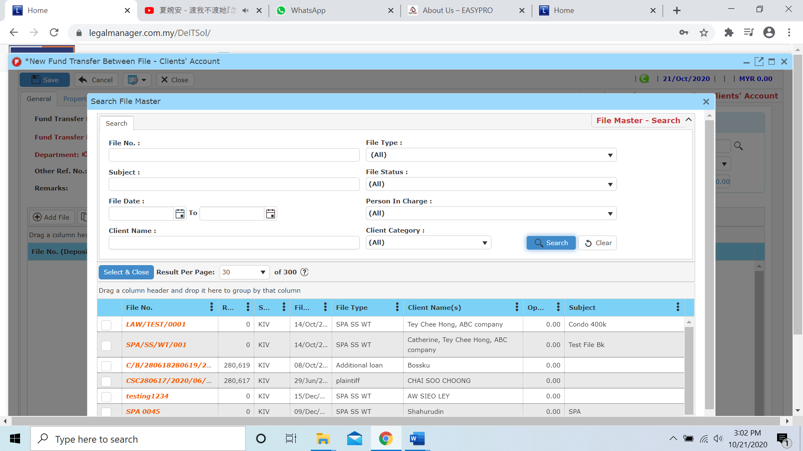

* After select the file, we can continue to the activity, you can click to the first column to select the category of activity

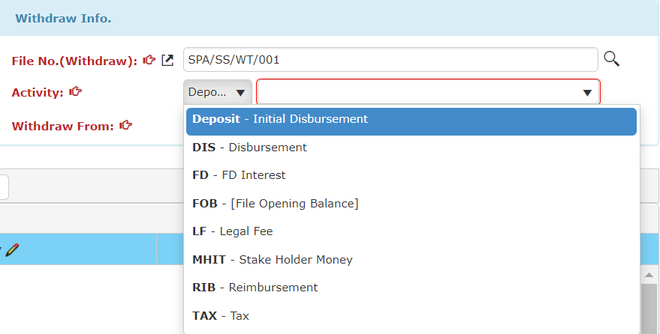

* Hence, after the select the category you can choose any activity in the category of activity you selected

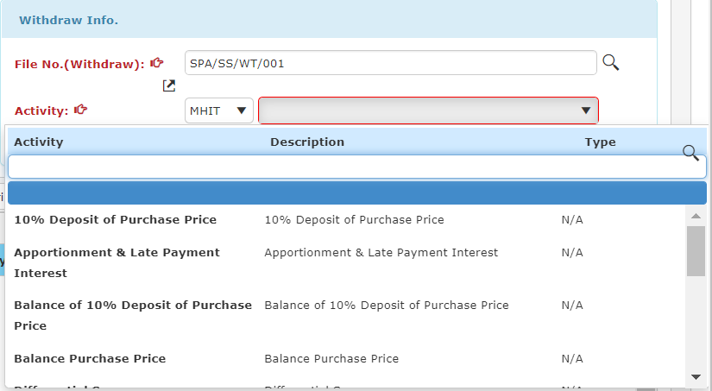

* After that, click the column of withdraw from and choose the bank account to do fund transfer

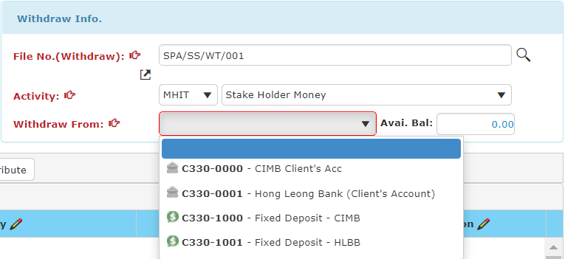

Shown Available Balance

* When you finished key in the information, you can Add File, Add a Copy, Remove and Auto Distribute balance in this section

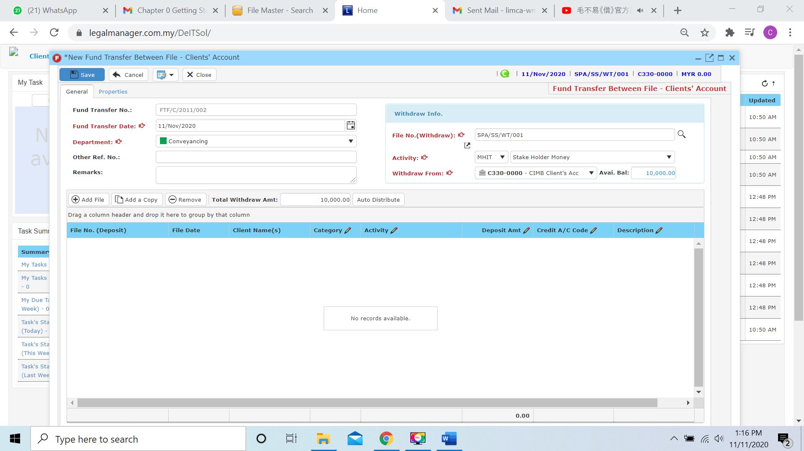

(example: there is available balance 10000 in CIMB client’s acc for activity MHIT skate holder money)

**Add File**

* While you click to the Add File, the system will provide a search file and you can insert your requirement to search

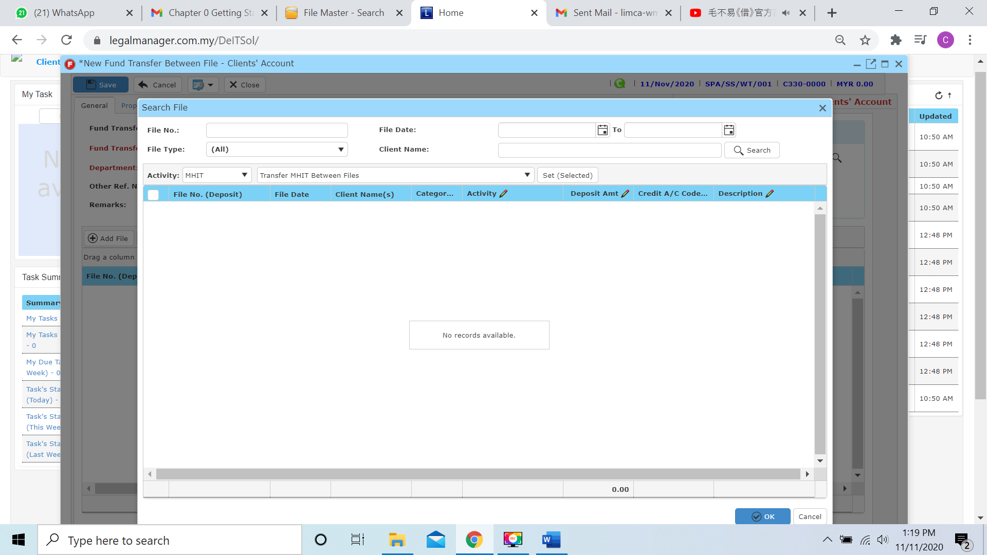

* After you found the file that you search, you can click to enter deposit amount to the file as figure below shown

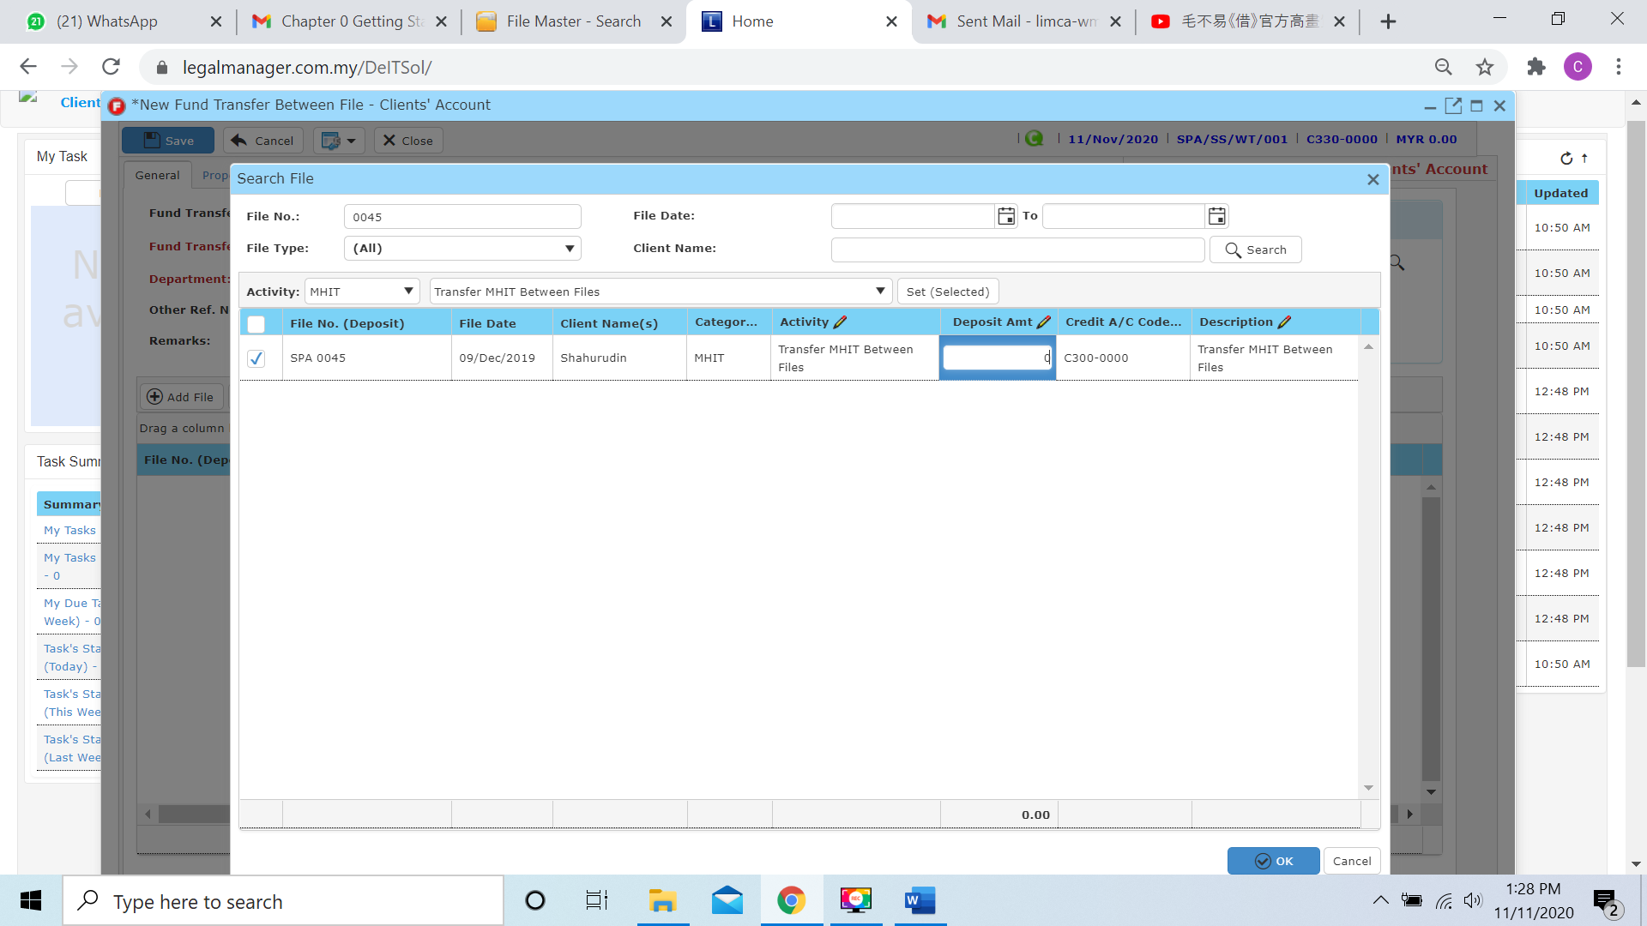

* For example, I will deposit 2000 to File No. SPA 0045, then the MHIT stake money holder in SPA/SS/WT/001 will less be 10000 – 2000 = 8000

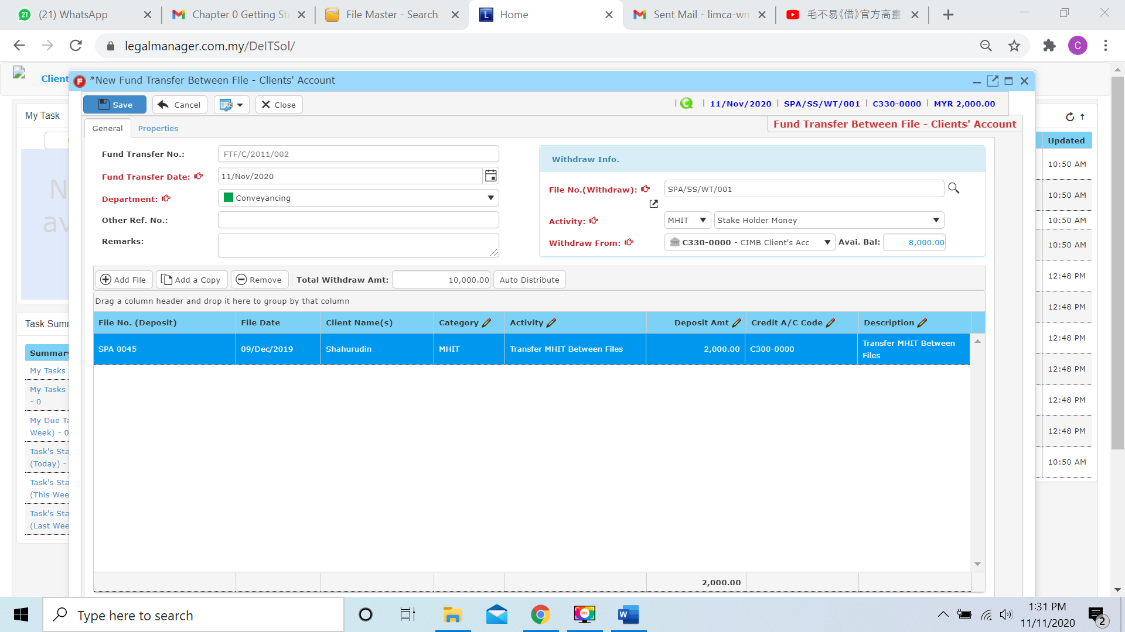

Note: In this example, the available balance for MHIT stake holder money of SPA/SS/WT/001 only 10000 and user want to transfer 15000 to SPA 0045, If the deposit amount is exceeded available balance, the available balance in the withdraw info section will be negative

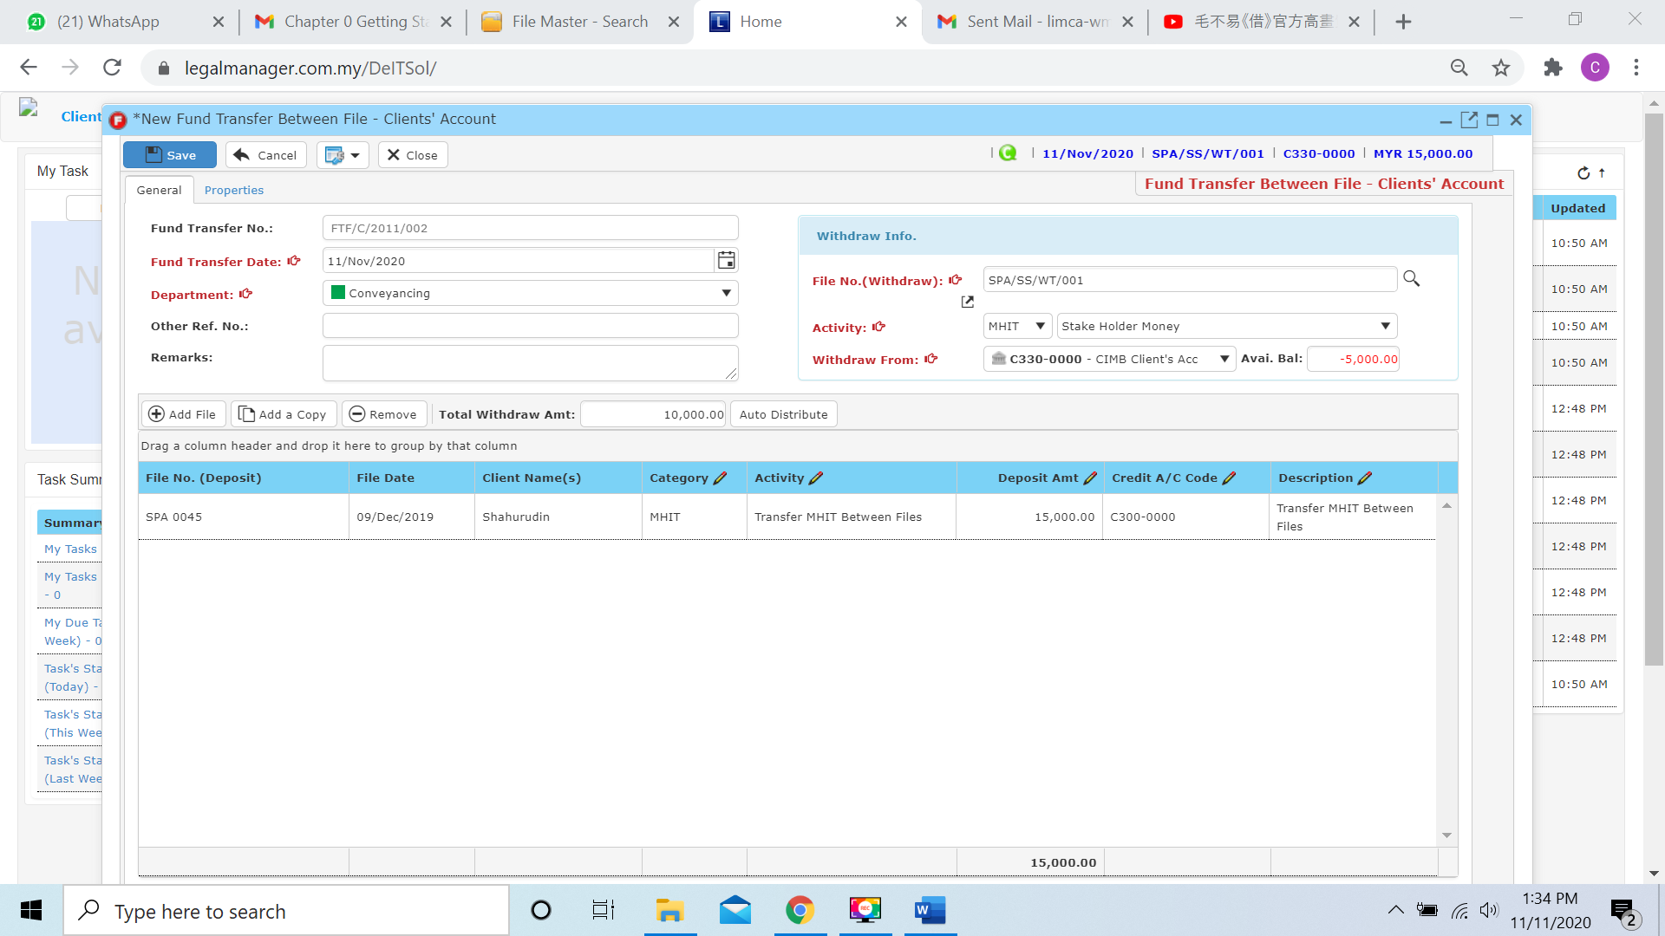

**Add a Copy**

* For Add a Copy, you can duplicate a selected row in the table

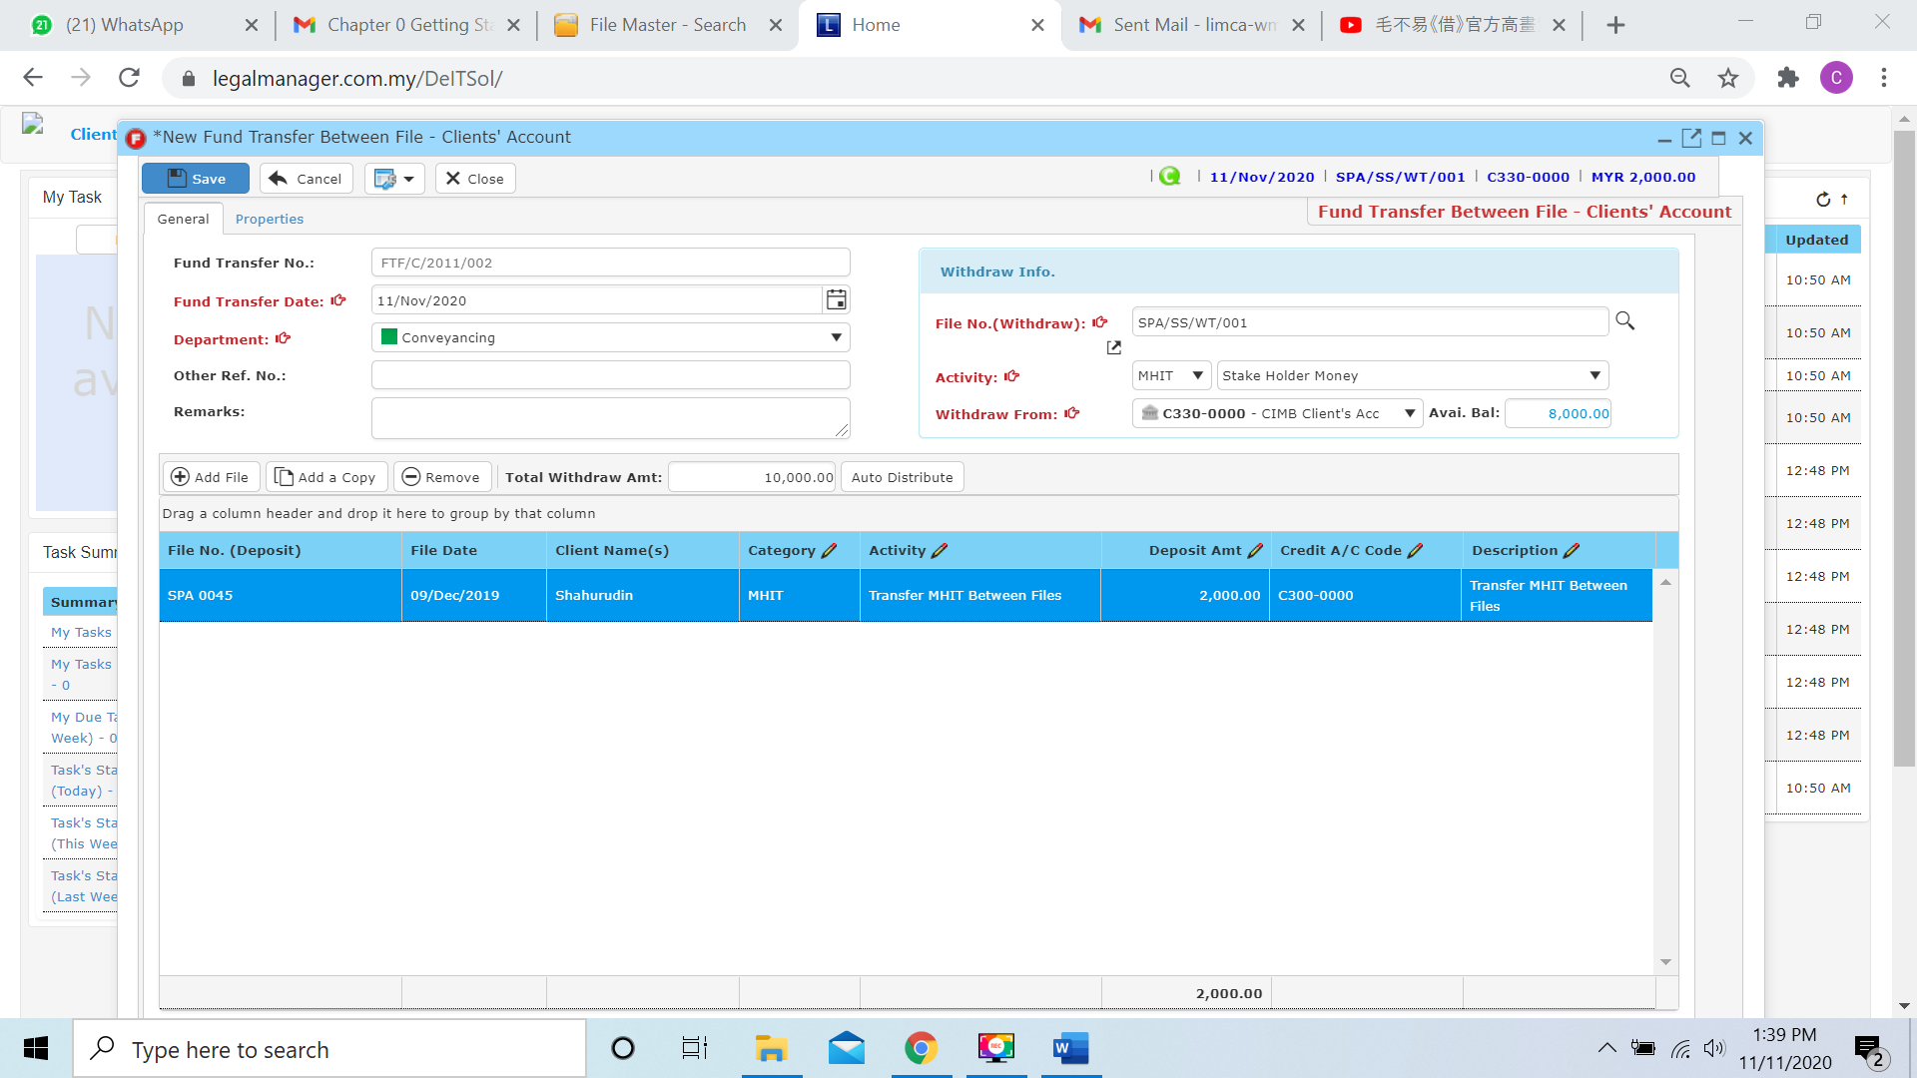

* After you click add a copy, it will copy the row as below figure shown

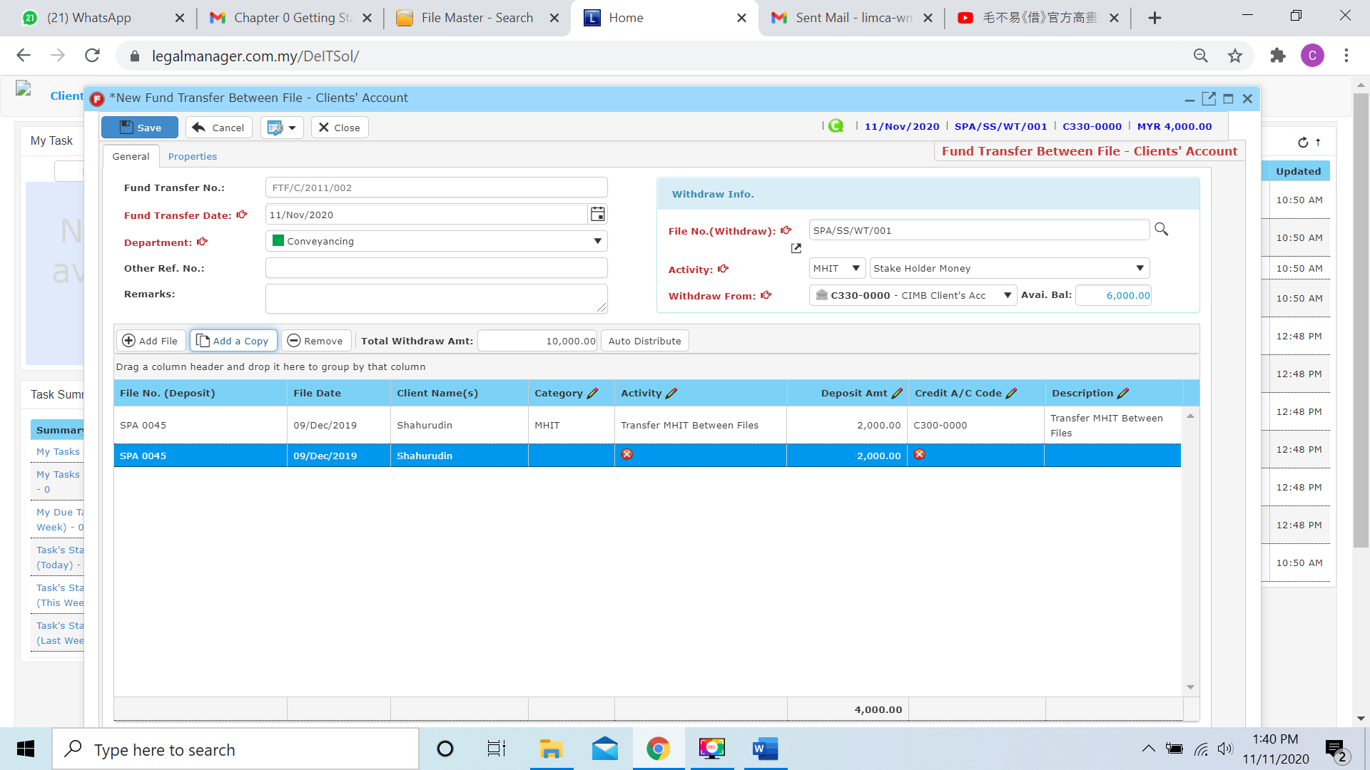

* It will copy the exactly file no., date, client and deposit amount however you have to choose those others like category and activity by yourself

**Remove**

* For the remove, you have to select the record in the list and click remove to erase the record
* For example, I will remove the empty row selected

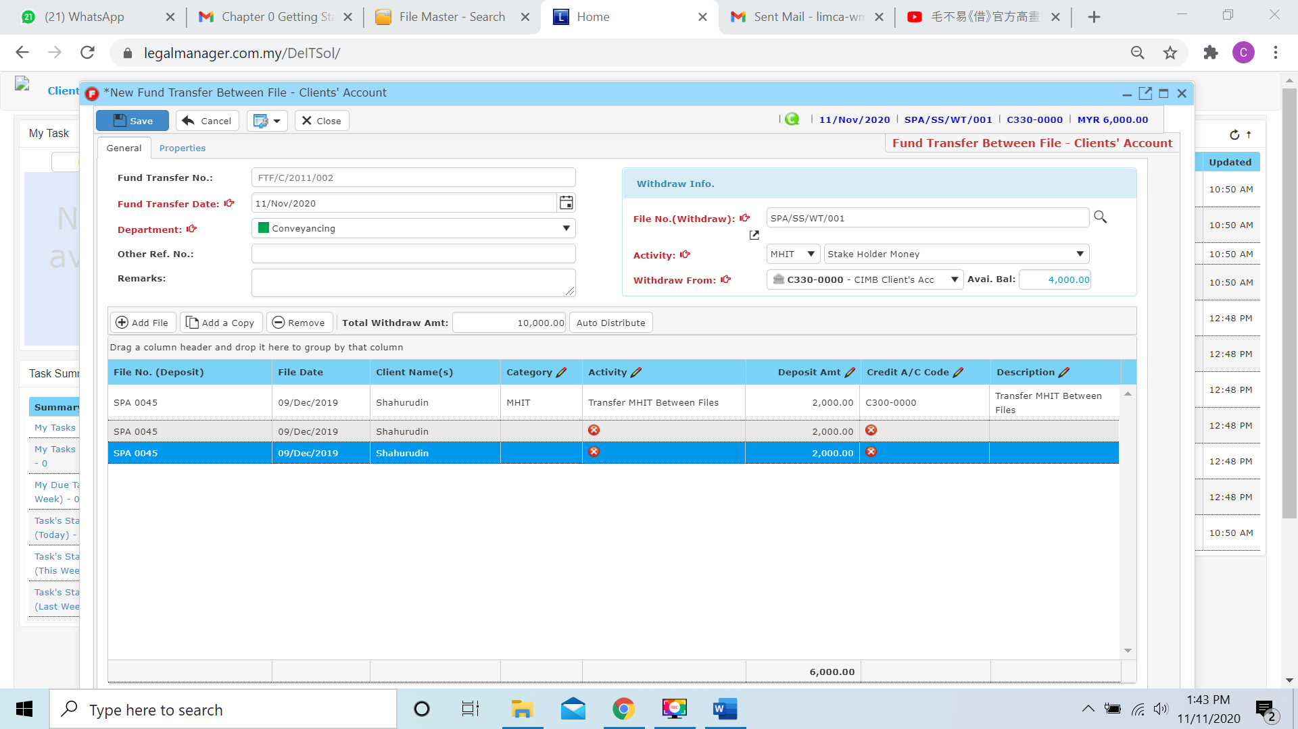

* After you click the remove button it will erase the selected row



**Auto Distribute**

* Before using the auto distribute function, you have to key in the Total Withdraw Amount 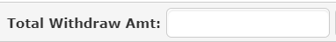 (e.g. I will be entered 4 thousands)

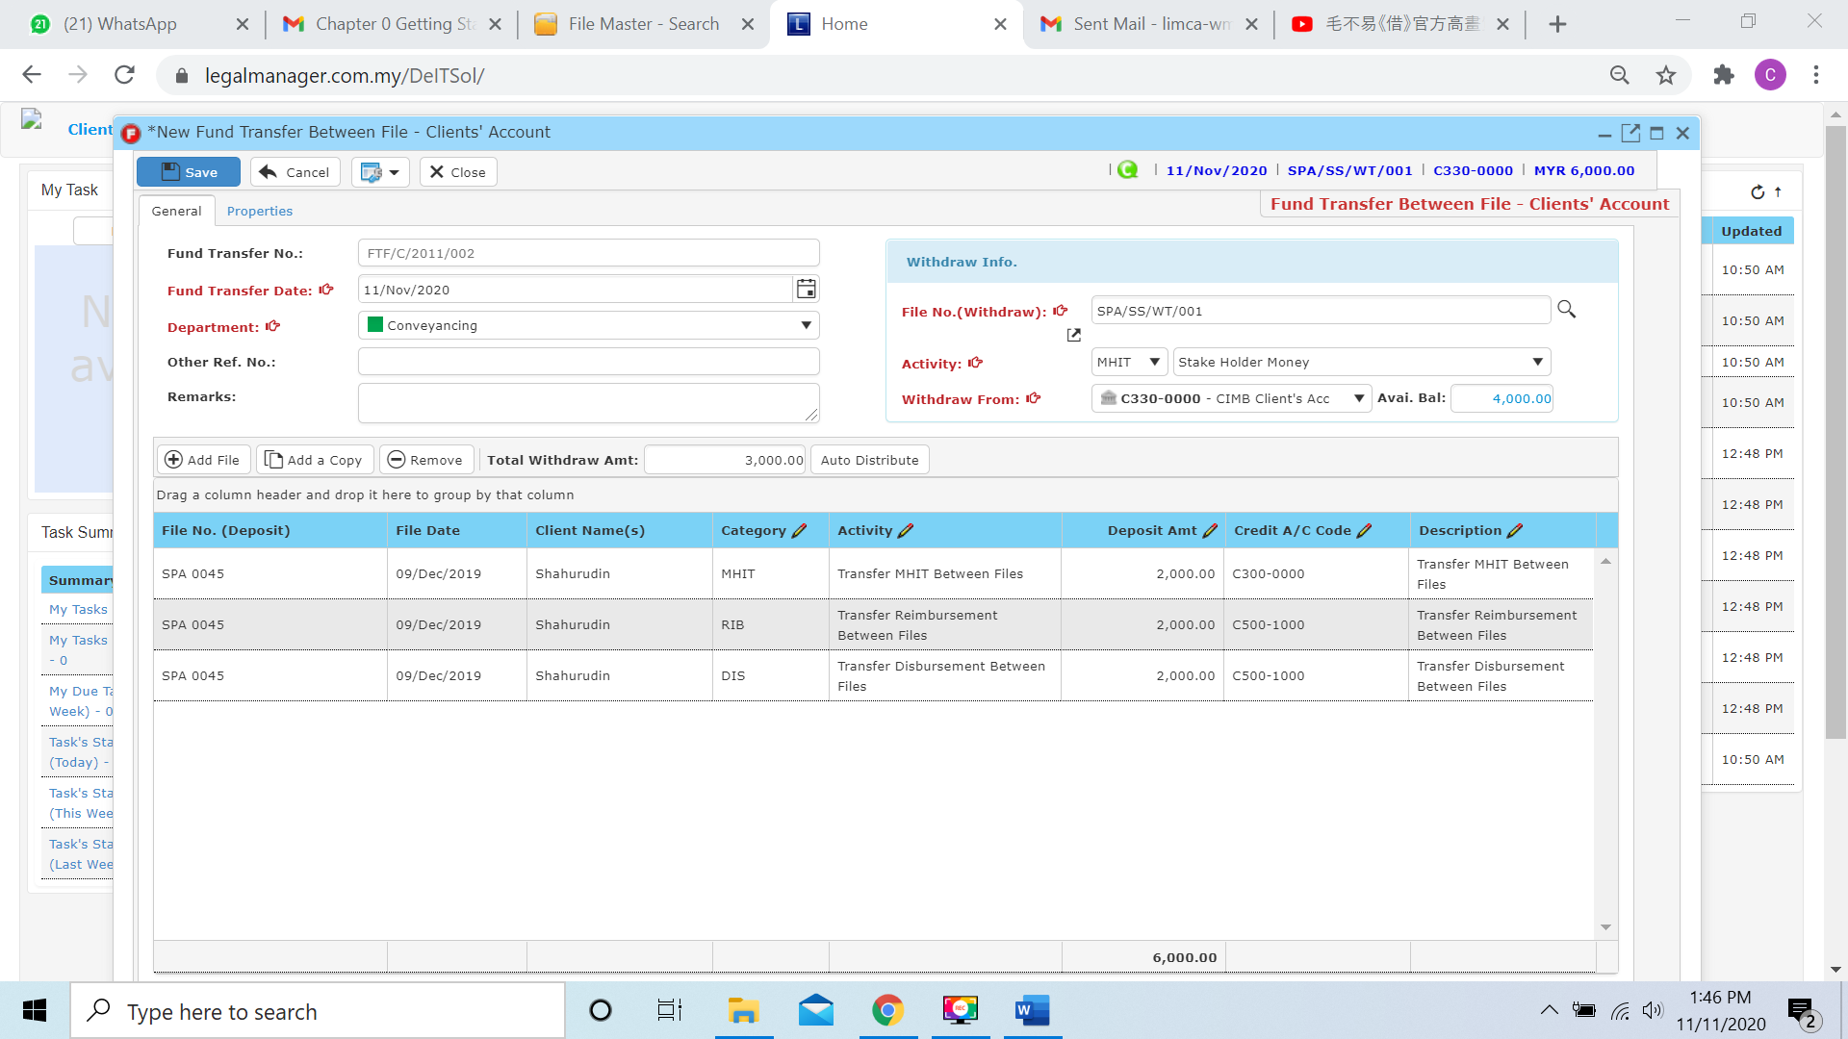

* After entered the amount, when you click to ‘Auto Distribute’ the system will equally divide and distribute to the file in the table

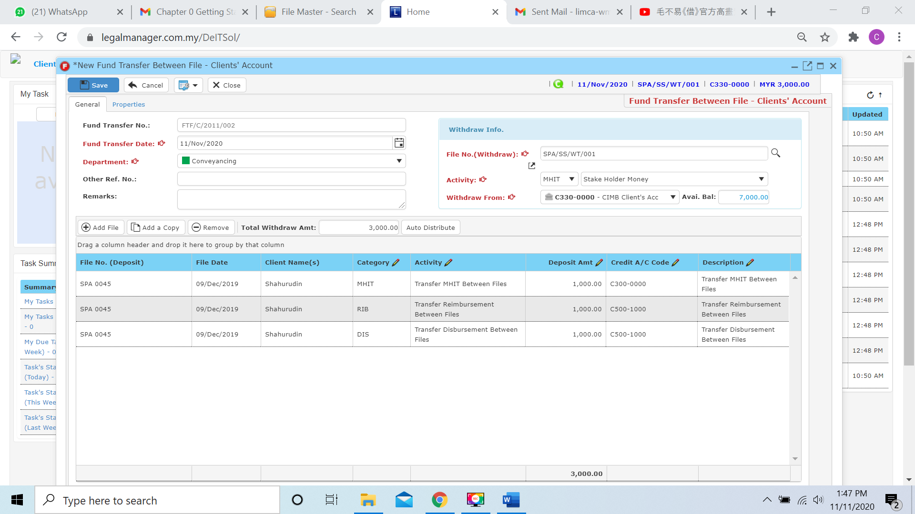

* Other than that, you can view the posting details with clicking this icon 

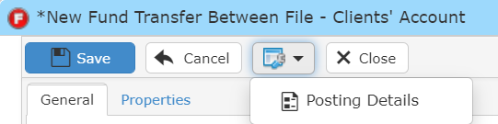

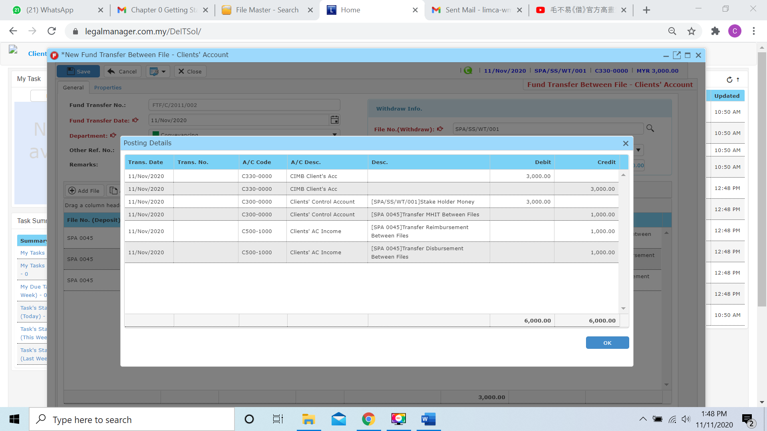

* You can click to the next tab ‘Properties’

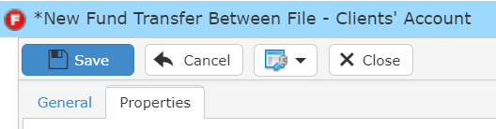

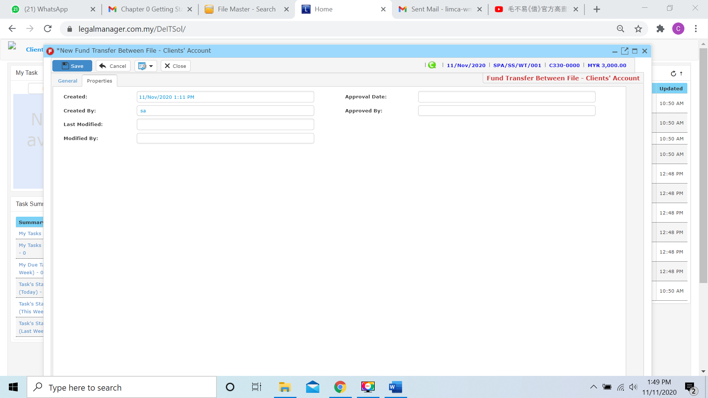

* You can view the information of the record once who modify the fund transfer between file – client’ a/c then there will show the last modified and modified by who
* Once you finish all the instruction above, click ‘Save’ then you are done to create a New Fund Transfer Between File – Client’ A/C.

Important Note: Operate Method for all the function related to fund transfer Chapter 9.1 til Chapter 9.5 is almost the same as all the instruction above and user just have to diffrentiate File and Bank or Client and Office account only.

**9.2 Manage File Fund Transfer**

This option enables you to add, edit, and delete a File Fund Transfer. It also allows you to keep track of your File Fund Transfer details and all related information.

* To open Manage File Fund Transfer, on the **SmartLeg@l** navigation, click **Transfer** and go to **Manage File Fund Transfer** then search the File Fund Transfer you wish to modify.

**Manage File Fund Transfer**

* Search the File Fund Transfer you wish to manage through type the search criteria or search by advanced.
* To start a new search or to clear the search results, click ‘**Clear**’.

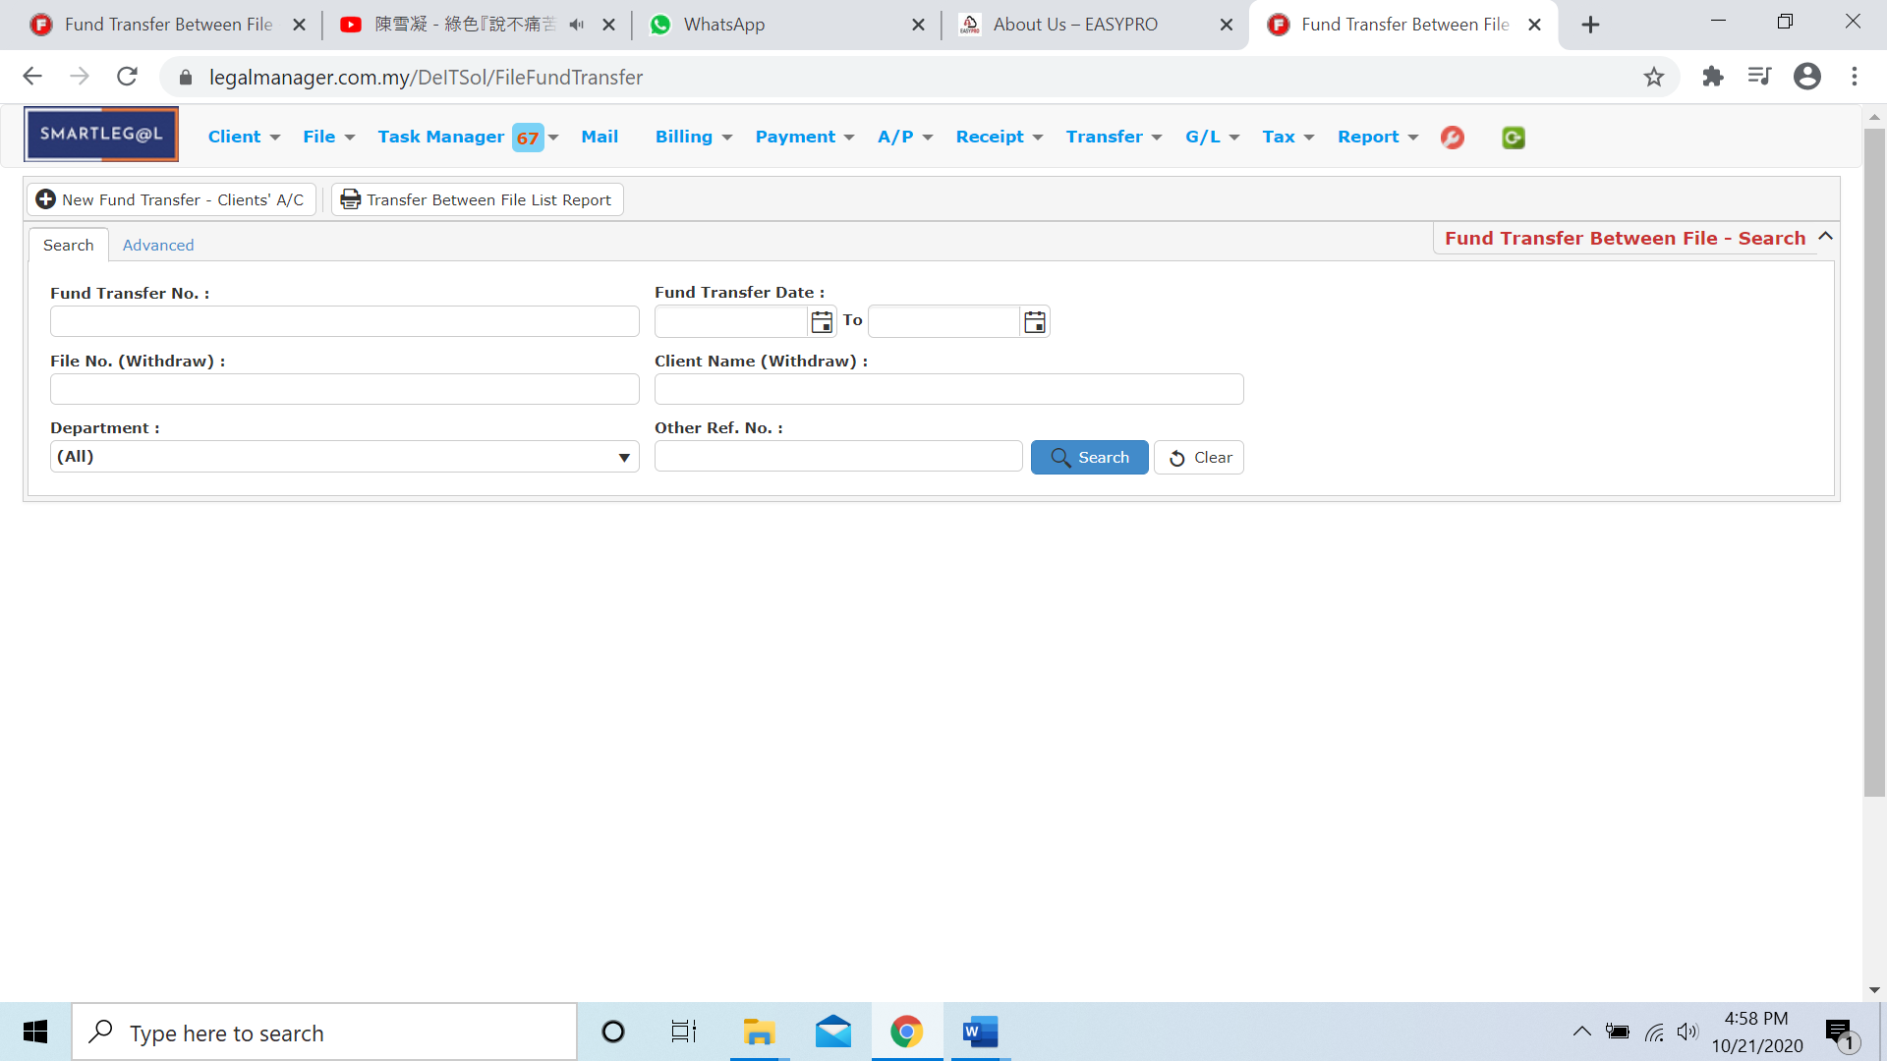

Figure: Manage File Fund Transfer - Search

**Advanced Search**

* This function can be used to find a invoice by searching other information that is not captured in the ‘General’ section.
* Define search criteria:

**- Field** - Choose the field you want to search.

**- Condition** - Search condition

**- Value** - Type in the detail you want to find.

* Click ‘**Add to list**’, to define more than one criteria.
* Click ‘**Find**’, search results will be displayed at search record list. You can open an item in the search results list by double-clicking.
* To start a new search or to clear the search results, click ‘**Clear**’.
* Click ‘**Export**’ to print the desired search results in txt, excel or html format.

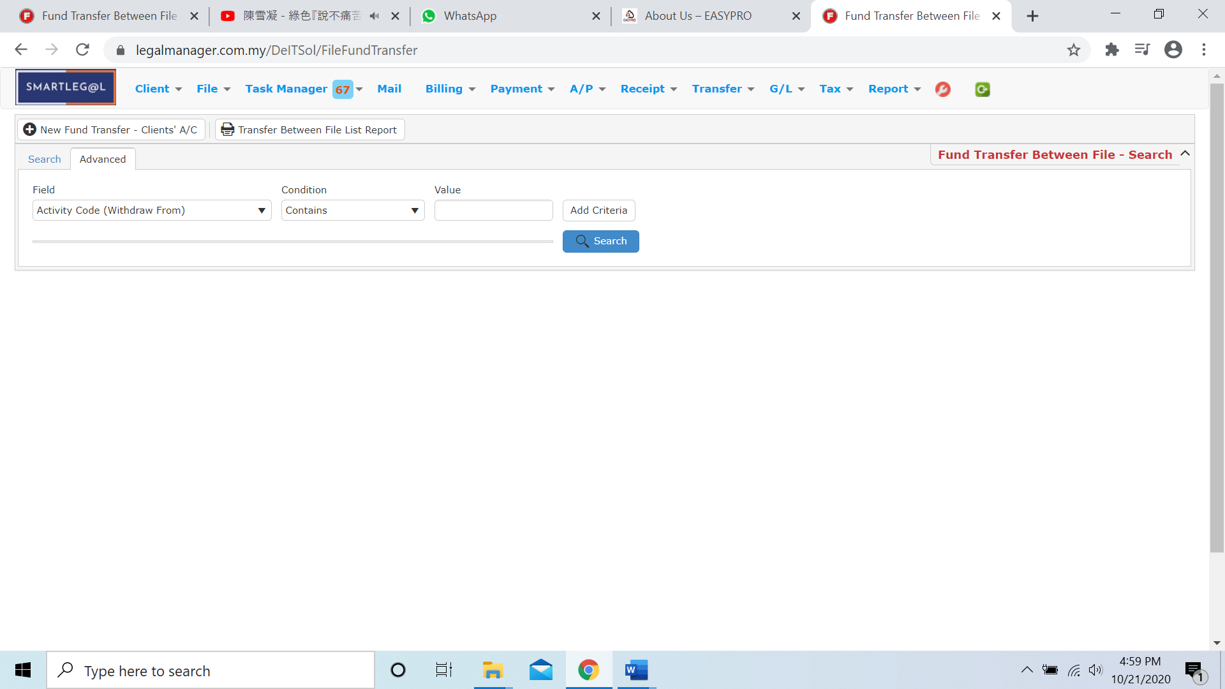

Figure: Manage File Fund Transfer– Advanced Search

* Other than Search File Fund Transfer you can create of New File Fund Transfer by clicking 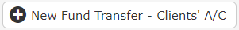 and it will pop up New File Fund Transfer input form and you may refer to Chapter 9.1 New File Fund Transfer

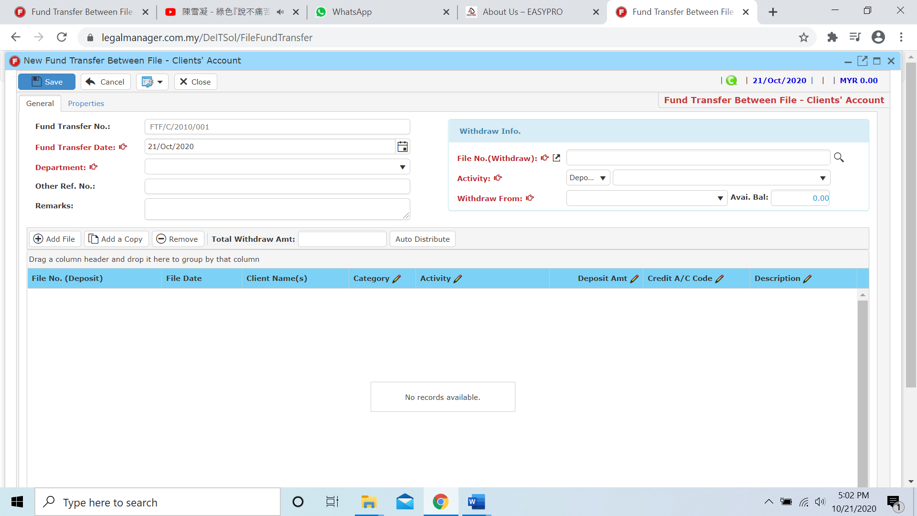

* You can print or preview the Transfer Between File List Report while you click to 
* It will pop-up a Transfer Between File List Report as below and you can insert you requirement to filter the report

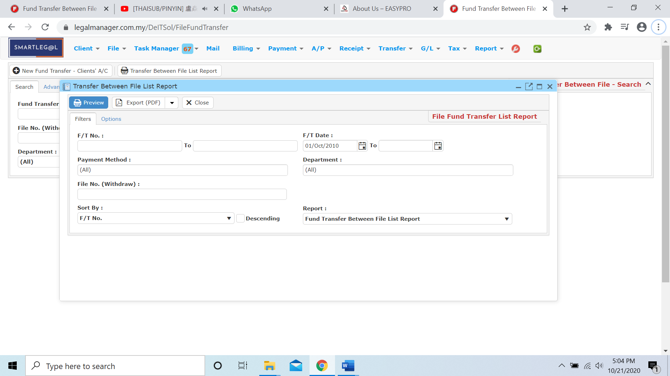

* Besides, you can preview the report
* You can also export the report into PDF or excel by clicking

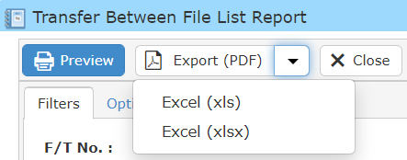

Note: For Chapter 9.6 Manage Bank Fund Transfer the module is similar to Chapter 9.2 Manage File Fund Transfer you may refer above.

**9.3 New Bank Fund Transfer (Client’ A/C)**

* Bank Fund Transfer is money in the same file transfer to different bank
* To open New Bank Fund Transfer (Client’ A/C), on the **SmartLeg@l** navigation, click **Transfer** and go to **New Bank Fund Transfer (Client’ A/C)**.

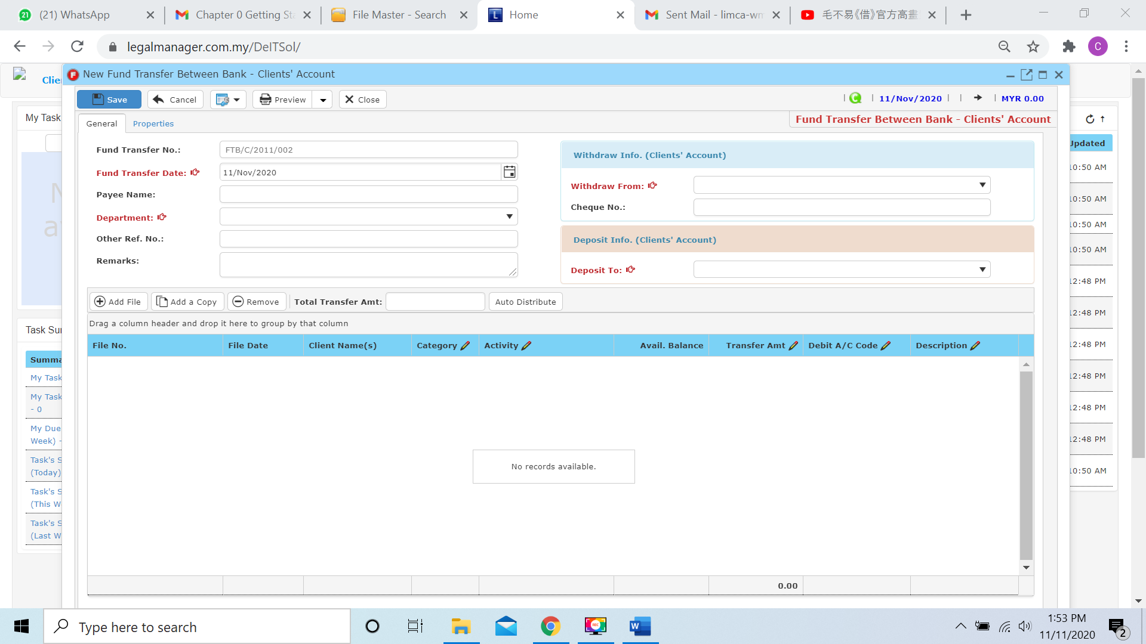

* Key in necessary information
* Fund Transfer No. is auto generated by the system
* Key in Fund Transfer Date and by default the date is auto generated with the date you click to New Bank Fund Transfer (Client’ A/C)
* Select a department from combo box



* In the Withdraw Info (Clients’ Account) section, you may select withdraw from which bank from the combo box

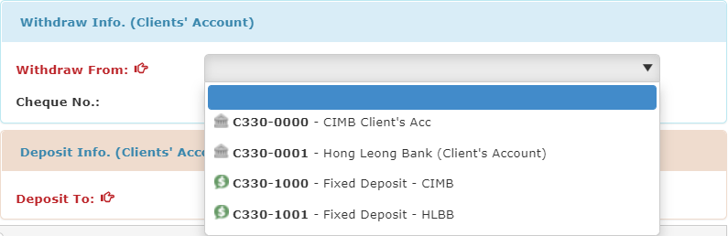

* After select the bank withdraw from, and you have to select the bank deposit to.

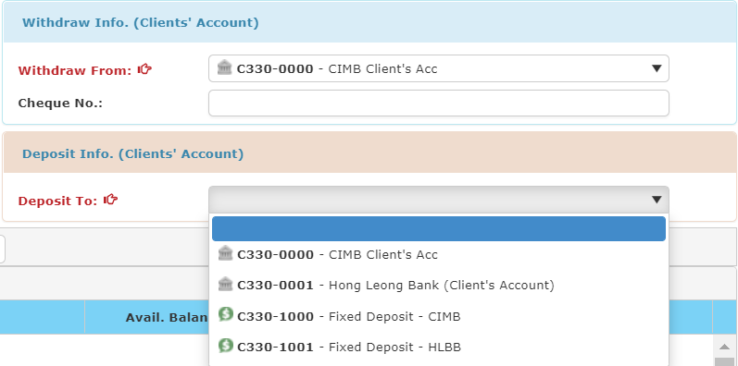

* When you finished key in and select the information and bank, you can Add File, Add a Copy, Remove and Auto Distribute balance in this section

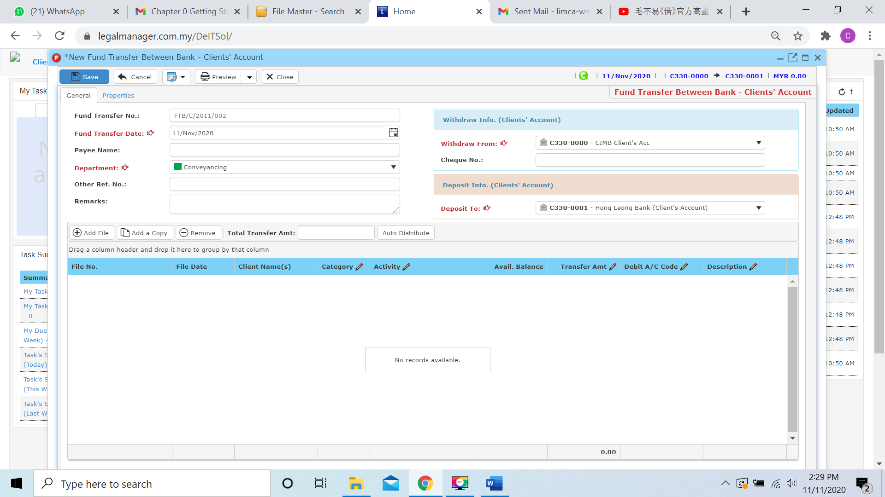

**Add File**

* While you click to the Add File, the system will provide a search file and you can insert your requirement to search

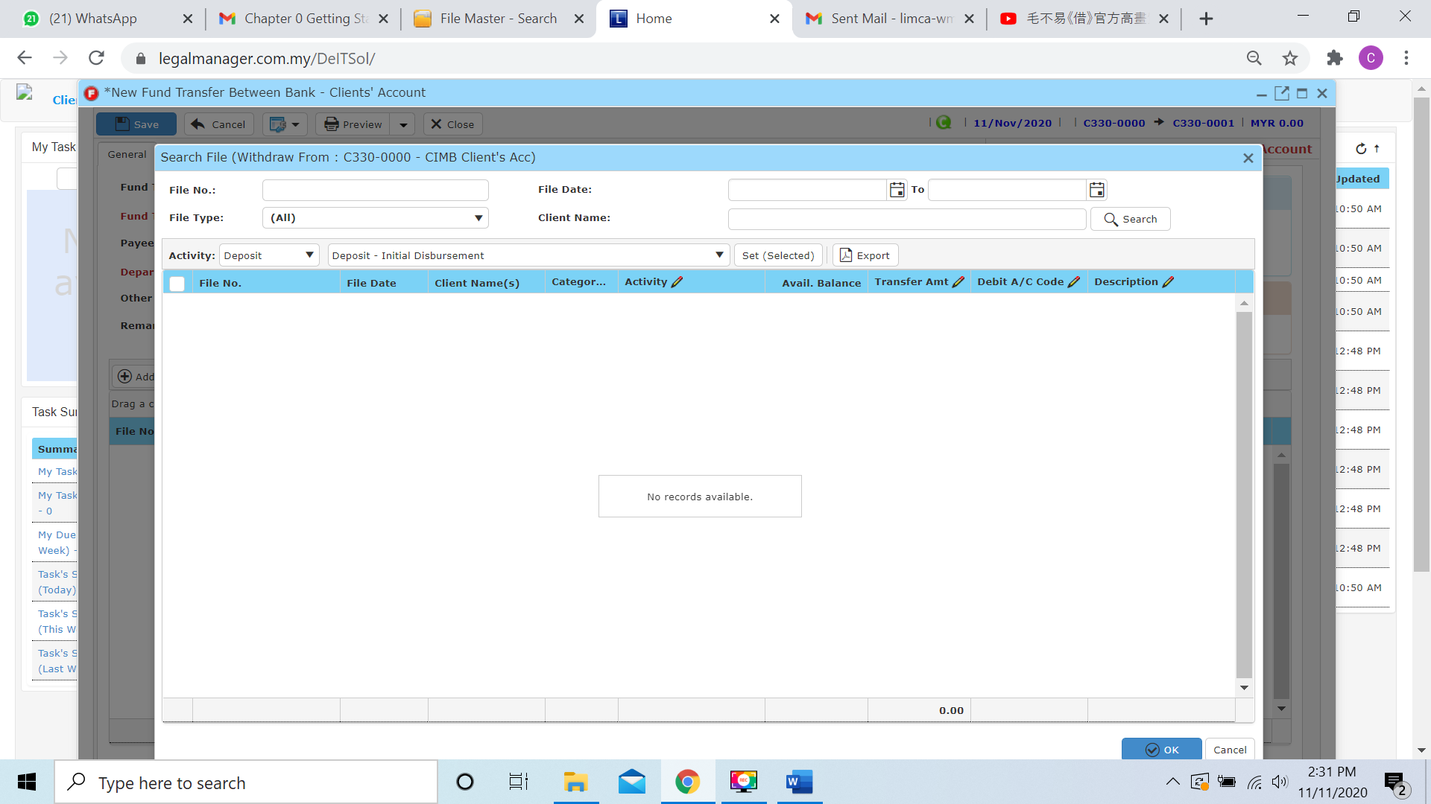

* Beside than you key in criteria on top side like file no, client name… to search, you can select the activity category to search.

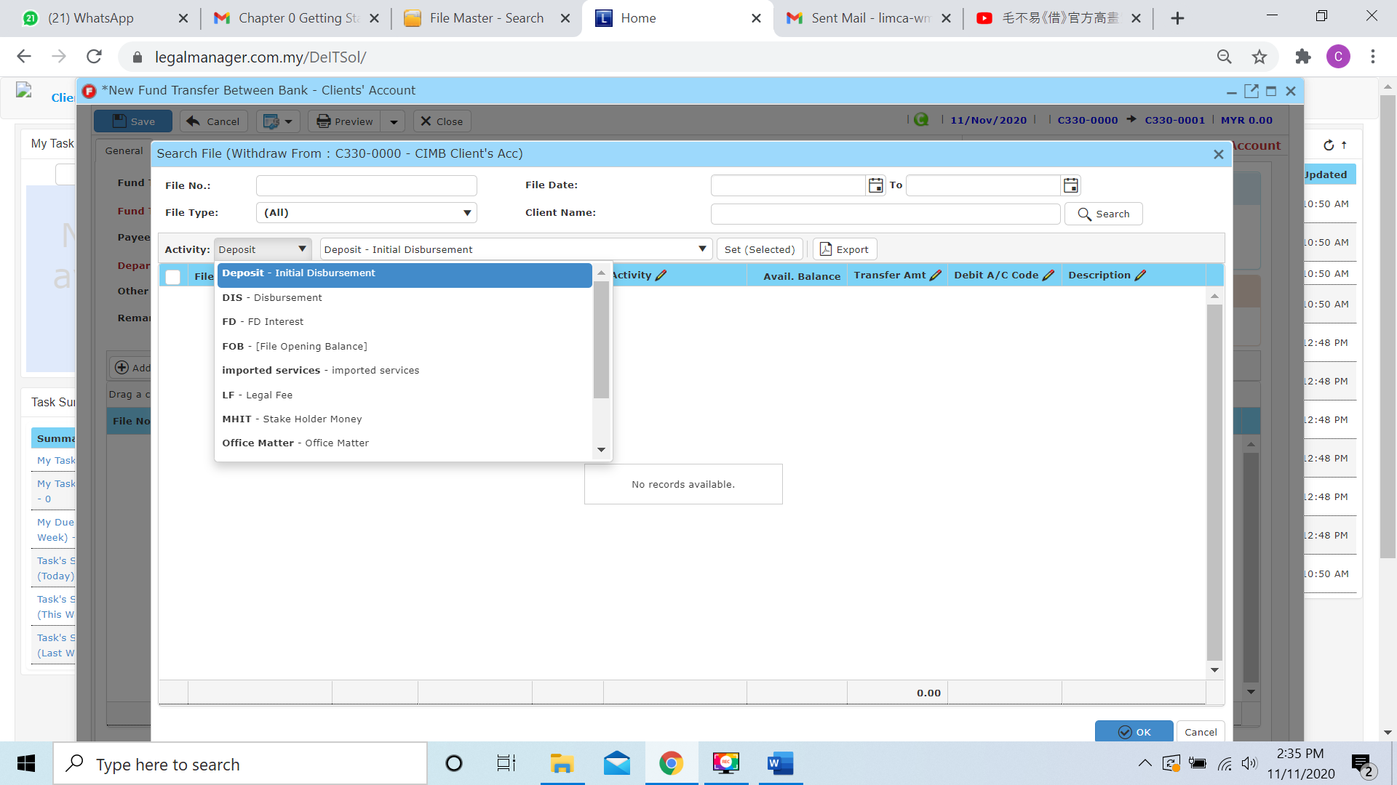

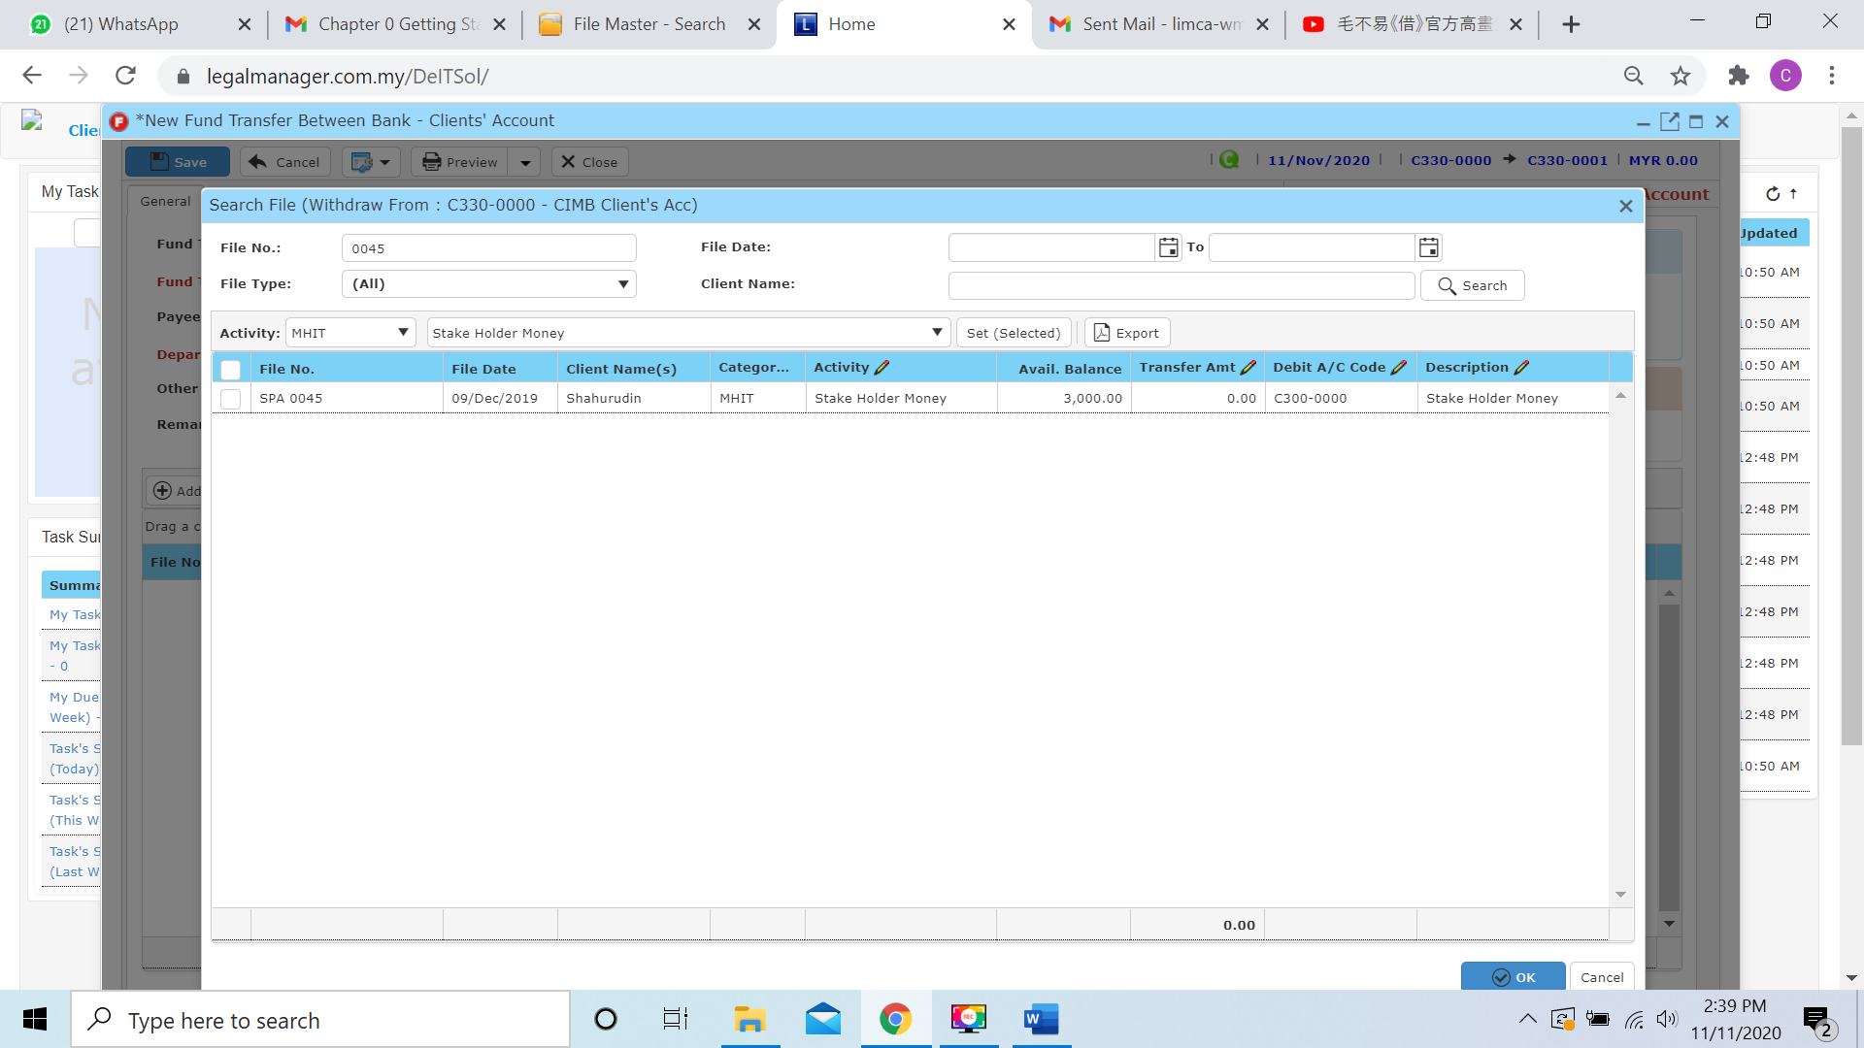

* When you found the file you search, you will see the available balance to transfer, when you tick to the file it will transfer all the available balance. Or else you can click to the transfer amount column to entered the amount you wish to transfer

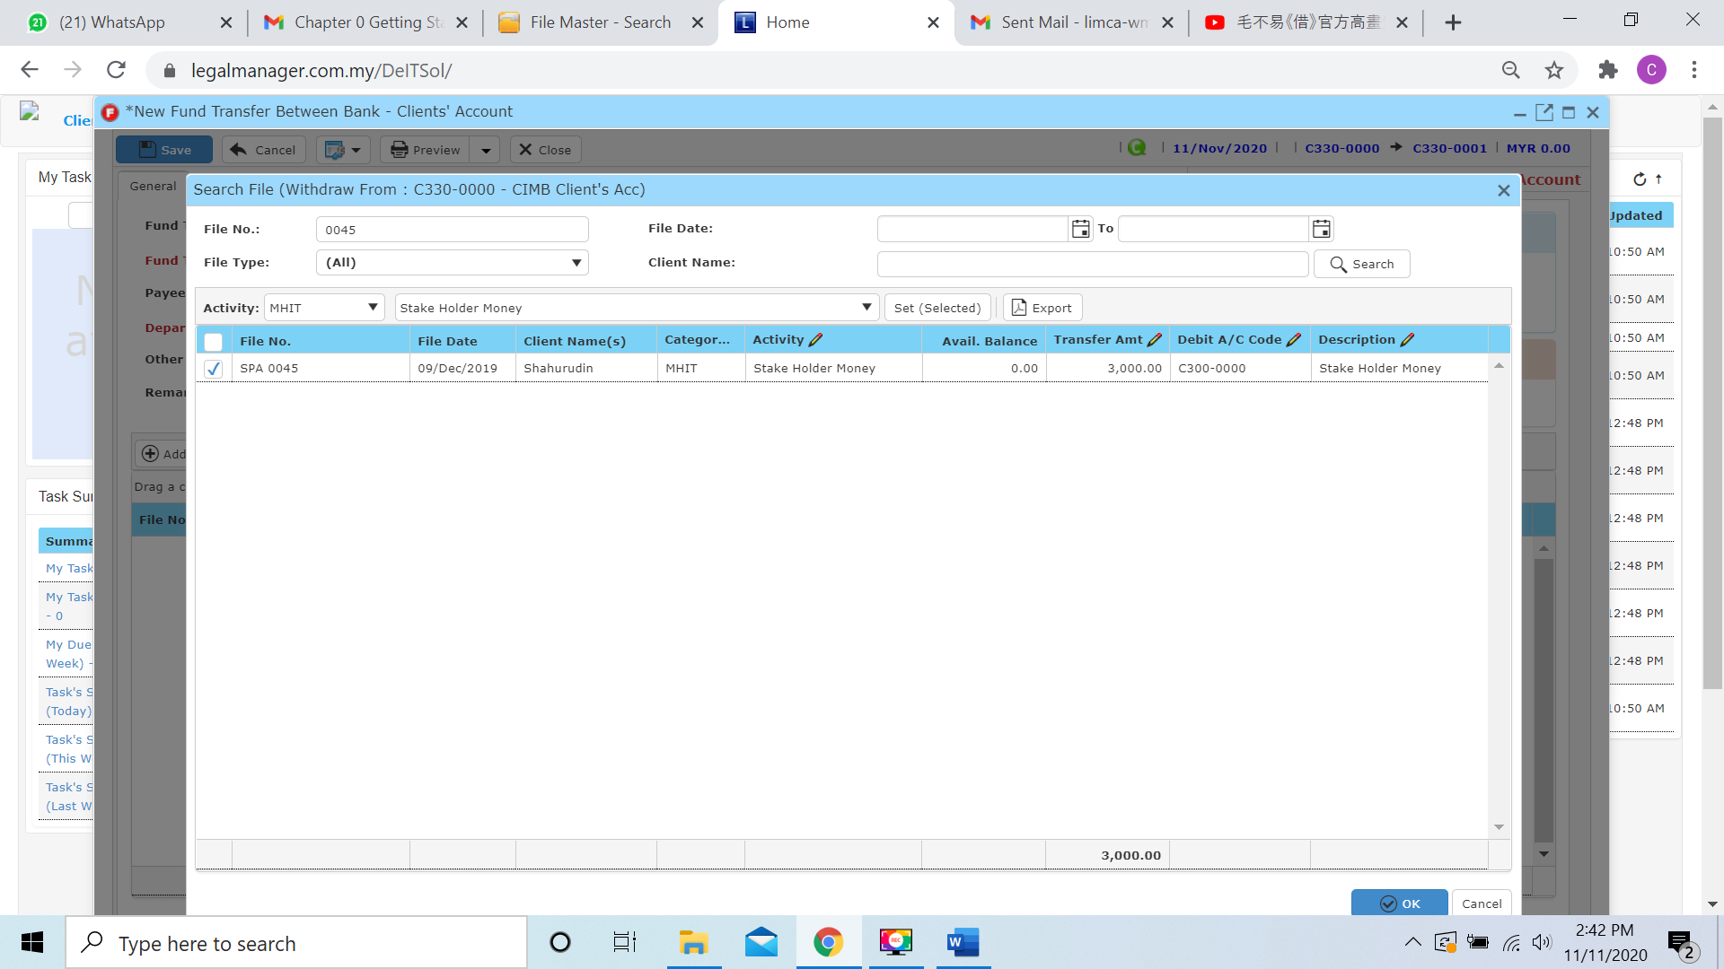

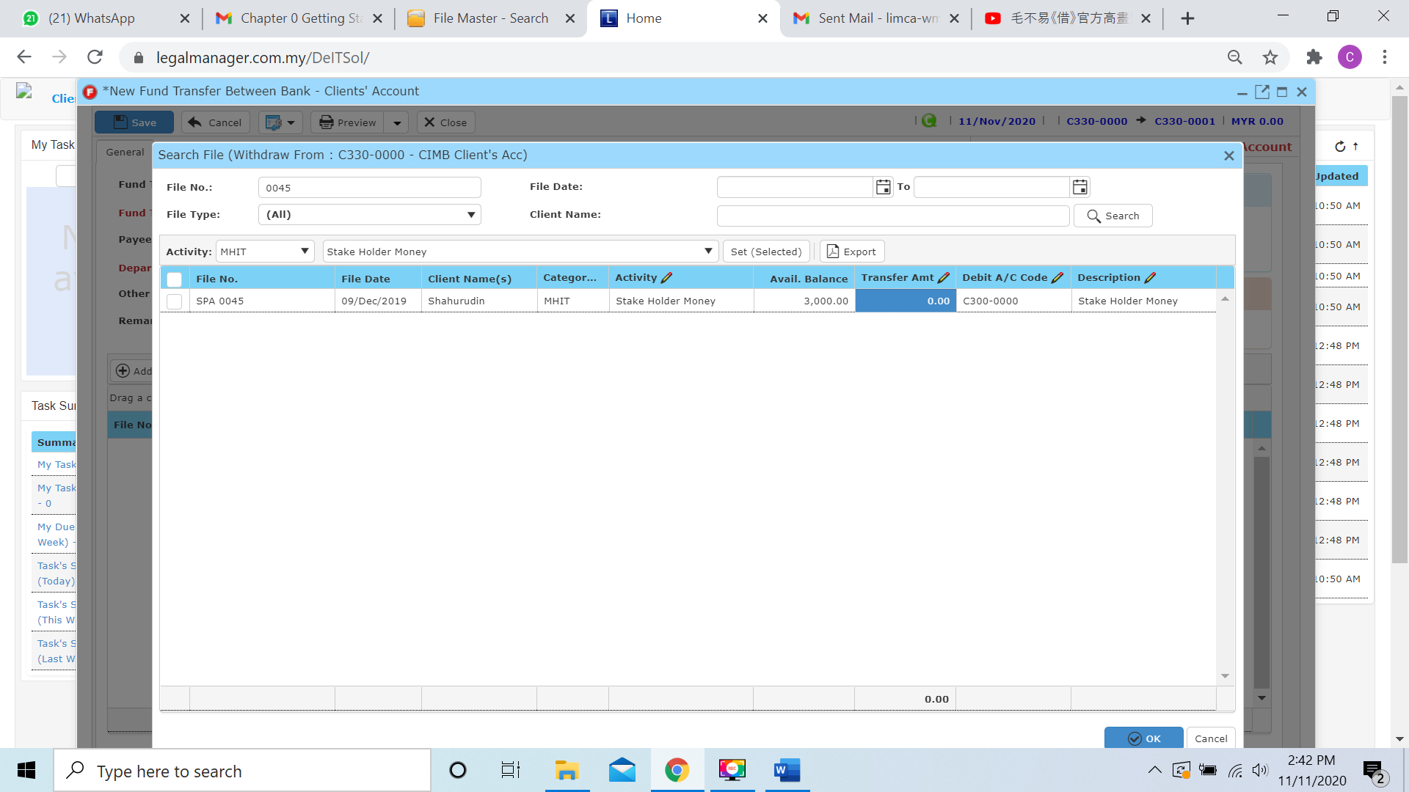

* For example, I will only transfer 1000 of available amount 3000

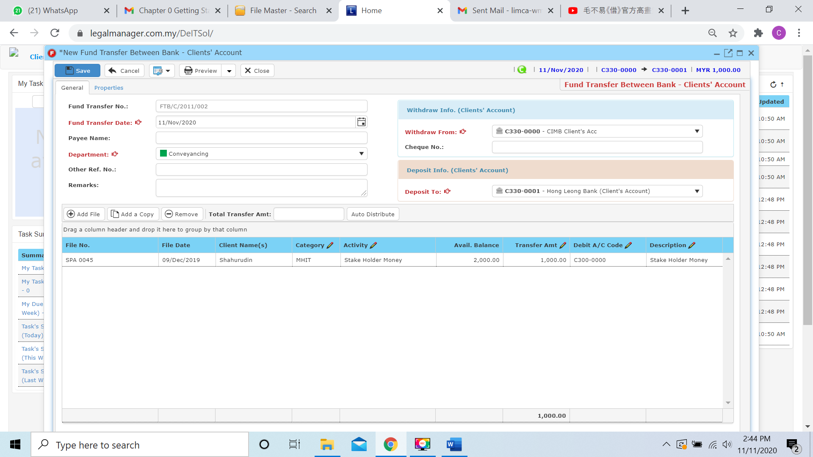

**Add a Copy**

* For Add a Copy, you can duplicate a selected row in the table

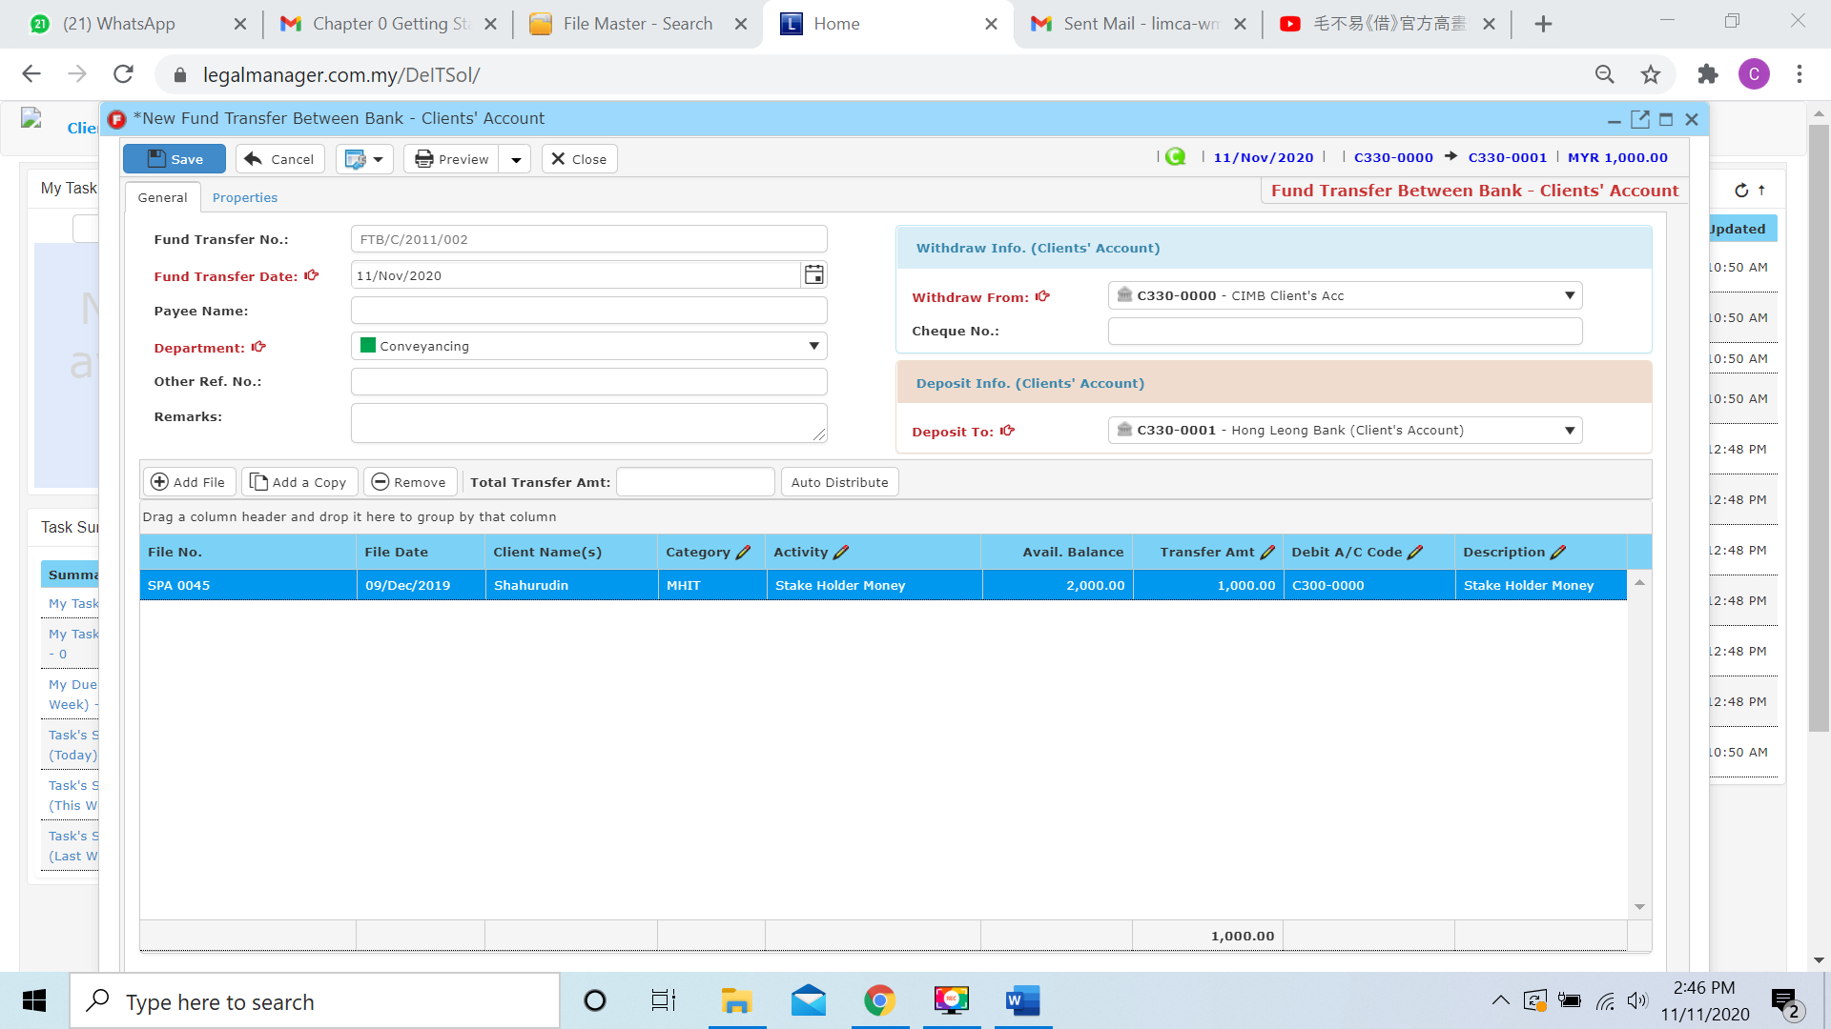

* After you click add a copy, it will copy the row as below figure shown

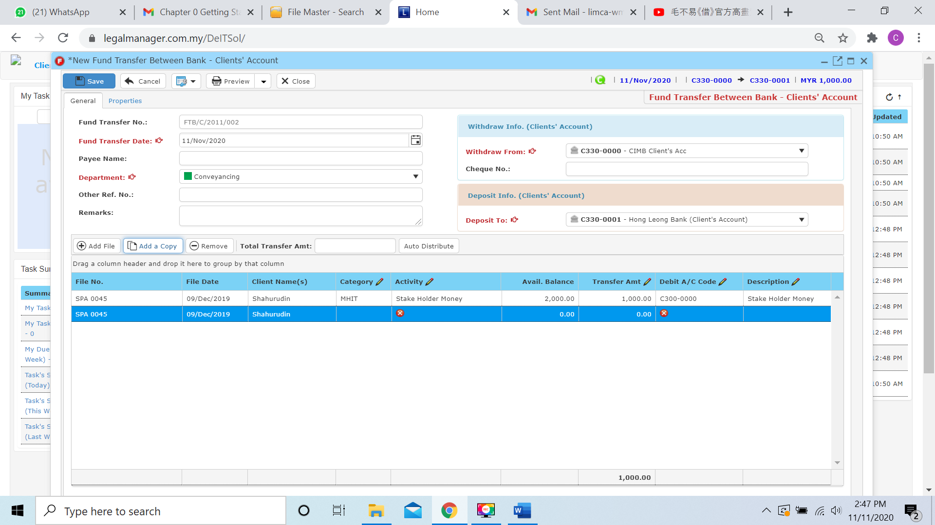

* It will copy the exactly file no., date, client and deposit amount however you have to choose those others like category and activity by yourself

**Remove**

* For the remove, you have to select the record in the list and click remove to erase the record
* For example, I will remove the empty row selected

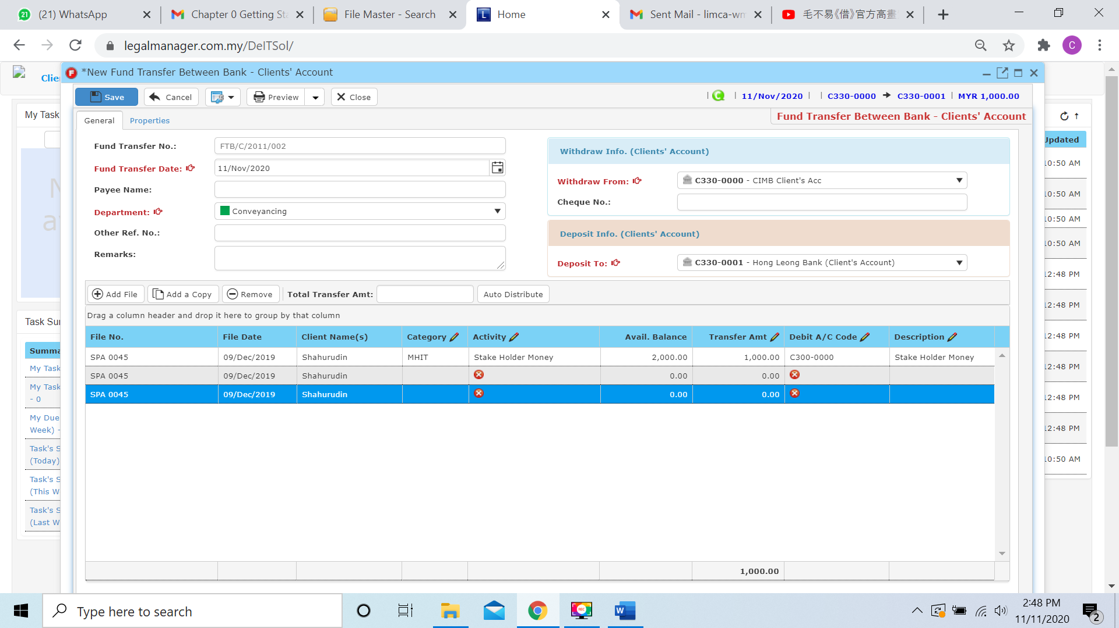

* After you click the remove button it will erase the selected row



**Auto Distribute**

* Before using the auto distribute function, you have to key in the Total Withdraw Amount 
* After entered the amount, when you click to ‘Auto Distribute’ the system will equally divide and distribute to the file in the table
* Other than that, you can view the posting details with clicking this icon 



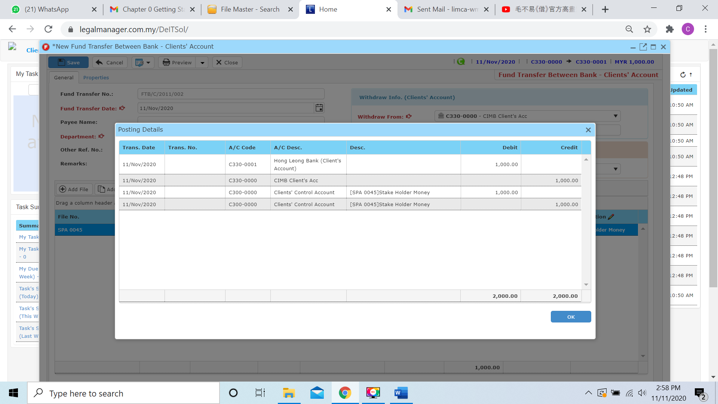

* You can click to the next tab ‘Properties’



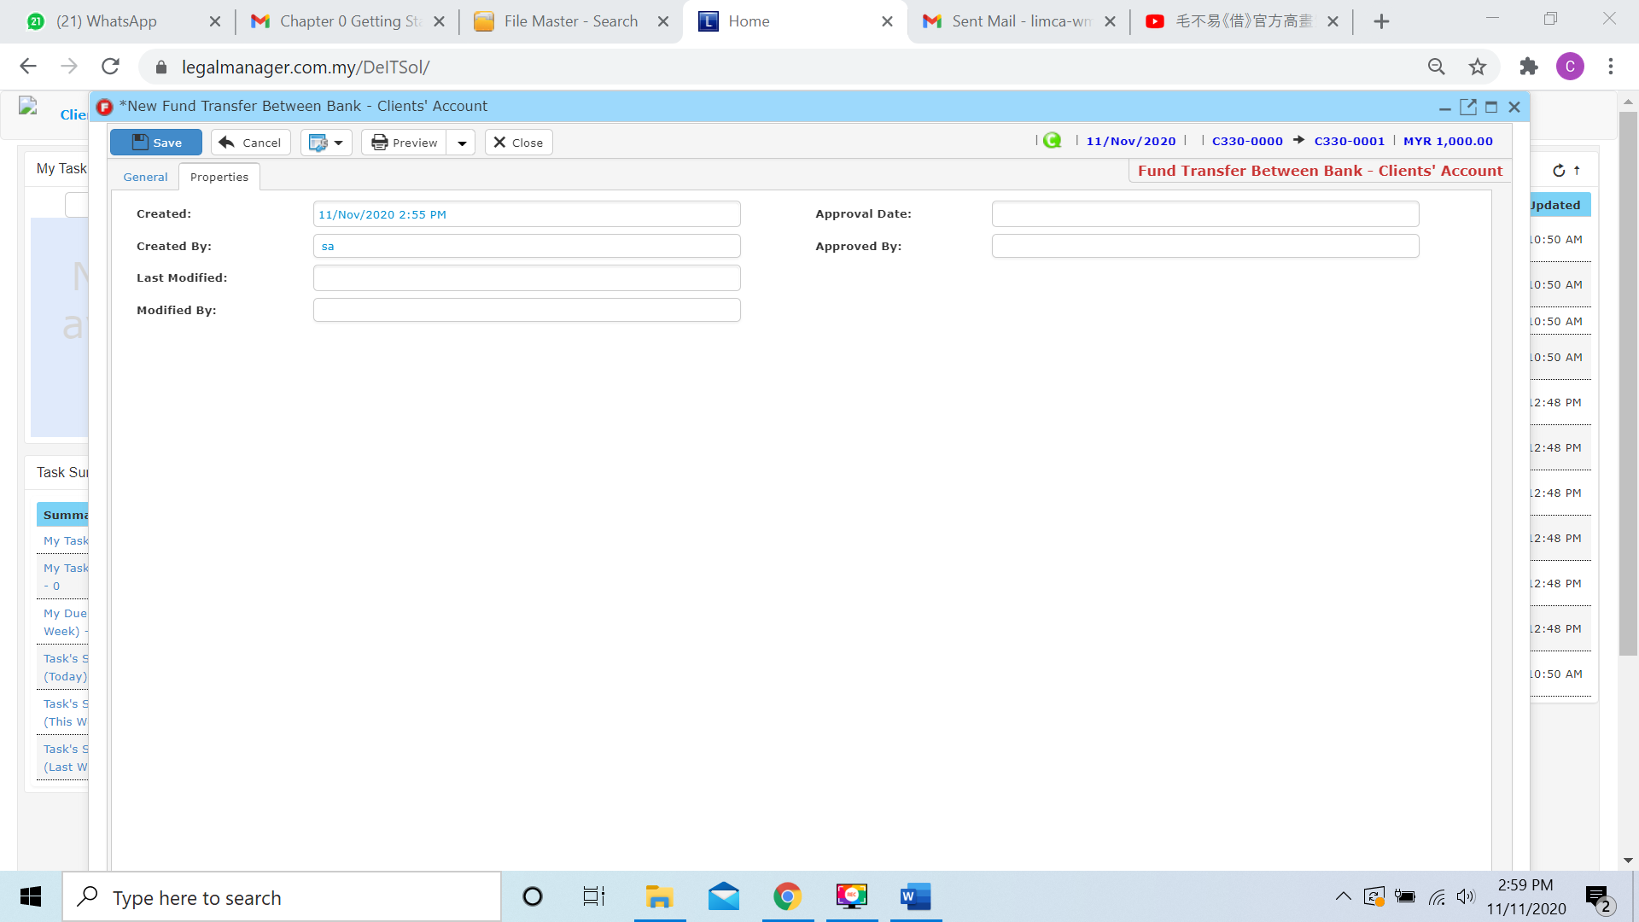

* You can view the information of the record once who modify the fund transfer between bank – client’ a/c then there will show the last modified and modified by who
* Once you finish all the instruction above, click ‘Save’ then you are done to create a New Bank Fund Transfer(Client’ A/C.)

**9.4 New Bank Fund Transfer - Client’ A/C to Office’ A/C**

* Bank Fund Transfer is money in the same file transfer to different bank
* To open New Bank Fund Transfer - Client’ A/C to Office’ A/C, on the **SmartLeg@l** navigation, click **Transfer** and go to **New Bank Fund Transfer - Client’ A/C to Office’ A/C**.

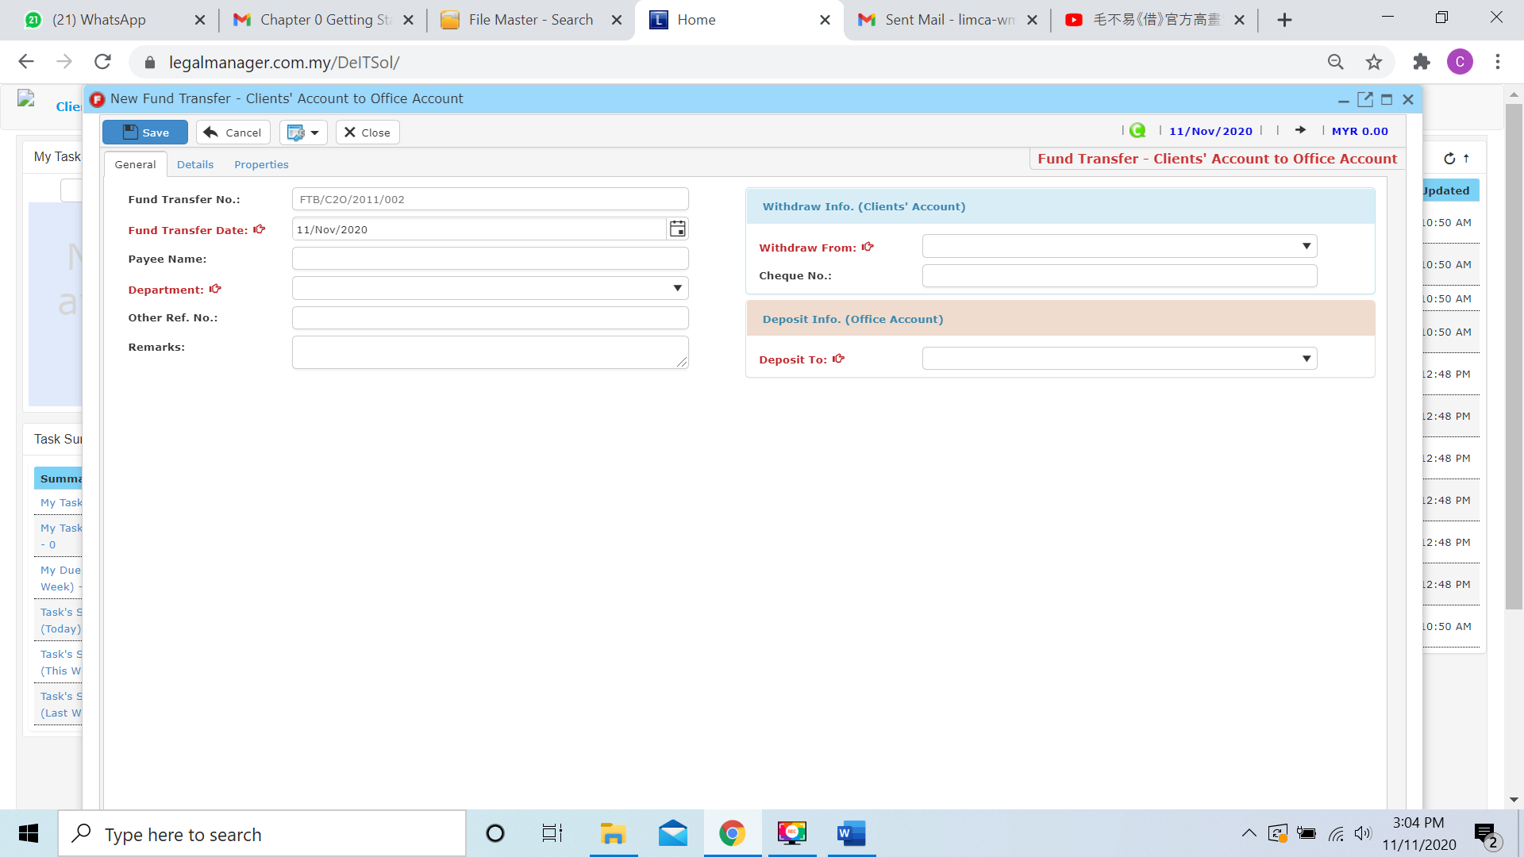

* Key in necessary information
* Fund Transfer No. is auto generated by the system
* Key in Fund Transfer Date and by default the date is auto generated with the date you click to New Bank Fund Transfer
* Select a department from combo box

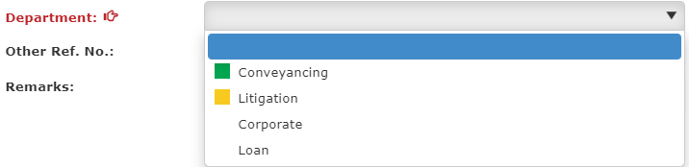

* In the Withdraw Info (Clients’ Account) section, you may select withdraw from which bank from the combo box

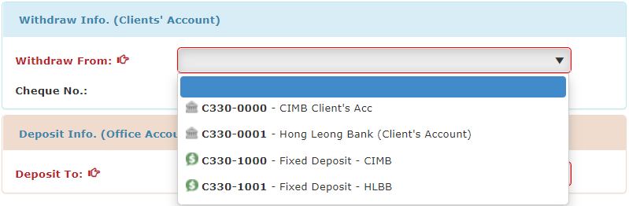

* After select the client acc withdraw from, and you have to select the office acc deposit to.

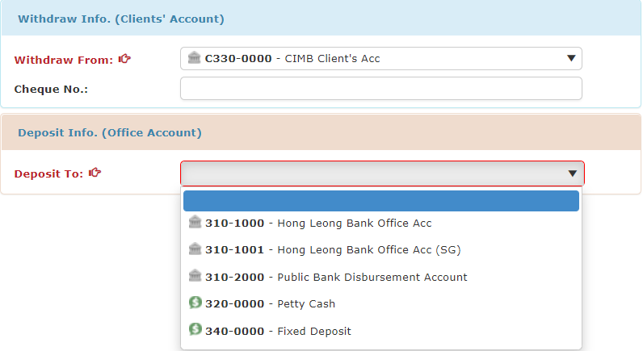

* When you finished key in and select the information and bank, you can click to the next tab ‘Details’

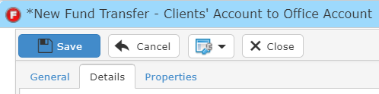

* When you click to the details tab, it will pop up a search file wizard as figure below shown, you can insert your requirement to search

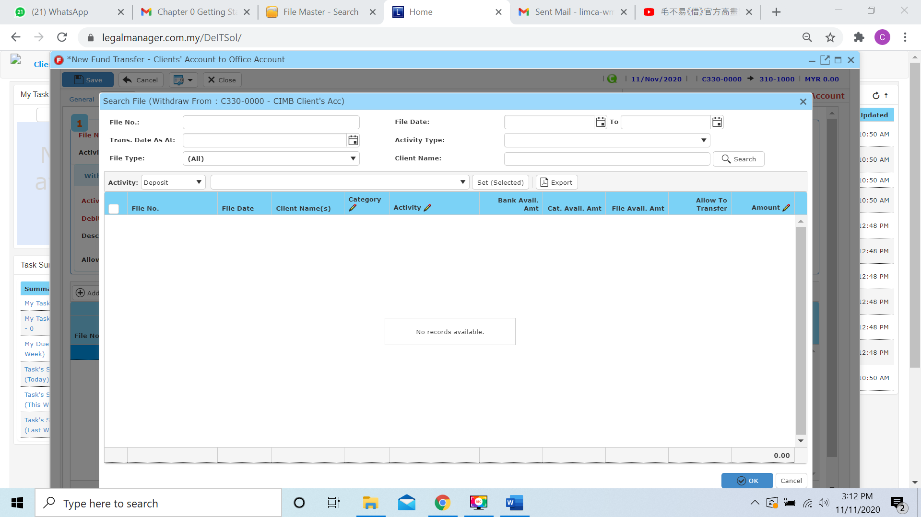

* Beside than you key in criteria on top side like file no, client name… to search, you can select the activity category to search.

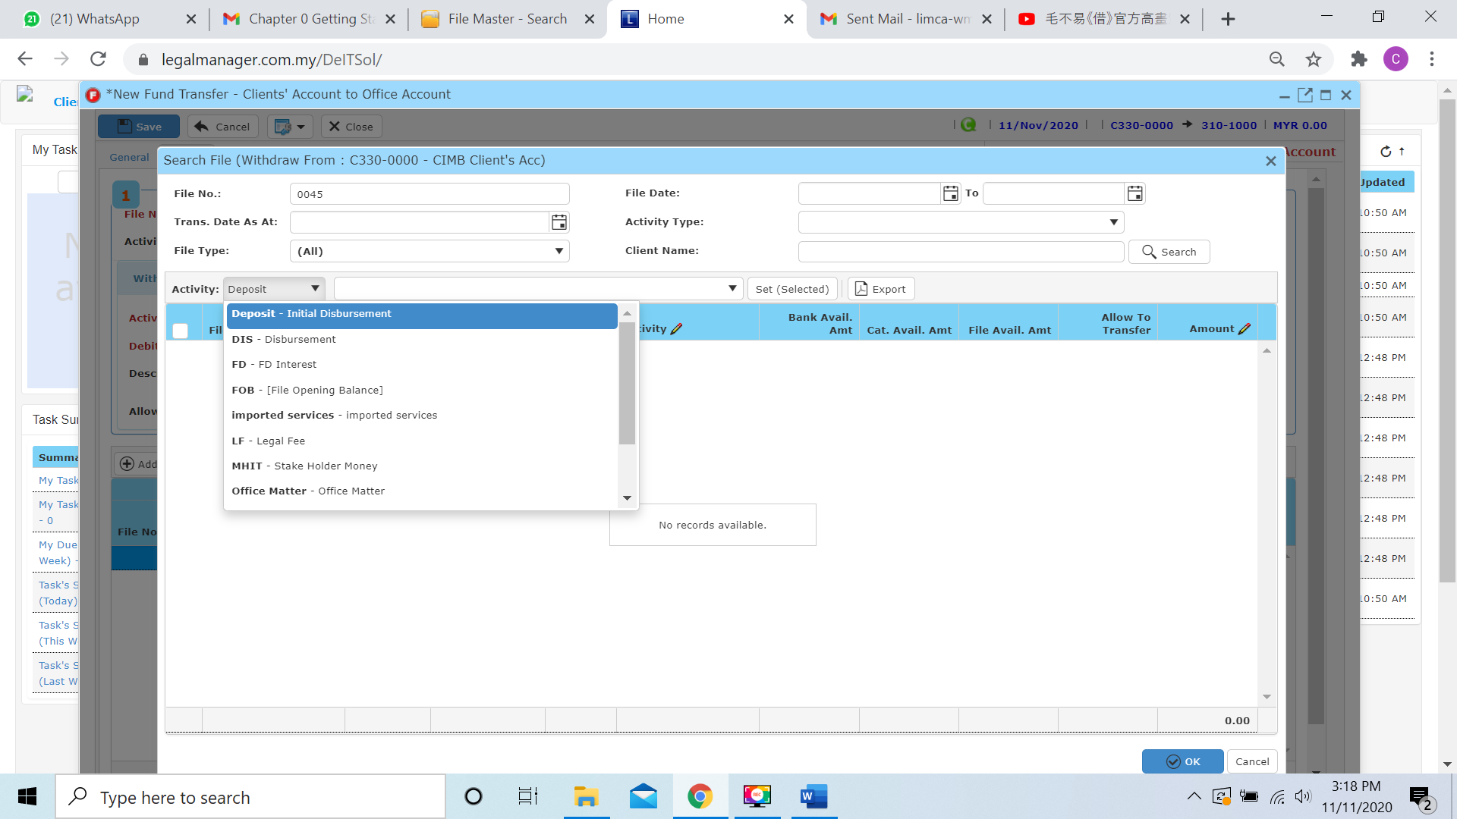

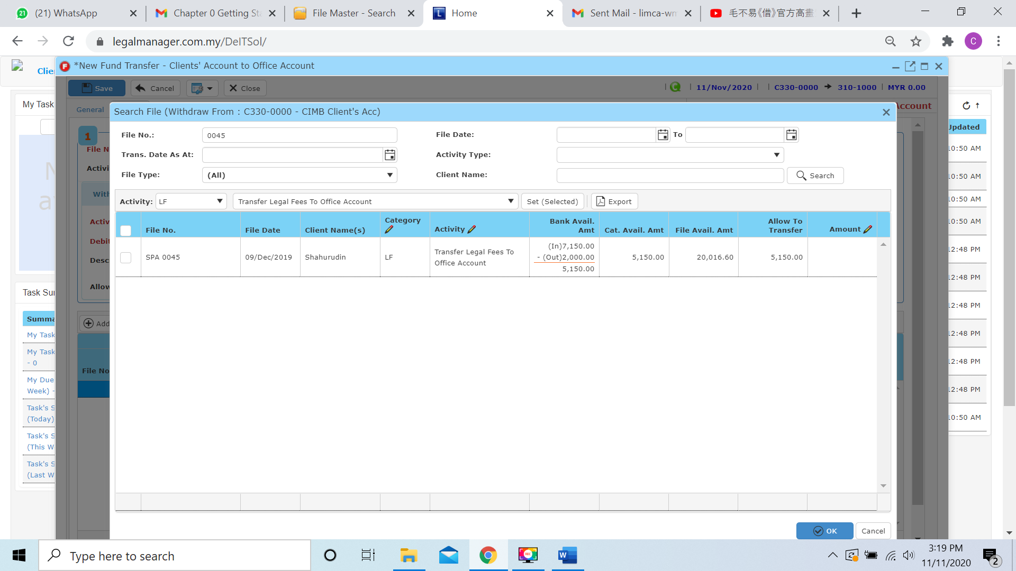

* When you found the file you search, you will see all the balance of the file, and one of the most important you can look at **Allow to transfer**, when you tick to the file it will transfer all the allow to transfer balance. Or else you can click to the amount column to insert the amount you wish to transfer

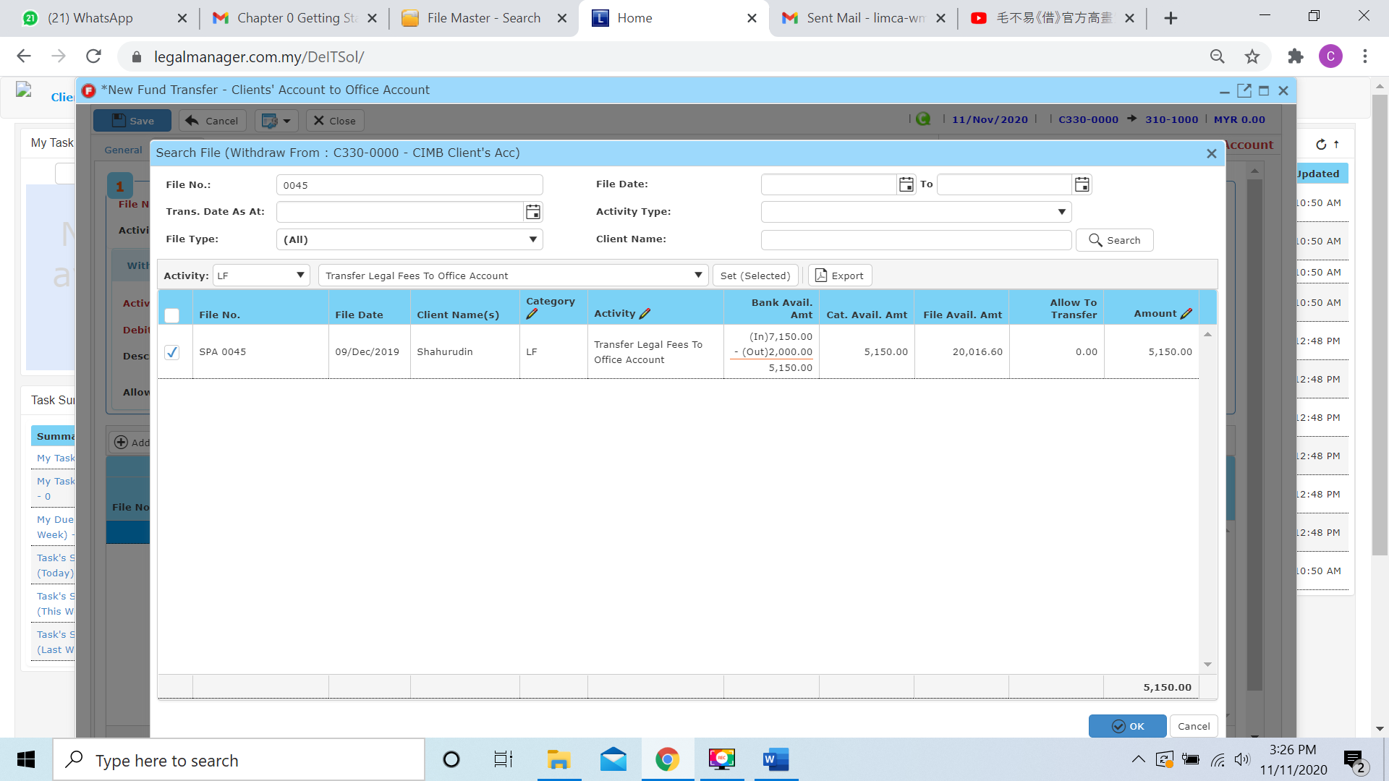

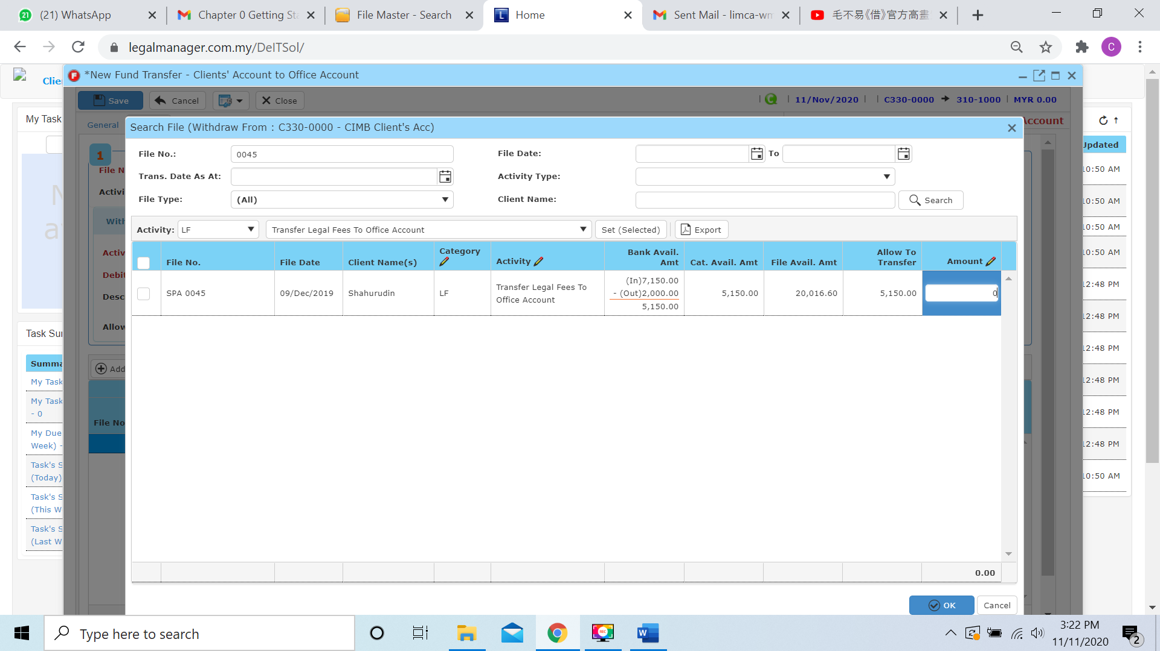

* For example, I will only transfer 1150 of balance allow to transfer 5150 and click to ‘**OK**’

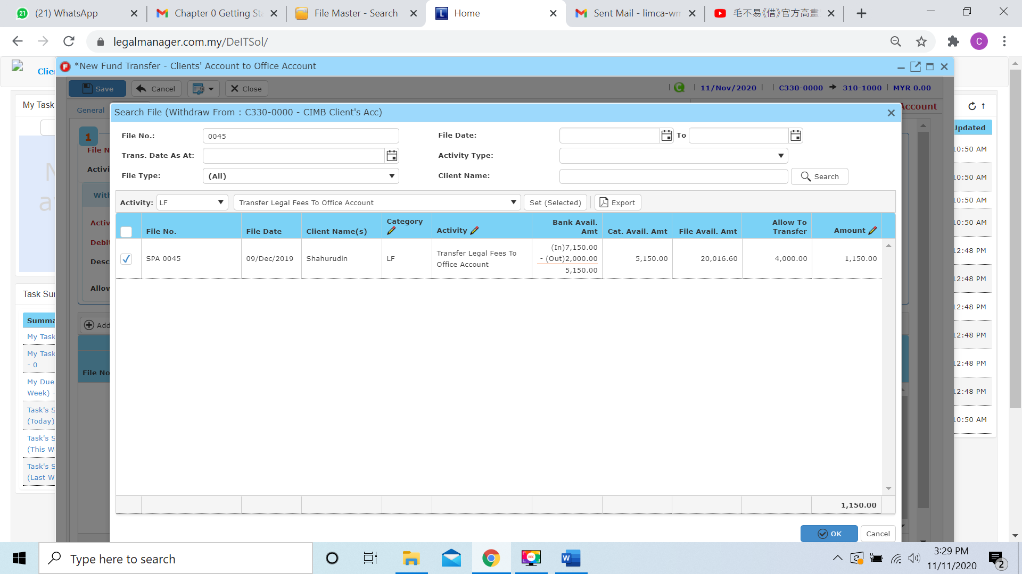

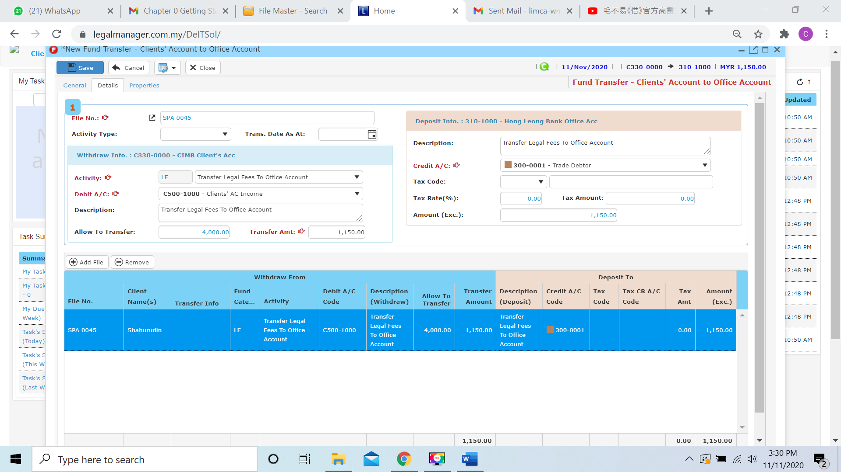

* Moreover, you can click  and it will pop up the search file wizard as procedure above again to add record, and you can click to  to remove the added file
* You can click to the next tab ‘Properties’

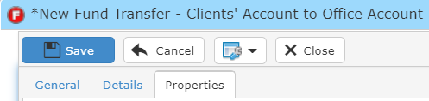

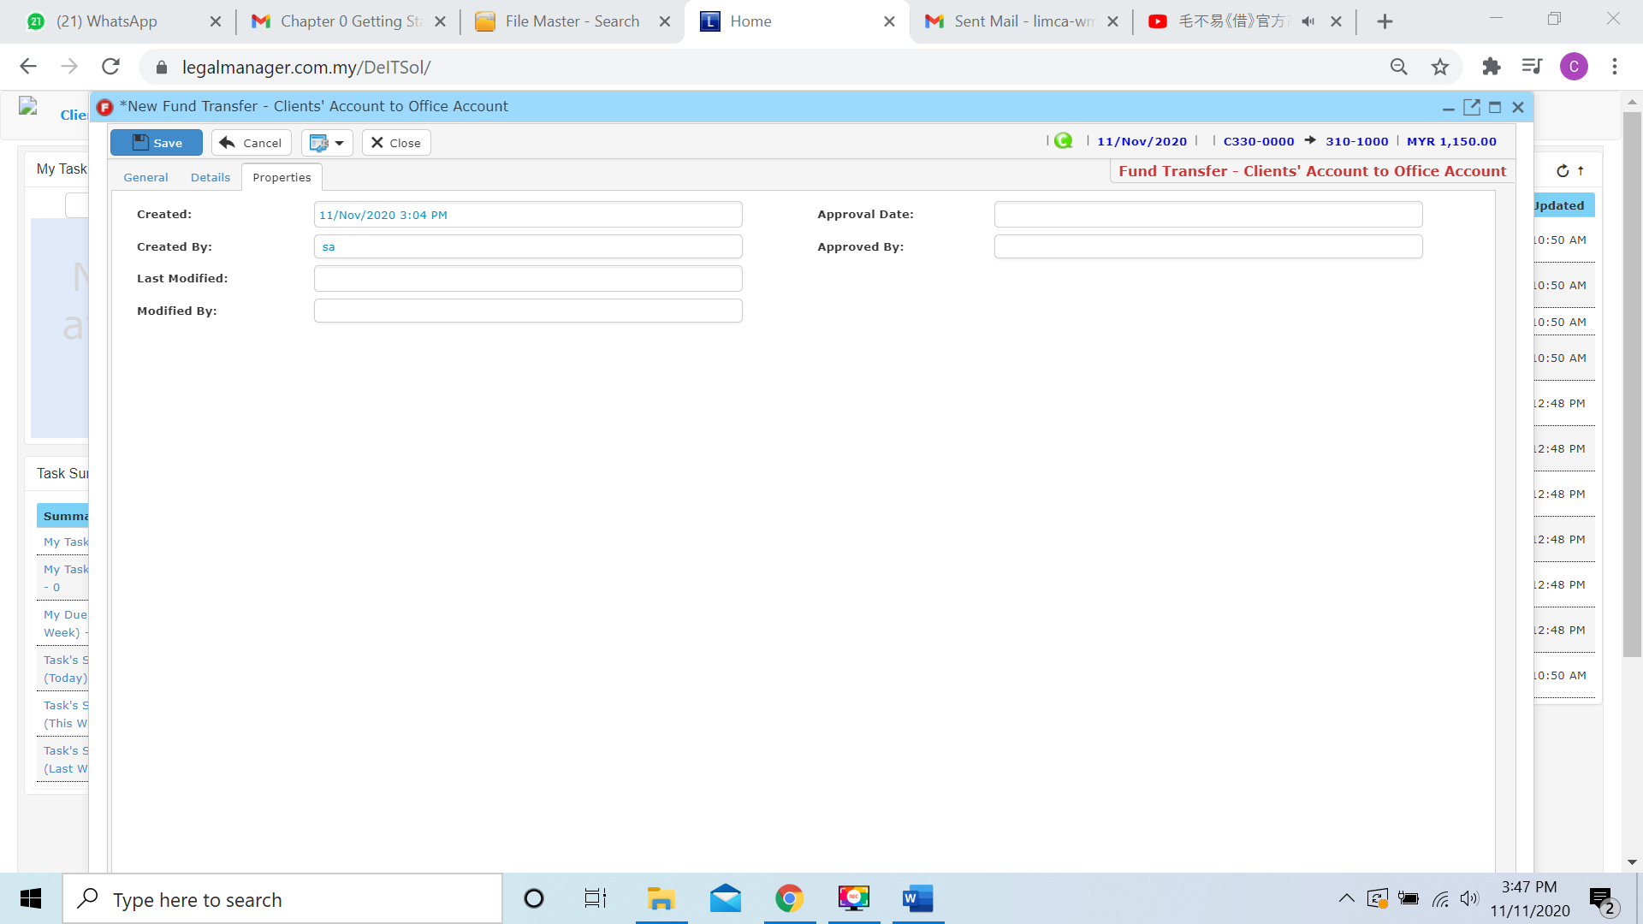

* You can view the information of the record once who modify the record then there will show the last modified and modified by who
* Once you finish all the instruction above, click ‘Save’ then you are done to create a New Bank Fund Transfer – Client’ A/C to Office A/C

**9.5 New Bank Fund Transfer - Office’ A/C to Client’ A/C**

* Bank Fund Transfer is money in the same file transfer to different bank
* To open New Bank Fund Transfer - Office A/C to Client’ A/C, on the **SmartLeg@l** navigation, click **Transfer** and go to **New Bank Fund Transfer - Office A/C to Client’ A/C**.

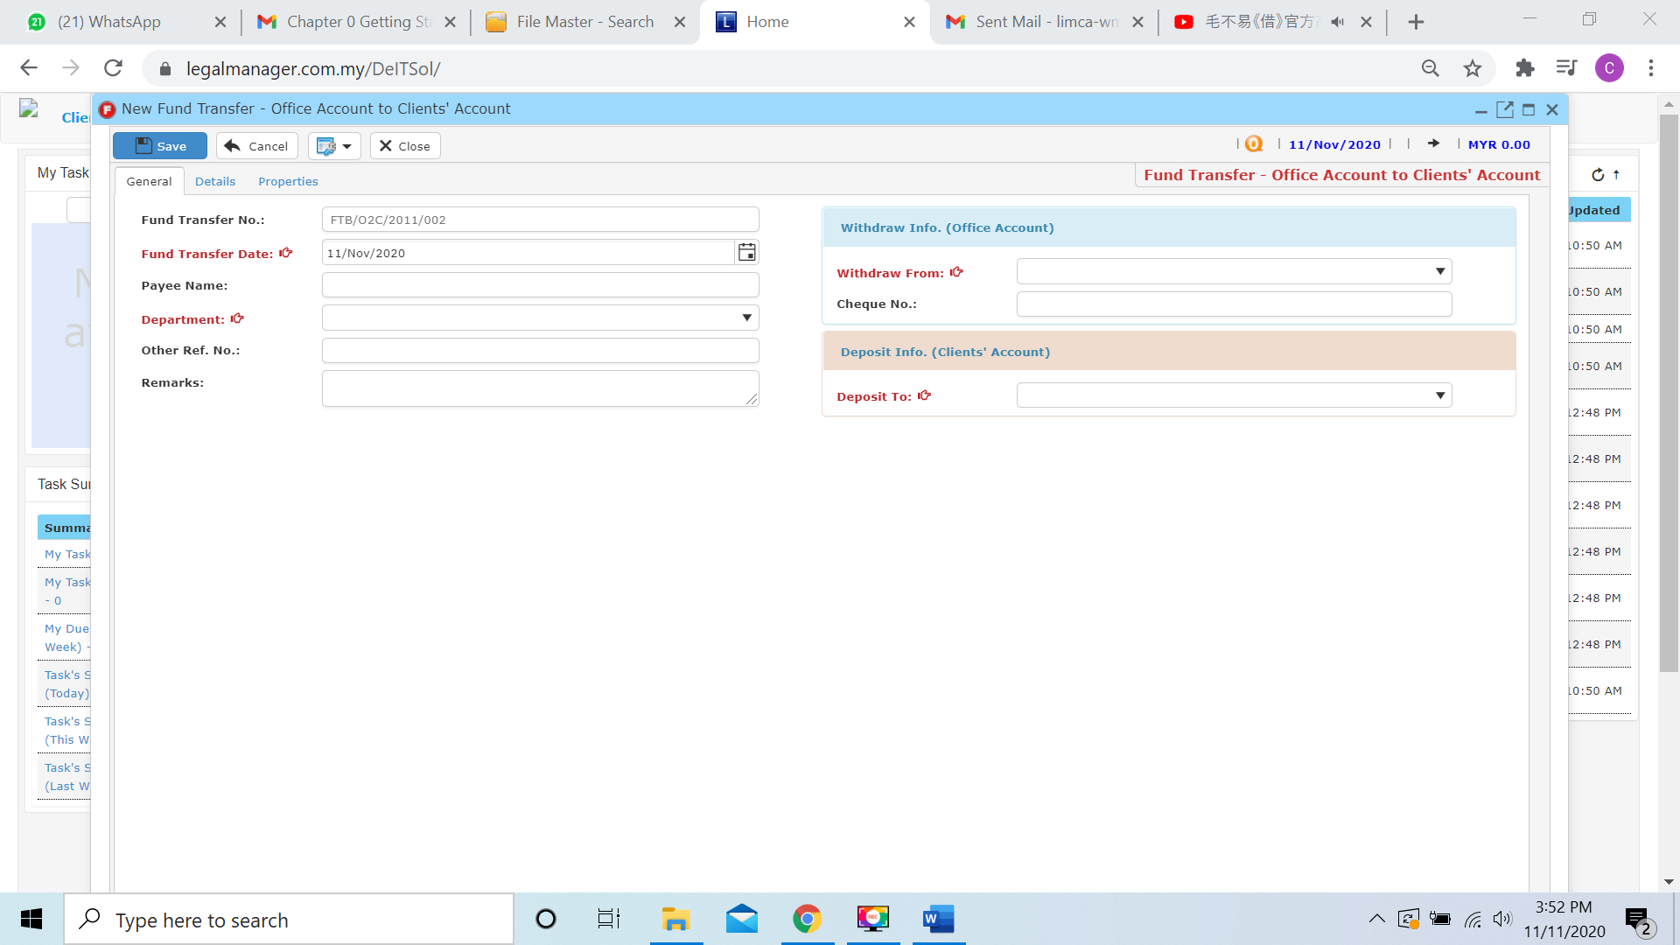

* Key in necessary information
* Fund Transfer No. is auto generated by the system
* Key in Fund Transfer Date and by default the date is auto generated with the date you click to New Bank Fund Transfer
* Select a department from combo box



* In the Withdraw Info (Office Account) section, you may select withdraw from which bank from the combo box

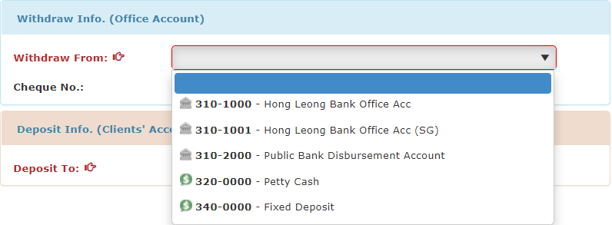

* After select the office acc withdraw from, and you have to select the client acc deposit to.

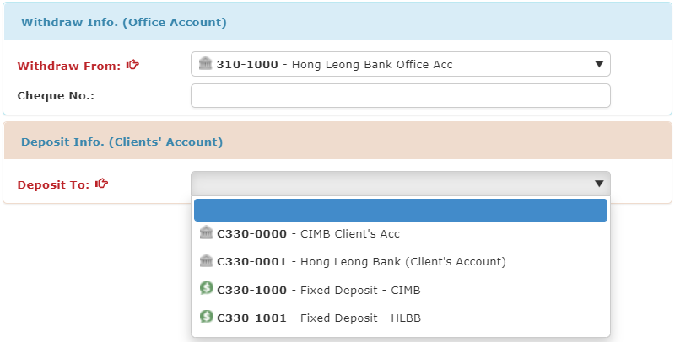

* When you finished key in and select the information and bank, you can click to the next tab ‘Details’

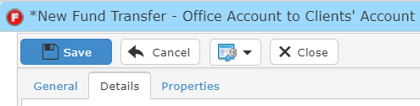

* When you click to the details tab, it will pop up a search file wizard as figure below shown, you can insert your requirement to search

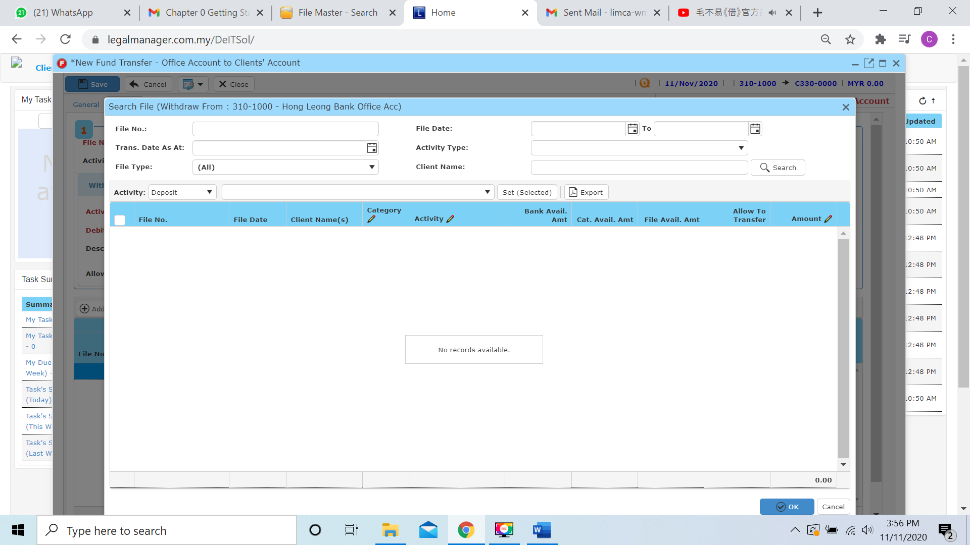

* Beside than you key in criteria on top side like file no, client name… to search, you can select the activity category to search.

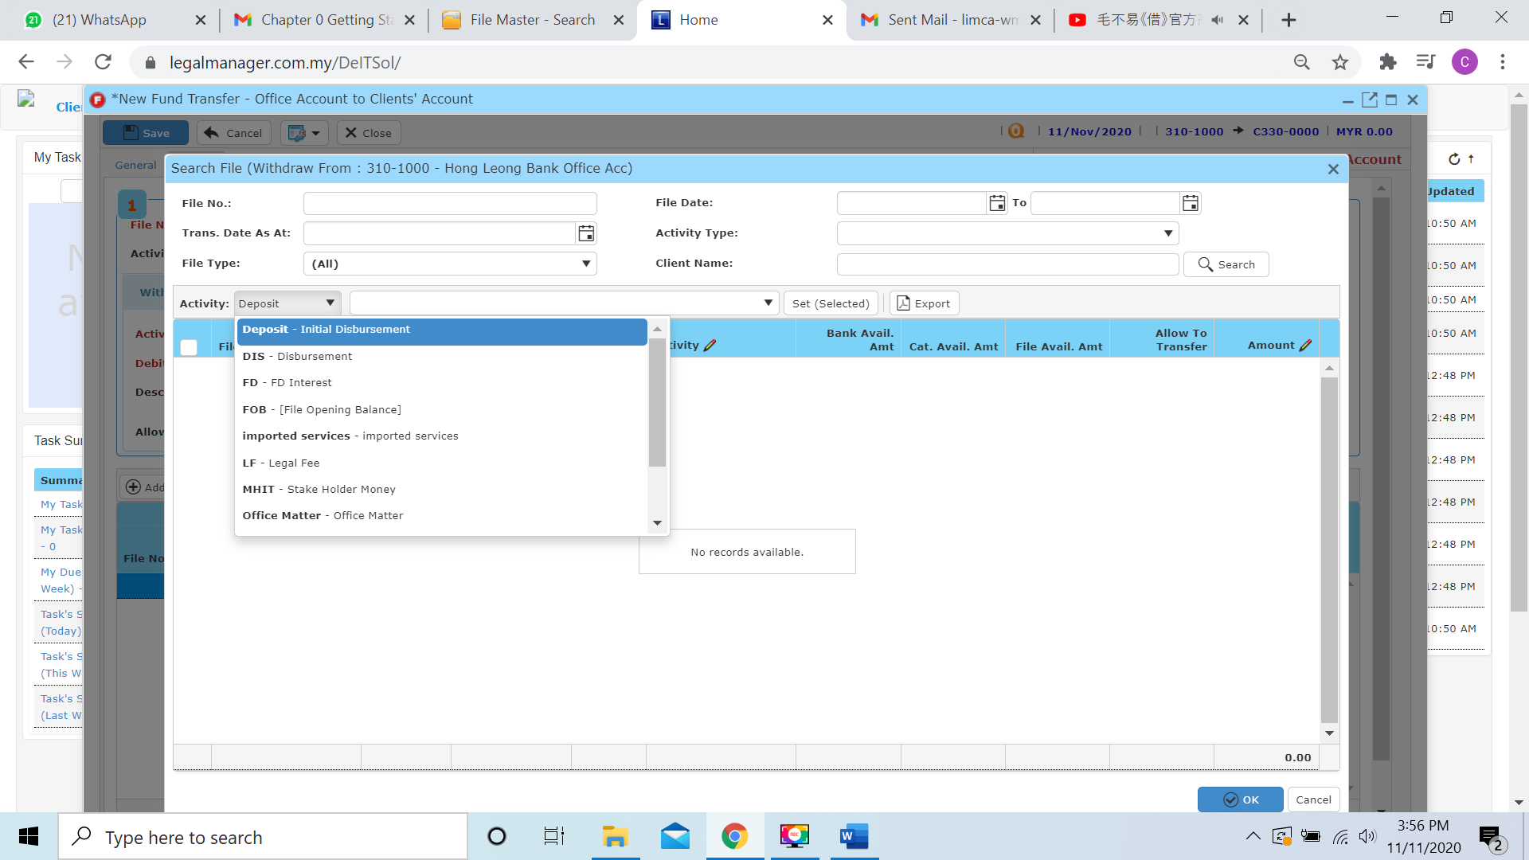

* When you found the file you search, you will see all the balance of the file, and one of the most important you can look at **Allow to transfer**, when you tick to the file it will transfer all the allow to transfer balance. Or else you can click to the amount column to insert the amount you wish to transfer

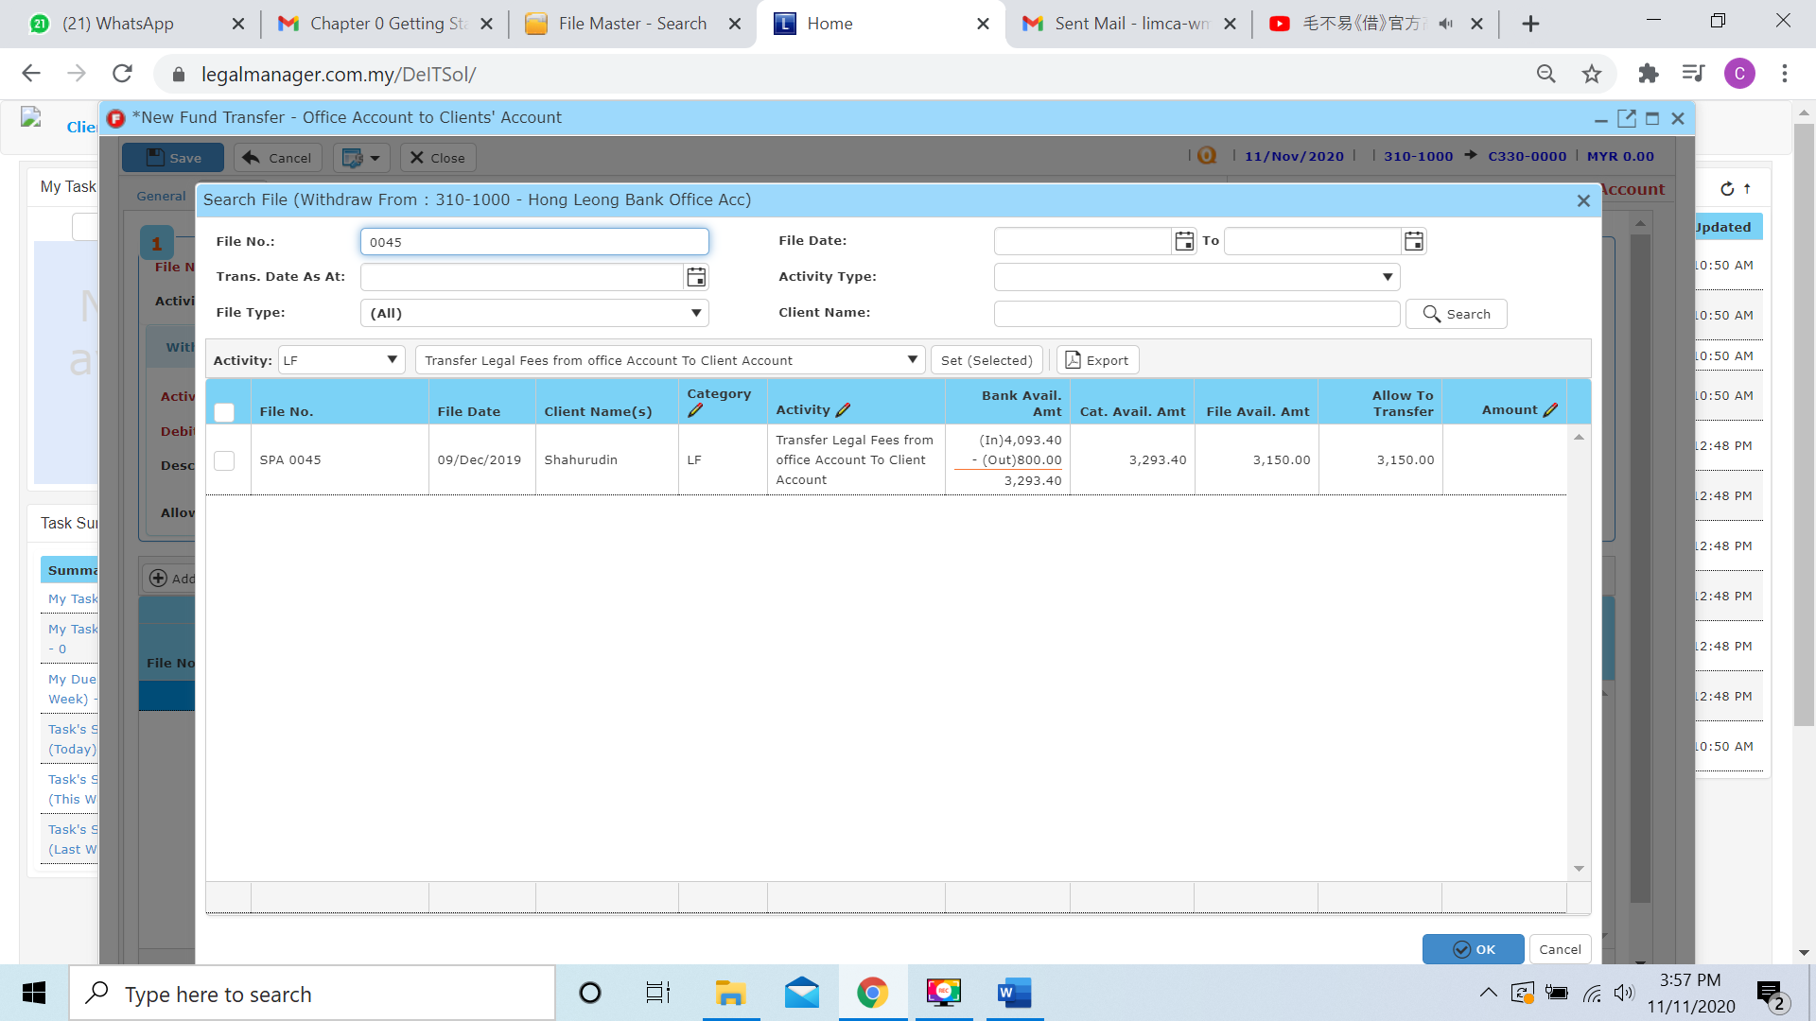

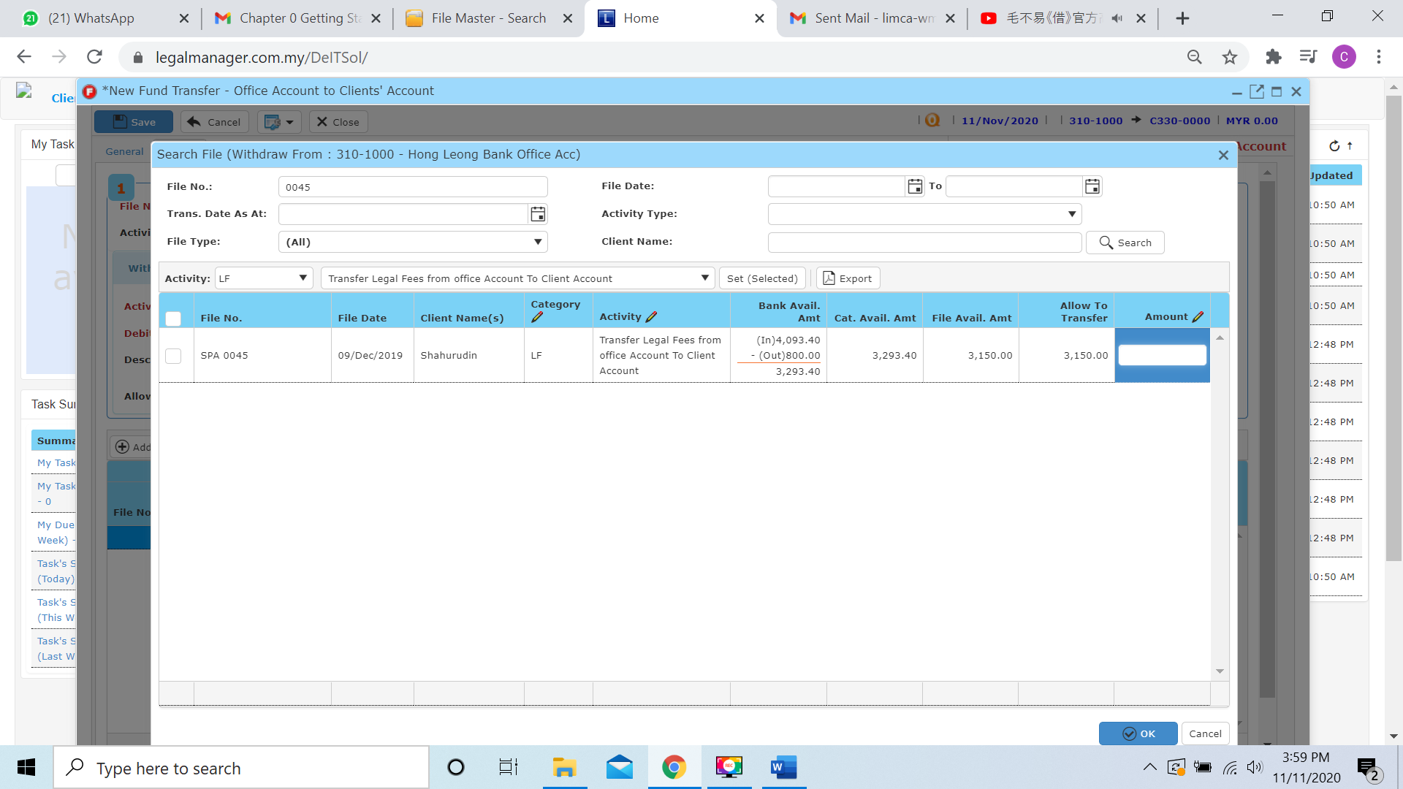

* For example, I will only transfer 2150 of balance allow to transfer 3150 and click to ‘**OK**’

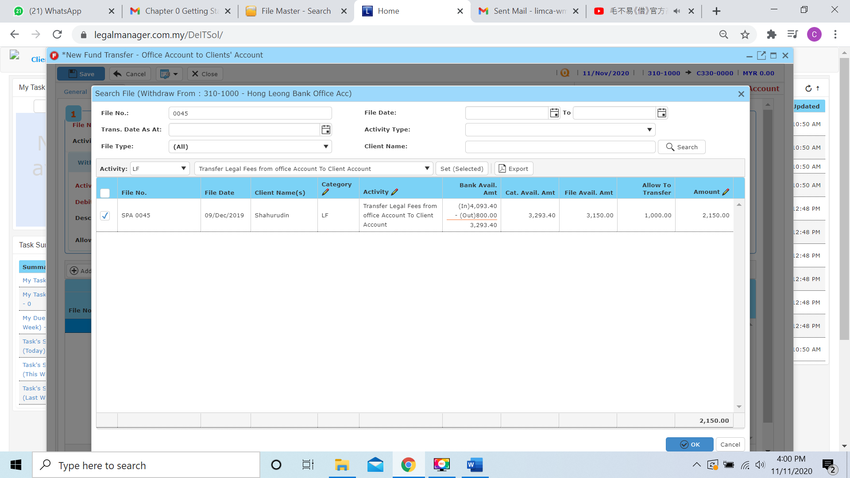

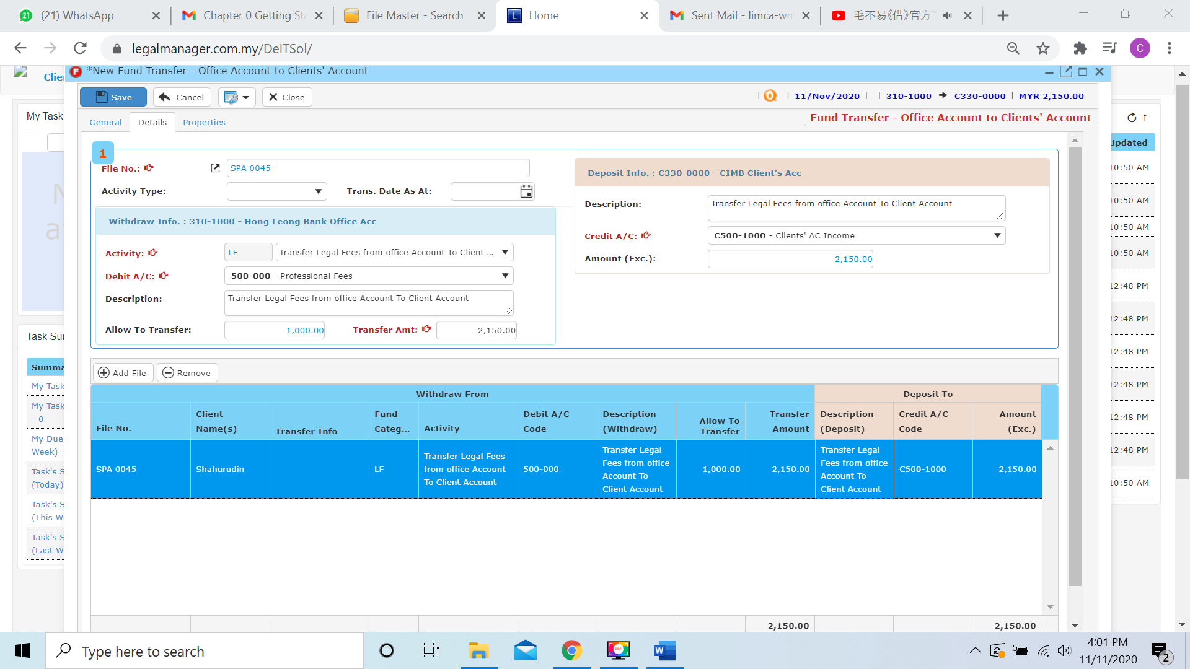

* Moreover, you can click  and it will pop up the search file wizard as procedure above again to add record, and you can click to  to remove the added file
* You can click to the next tab ‘Properties’

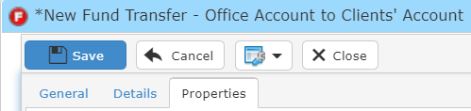

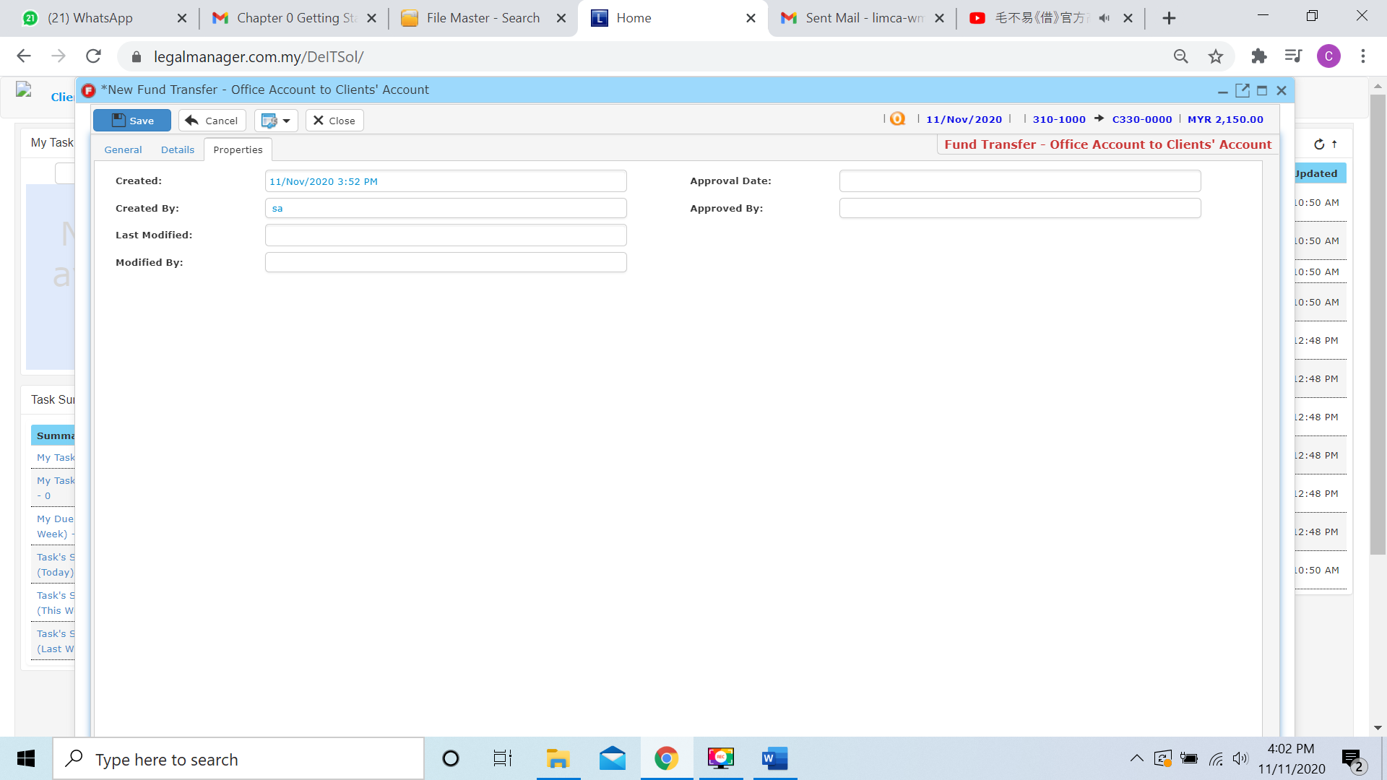

* You can view the information of the record once who modify the record then there will show the last modified and modified by who
* Once you finish all the instruction above, click ‘Save’ then you are done to create a New Bank Fund Transfer – Office A/C to Client’ A/C

**9.6 Manage Bank Fund Transfer**

This option enables you to add, edit, and delete a Bank Fund Transfer. It also allows you to keep track of your Bank Fund Transfer details and all related information.

* To open Manage Bank Fund Transfer, on the **SmartLeg@l** navigation, click **Transfer** and go to **Manage Bank Fund Transfer** then search the Bank Fund Transfer record you wish to modify.

**Manage Bank Fund Transfer**

* Search the Bank Fund Transfer you wish to manage through type the search criteria or search by advanced.
* To start a new search or to clear the search results, click ‘**Clear**’.

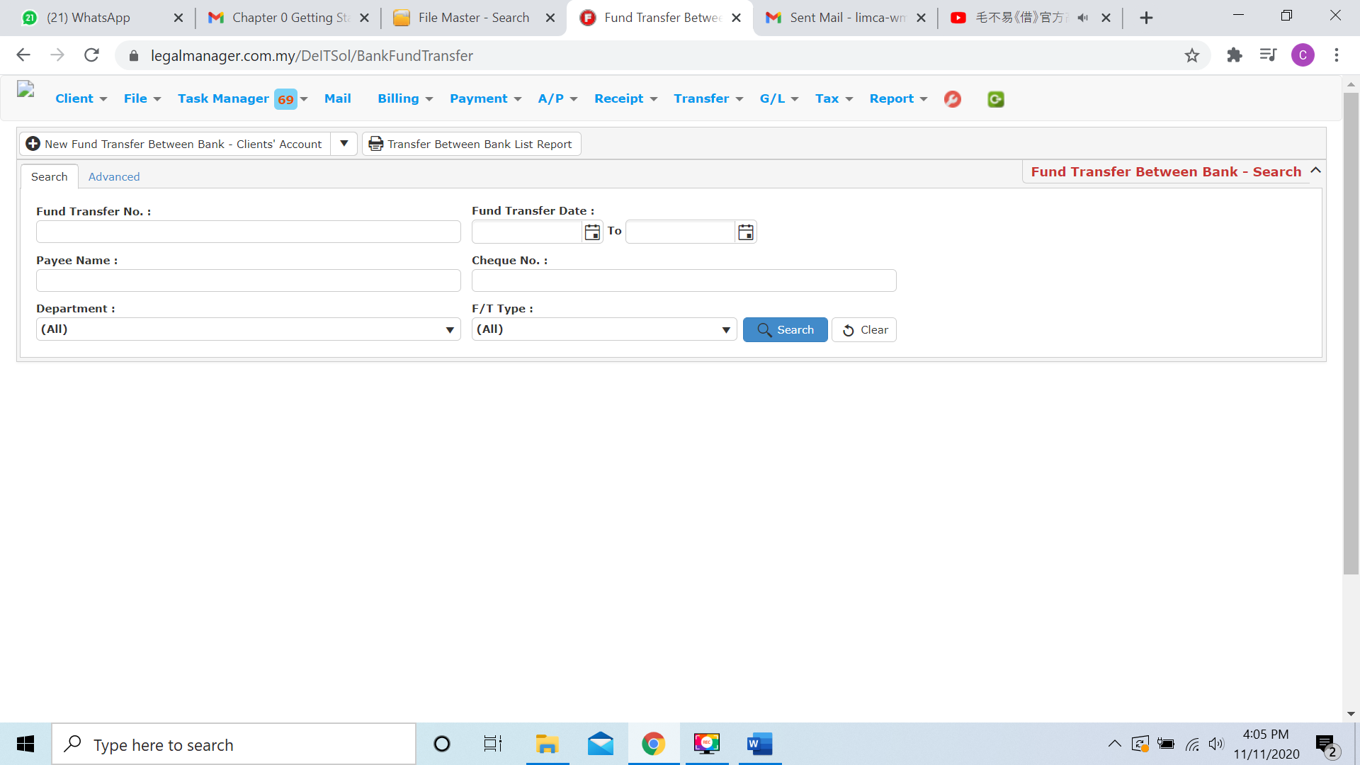

Figure: Manage Bank Fund Transfer - Search

**Advanced Search**

* This function can be used to find a invoice by searching other information that is not captured in the ‘General’ section.
* Define search criteria:

**- Field** - Choose the field you want to search.

**- Condition** - Search condition

**- Value** - Type in the detail you want to find.

* Click ‘**Add to list**’, to define more than one criteria.
* Click ‘**Find**’, search results will be displayed at search record list. You can open an item in the search results list by double-clicking.
* To start a new search or to clear the search results, click ‘**Clear**’.
* Click ‘**Export**’ to print the desired search results in txt, excel or html format.

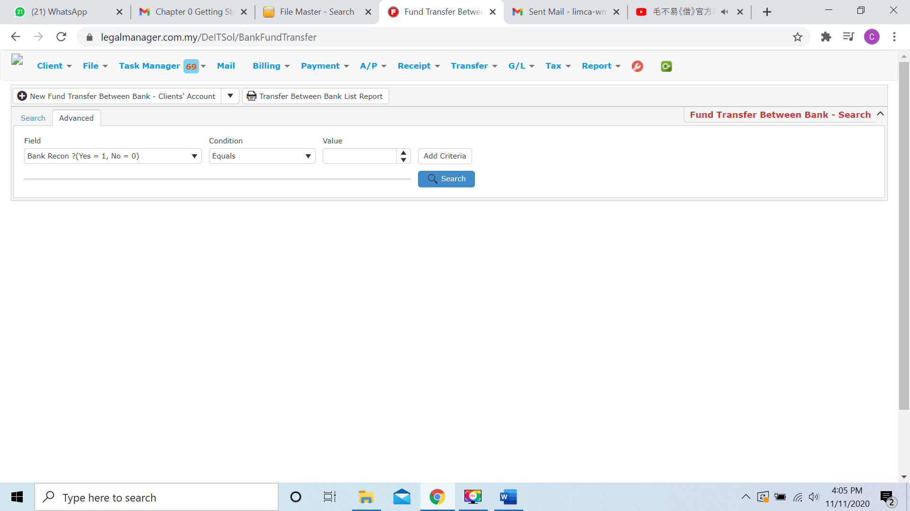

Figure: Manage Bank Fund Transfer– Advanced Search

* Other than Search File Fund Transfer you can create of New Bank Fund Transfer by clicking 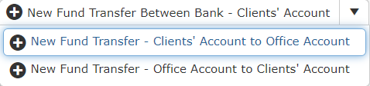 and it will pop up New Bank Fund Transfer input form and you may refer to chapter above to create a New Bank Fund Transfer
* You can print or preview the Transfer Between File List Report while you click to 
* It will pop-up a Transfer Between File List Report as below and you can insert you requirement to filter the report

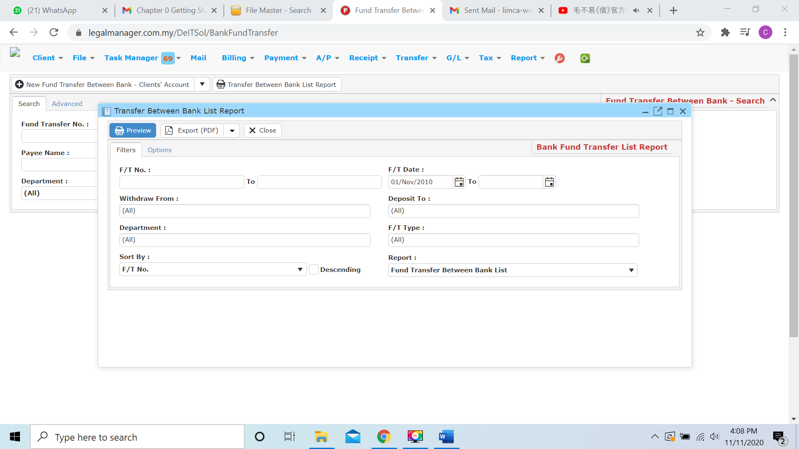

* Besides, you can preview the report
* You can also export the report into PDF or excel by clicking

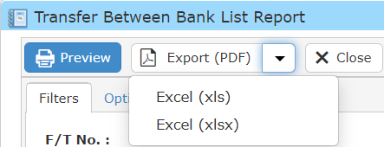

**9.7 New Trust Transfer (FD)**

* To open New Trust Transfer (FD), on the **SmartLeg@l** navigation, click **Transfer** and go to **New Trust Transfer (FD).**

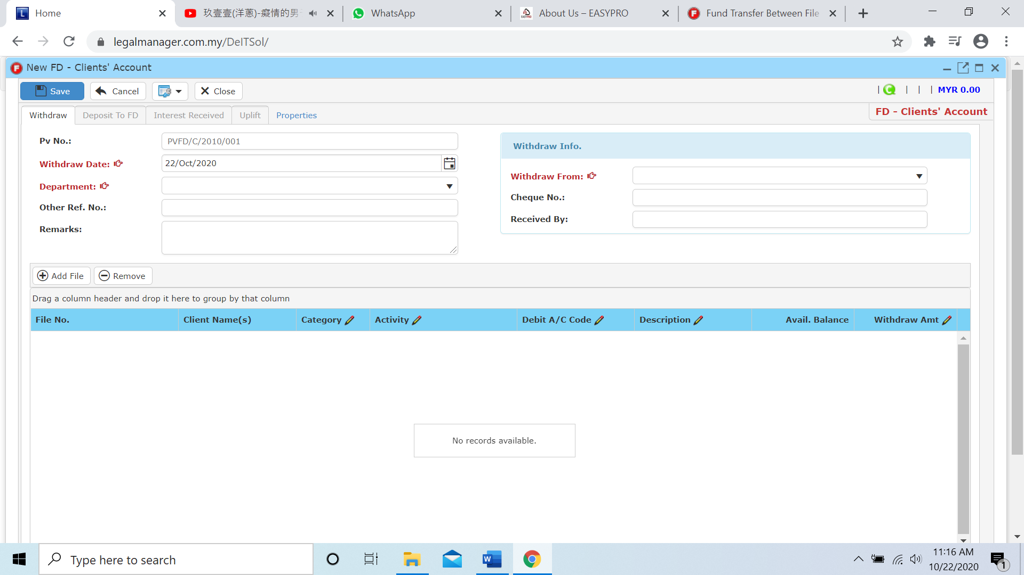

* Key in or select the Withdraw Date from calendar by clicking 
* Choose the department from the combo box
* Select Withdraw From in the withdraw info section

**Add File & Remove**

* You are allow to add file by clicking 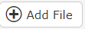
* When you click to the Add File, it will pop up a search file wizard based on the withdraw from client’ a/c you selected in the withdraw info section

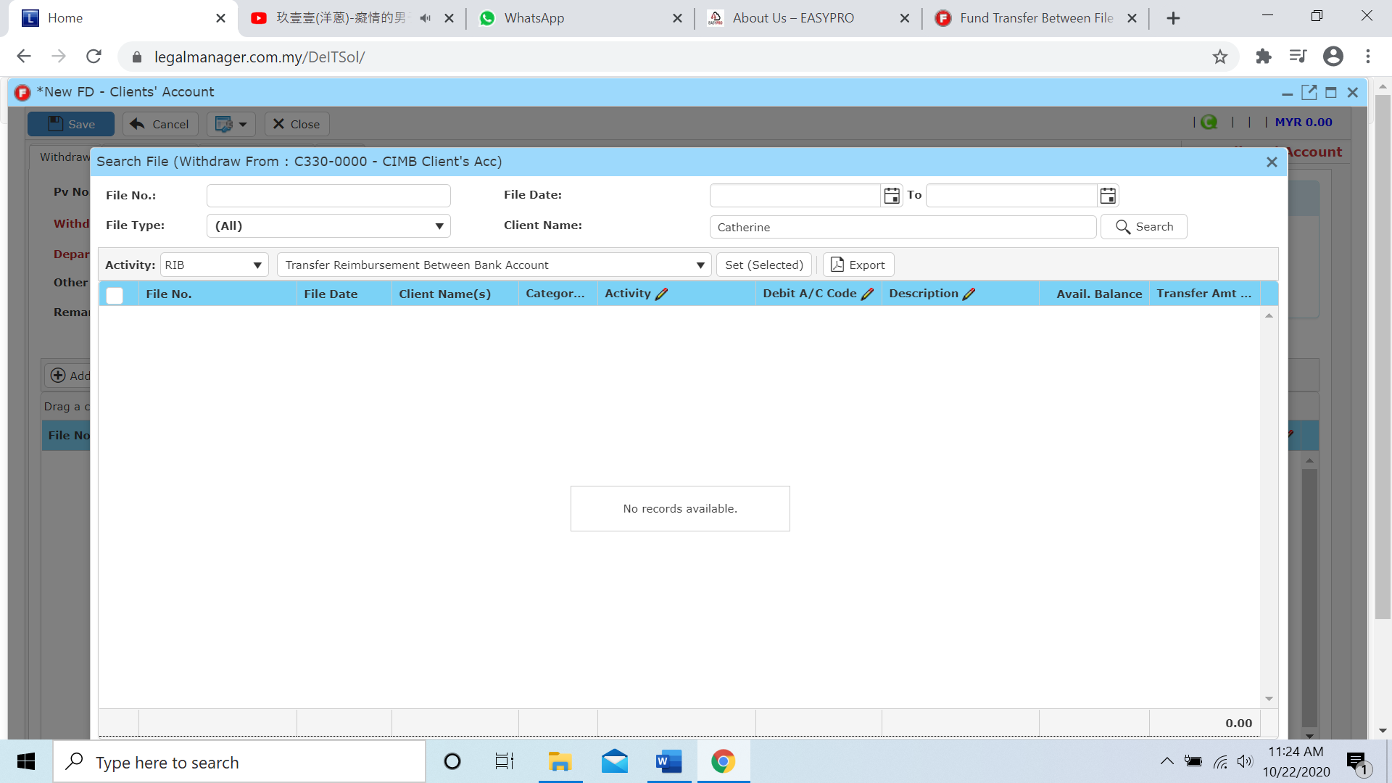

* If you want to erase the file you added in the list you can delete it by selecting the file and click to ‘Remove’

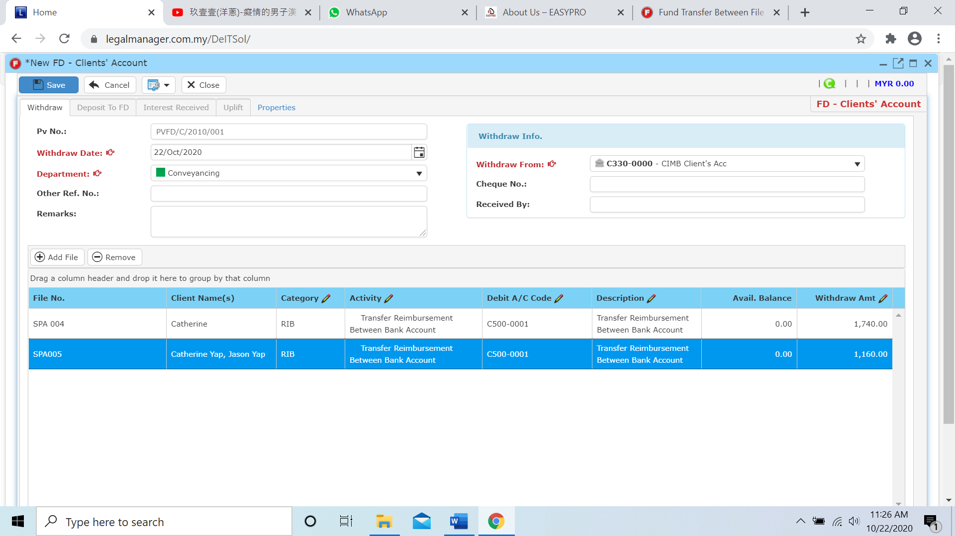

* When you click to remove it will erase the file

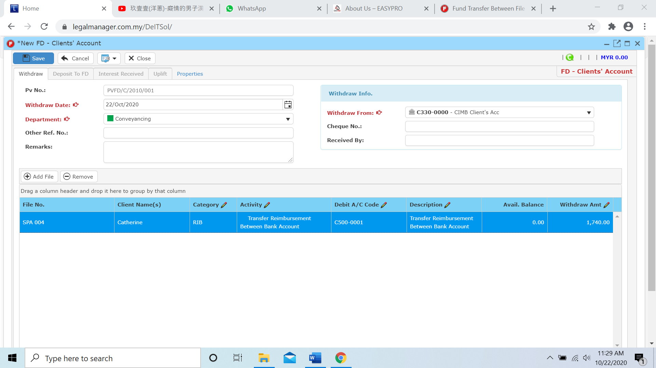

* After that, you can click to the last tab ‘Properties’

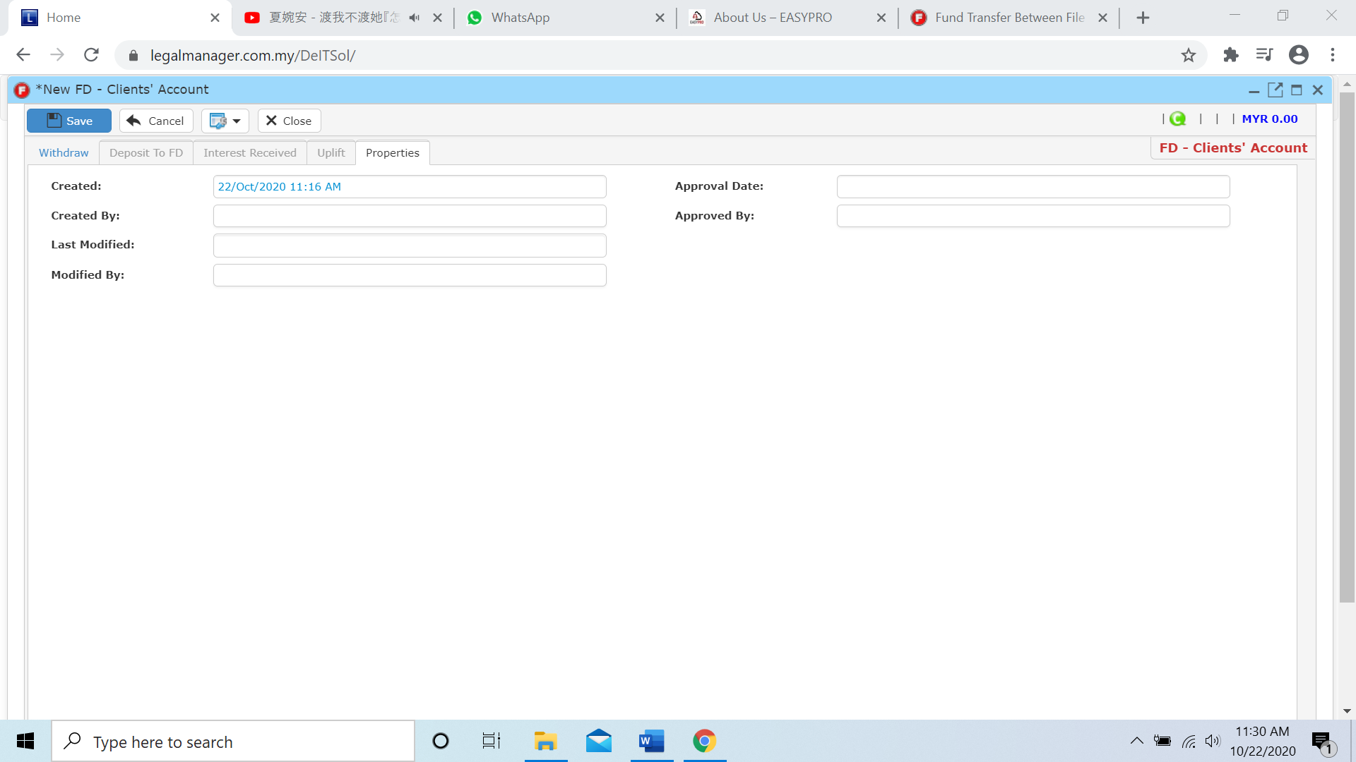

* You can view the information of the FD once who modify the FD then there will show the last modified, modified by who and it shown approval by and date as well.
* Click ‘Save’ to complete the New Trust Transfer FD

**9.8 New FD (Direct Deposit)**

* To open New FD(Direct Deposit), on the **SmartLeg@l** navigation, click **Transfer** and go to **New FD (Direct Deposit).**

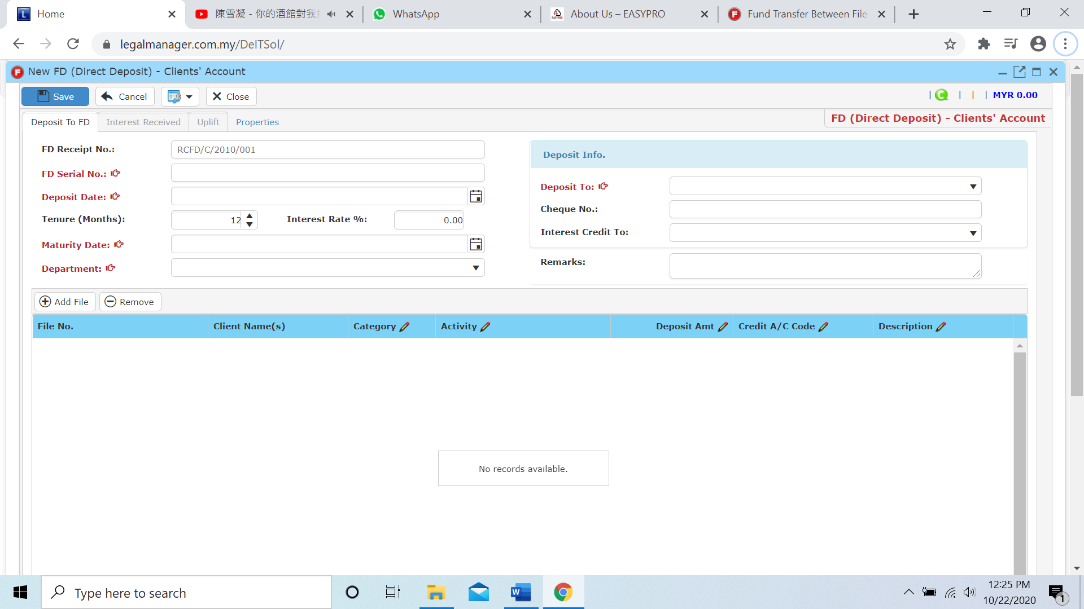

* It is compulsory to key in FD Serial No, Deposit and Maturity Date , Department and Deposit to which account.

**Add File & Remove**

* This add file function is also same as chapter above, click to 

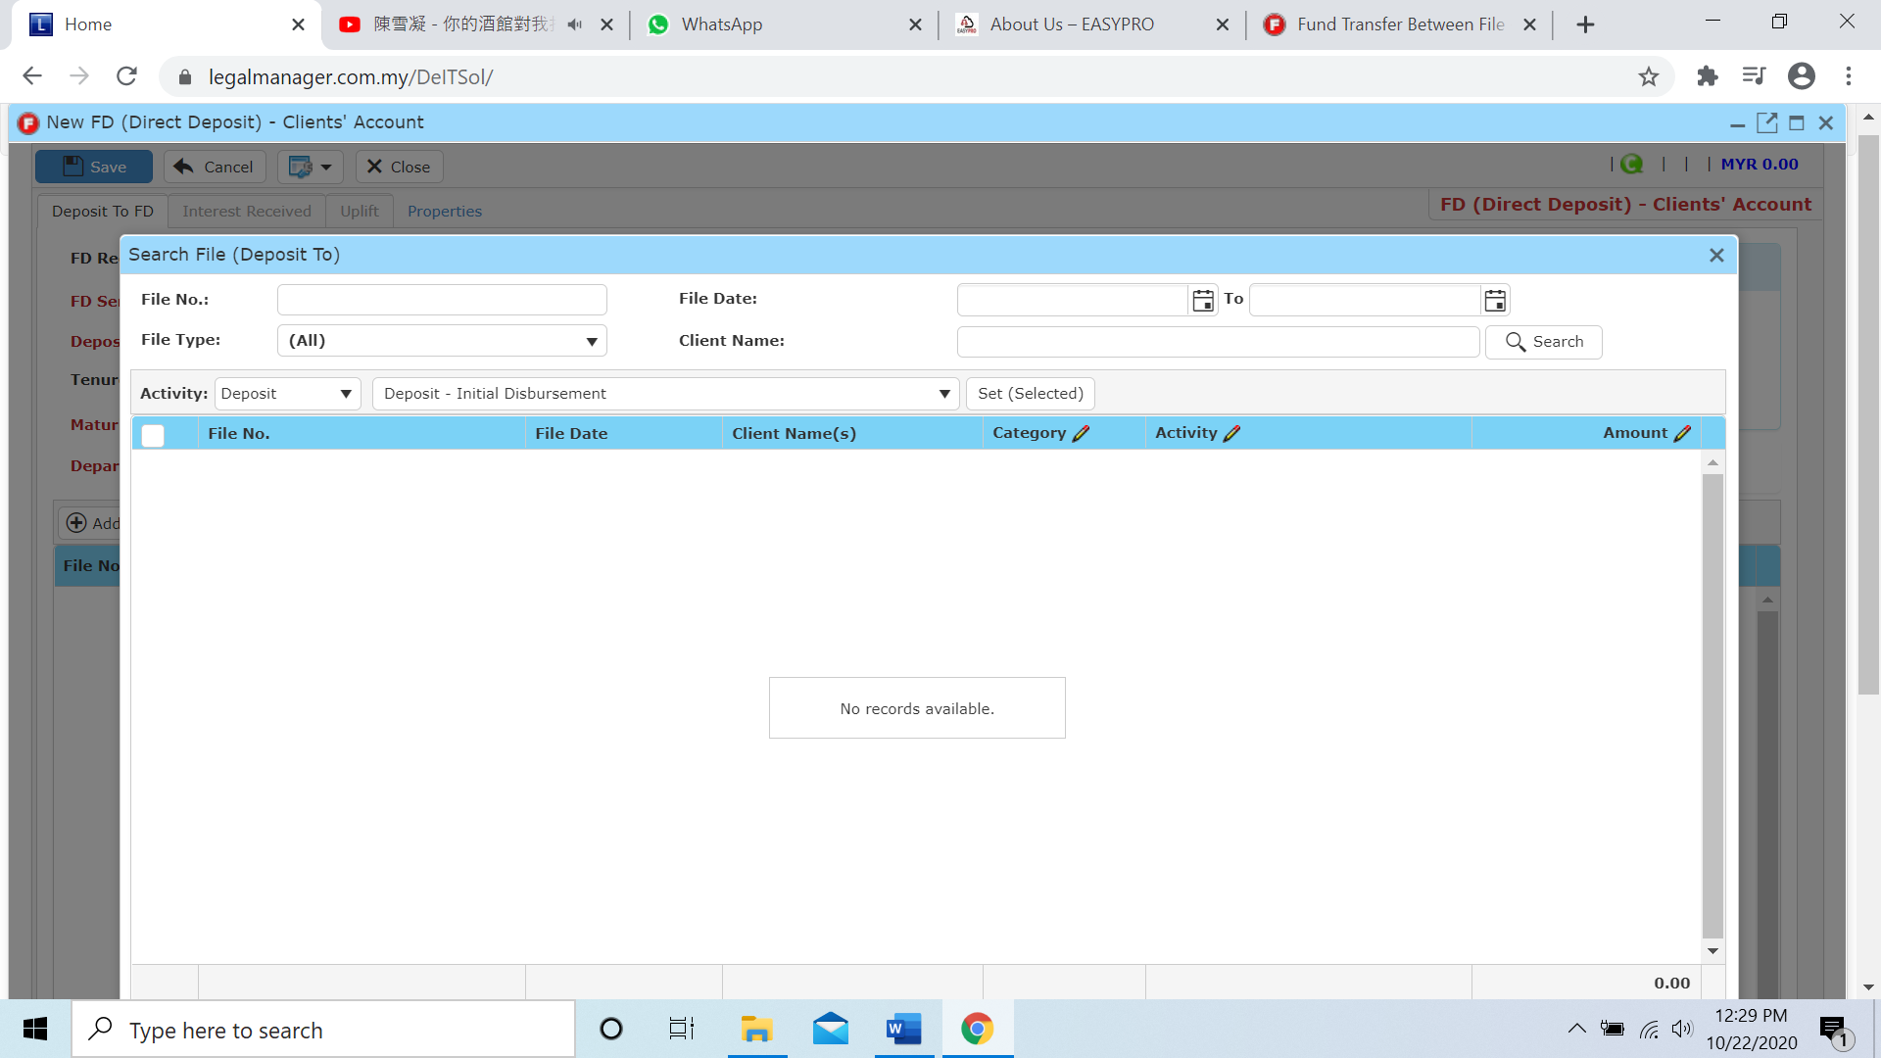

* After you add in the file, you can key in the deposit amount at this section by double clicking that column

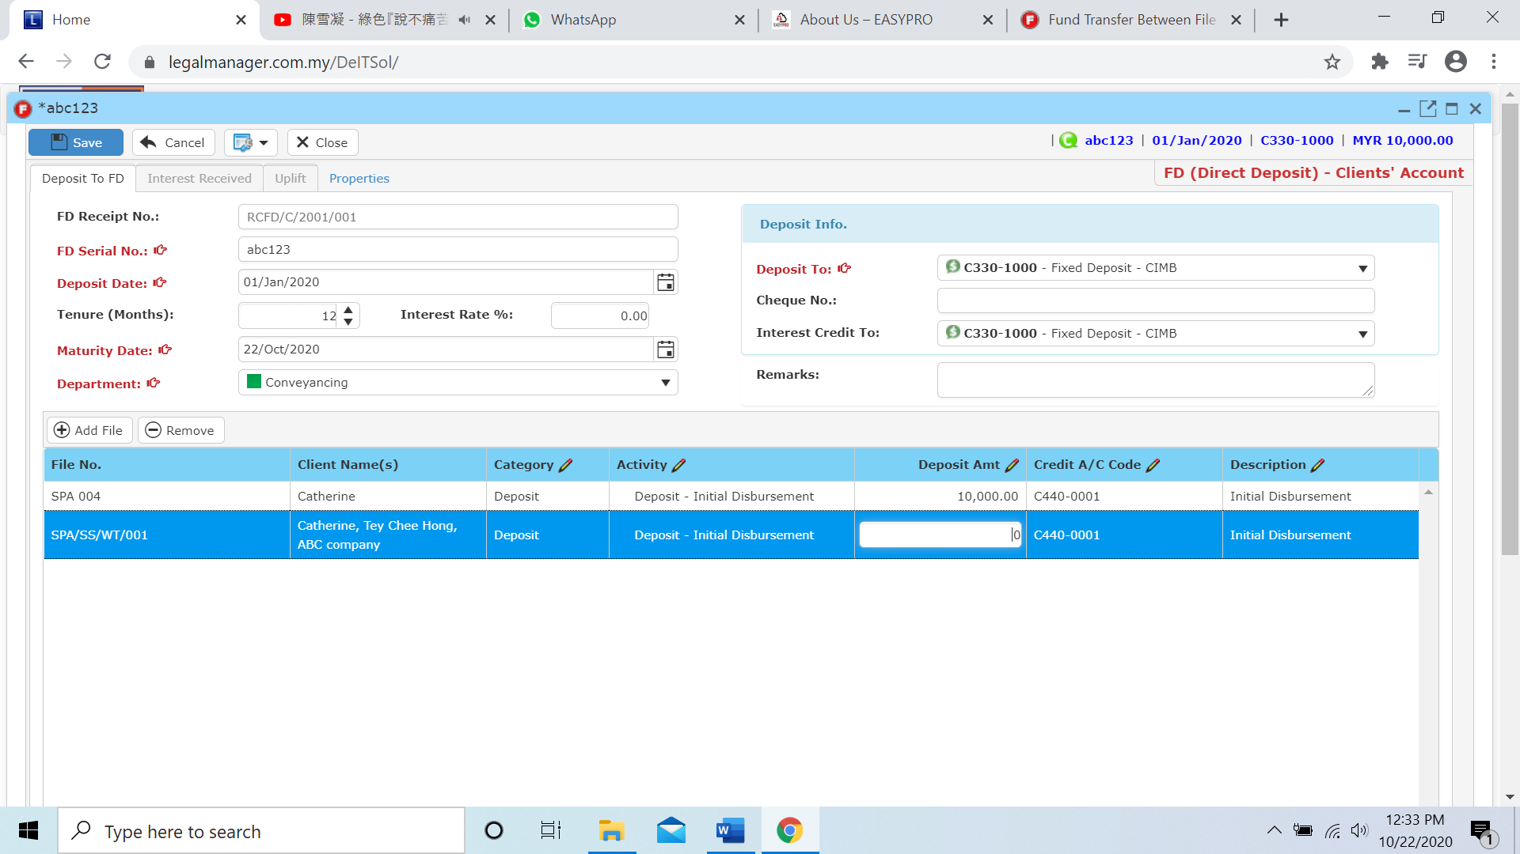

* To remove the file, select and click to ‘Remove’ 

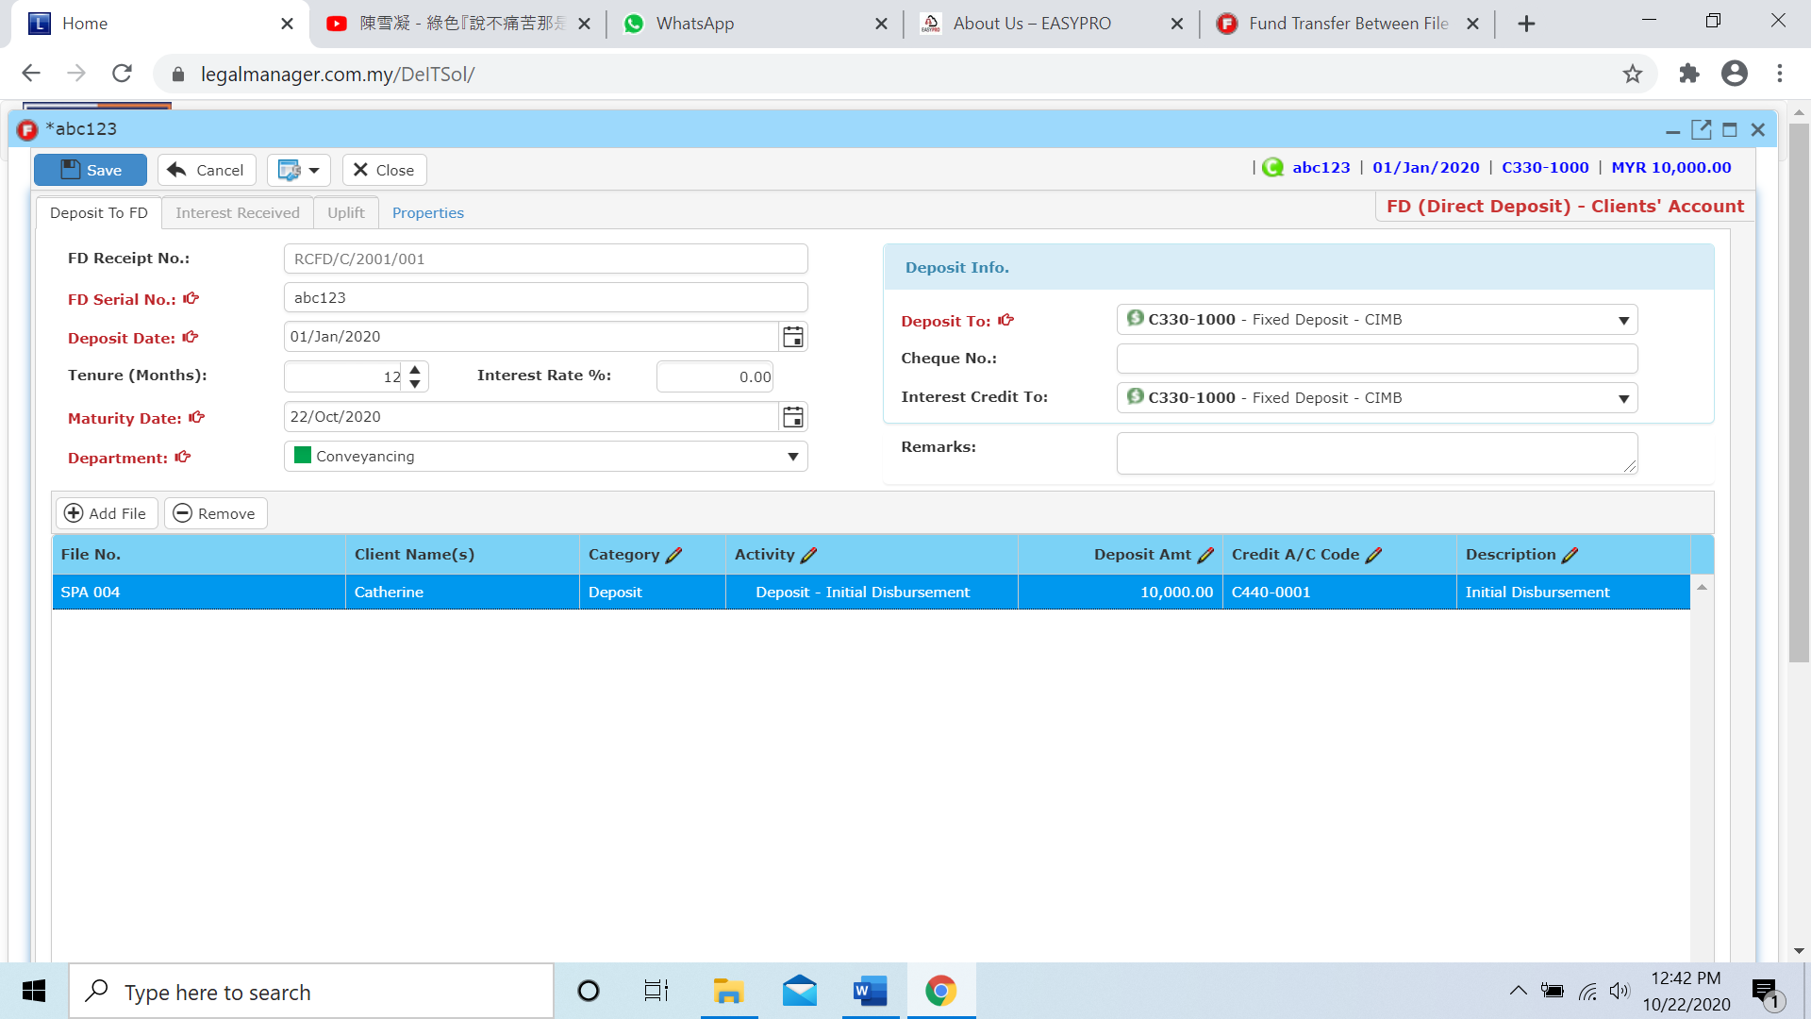

* After that, you can click to the last tab ‘Properties’

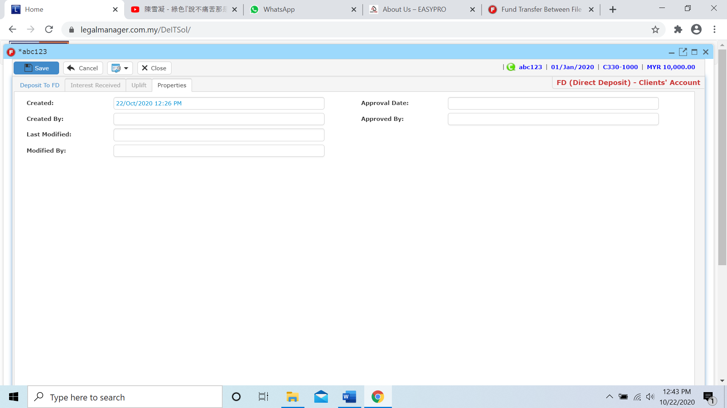

* You can view the information of the Direct FD once who modify the Direct FD then there will show the last modified, modified by who and it shown approval by and date as well.
* Click ‘Save’ to complete the New FD (Direct Deposit)

**9.9 Manage Trust Transfer**

This option enables you to add, edit, and delete a trust transfer. It also allows you to keep track of trust transfer details and all related information.

* To open Manage Trust Transfer, on the **SmartLeg@l** navigation, click **Transfer** and go to **Manage Trust Transfer**.

**Manage Trust Transfer**

* Search the record you wish to manage through type the search criteria or search by advanced.
* To start a new search or to clear the search results, click ‘**Clear**’.

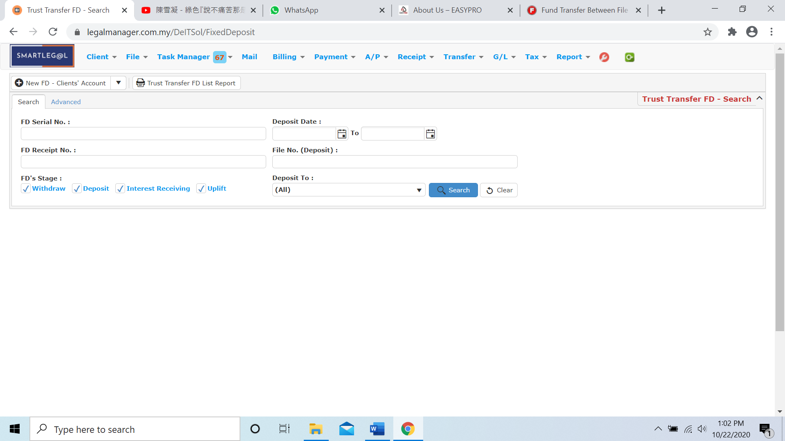

Figure: Manage Trust Transfer - Search

**Advanced Search**

* This function can be used to find a record by searching other information that is not captured in the ‘General’ section.
* Define search criteria:

**- Field** - Choose the field you want to search.

**- Condition** - Search condition

**- Value** - Type in the detail you want to find.

* Click ‘**Add to list**’, to define more than one criteria.
* Click ‘**Find**’, search results will be displayed at search record list. You can open an item in the search results list by double-clicking.
* To start a new search or to clear the search results, click ‘**Clear**’.
* Click ‘**Export**’ to print the desired search results in txt, excel or html format.

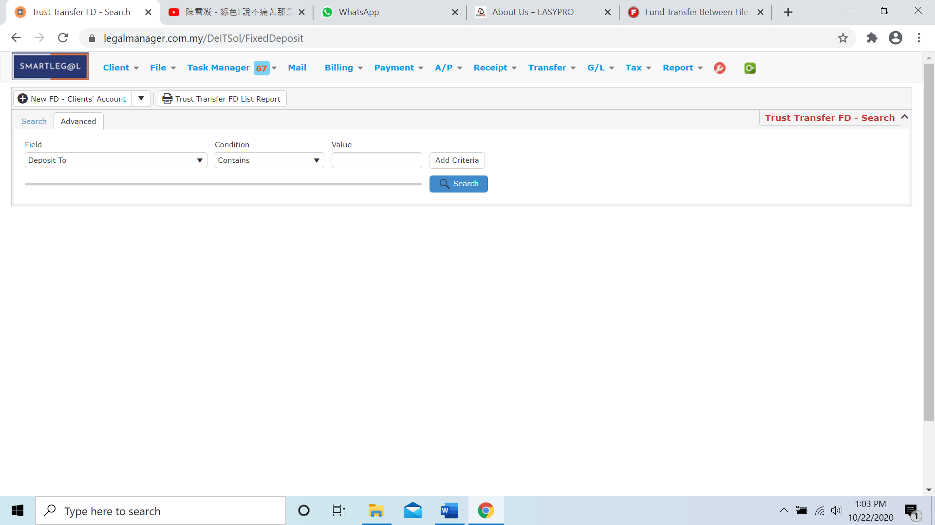

Figure: Manage Trust Record – Advanced Search

* Other than Search Trust Transfer you can create of New FD for client’ a/c by clicking 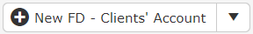 and it will pop up New FD Client’ A/C input form

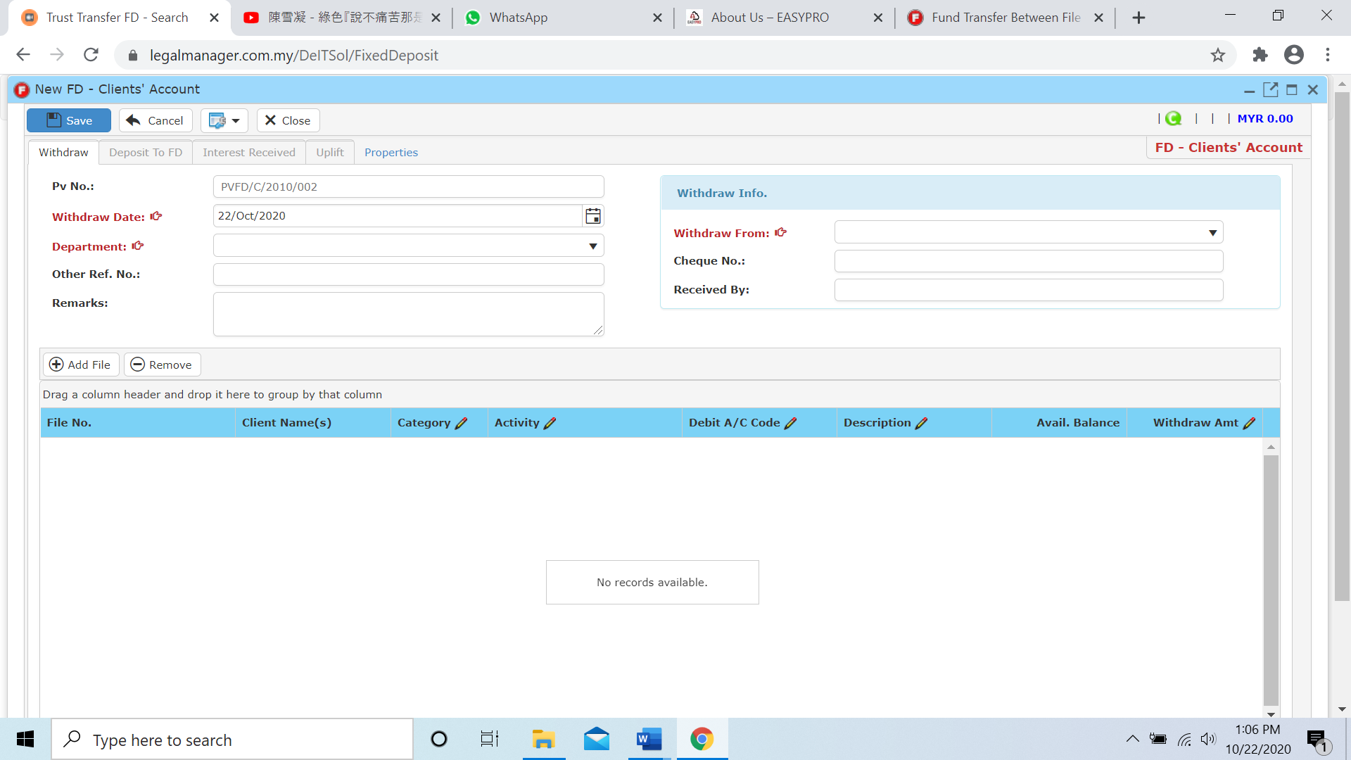

* You can print or preview the Trust Transfer FD List Report while you click to 
* It will pop-up a Trust Transfer FD List Report as below and you can insert your requirement to filter the report
* Besides, you can preview the report as figure below shown

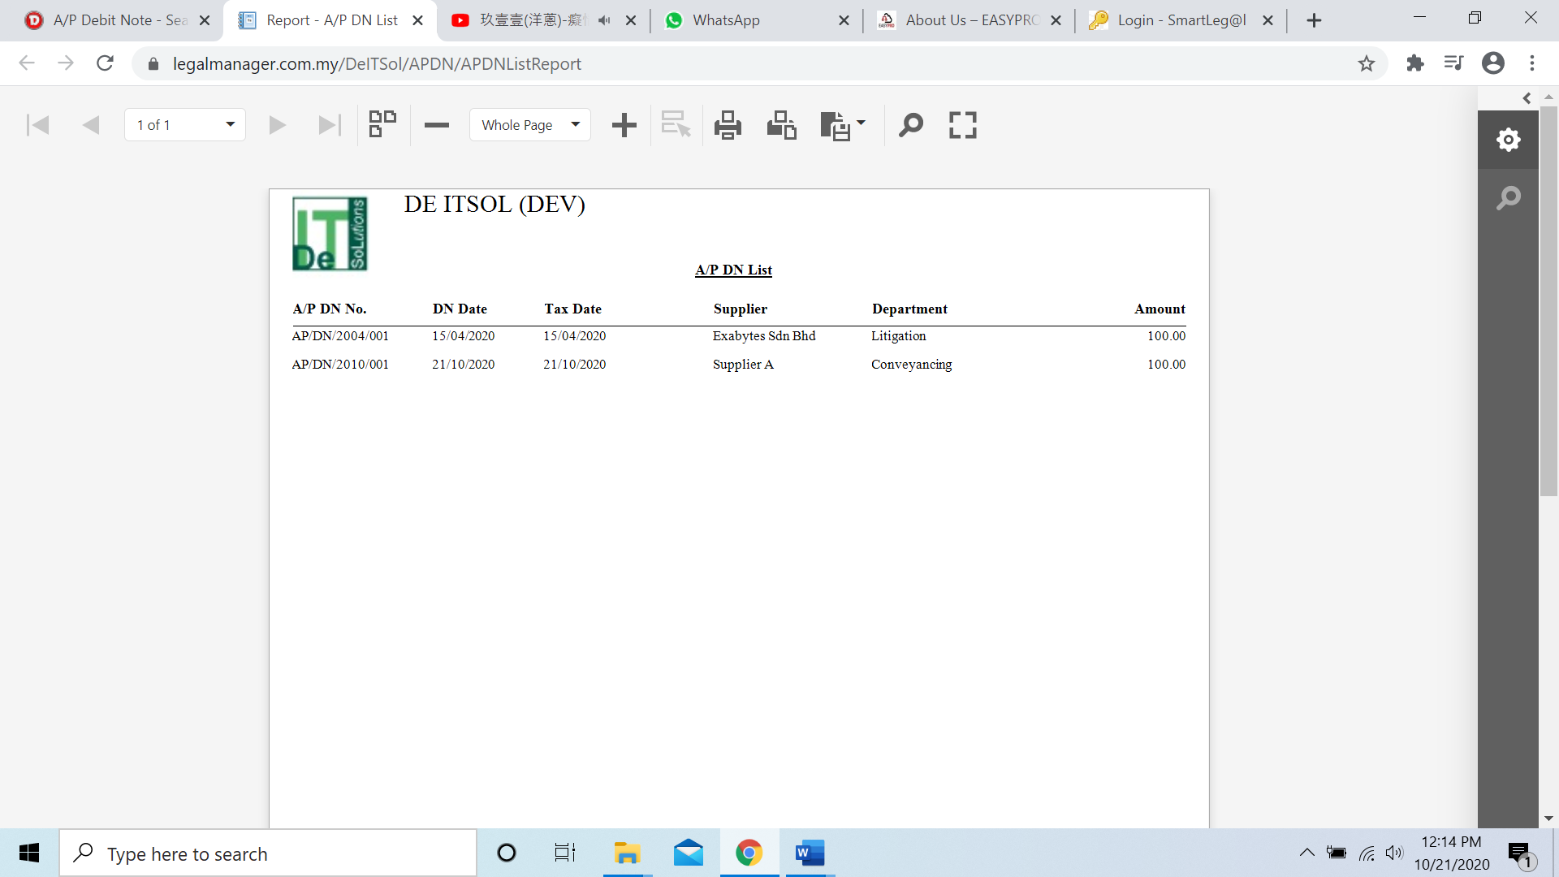

* You can also export the report into PDF or excel by clicking

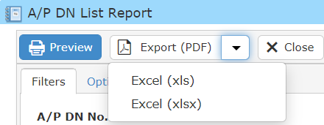

**Searched Result**

* Click ‘**Search**’ once, to show all supplier
* The Searched result will appeal at below, otherwise it will shown no record availble if the quotation you searched do not exist.
* Click ‘**Export**’ to print the desired search results in txt, excel or html format.

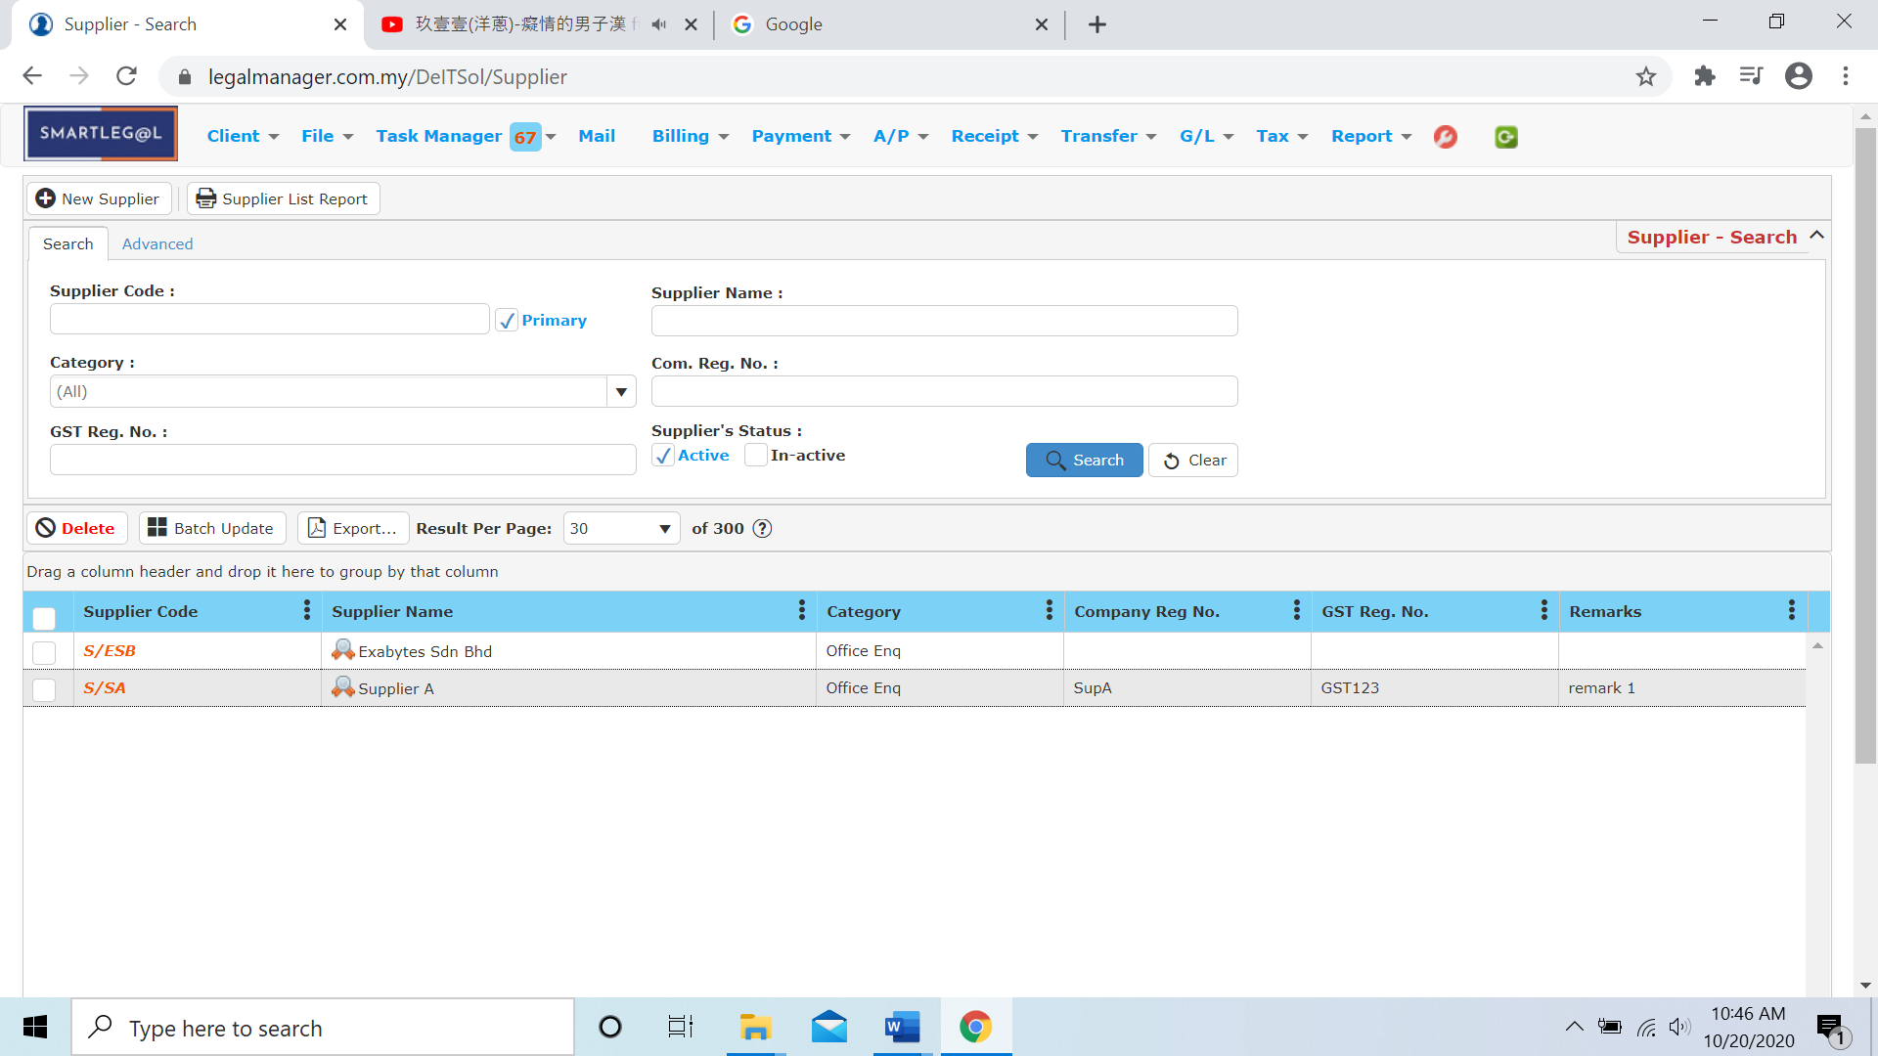

Figure: Manage Spplier – Search All Quotations

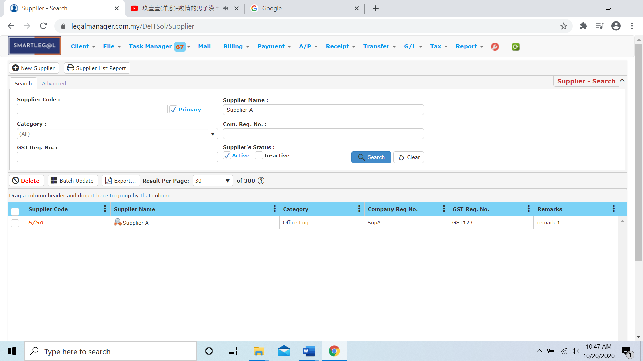

Figure: Manage Supplier – Searched Result

* After the quotation you searched appeal, you can choose to view, edit and preview those details by double-clicking the record.

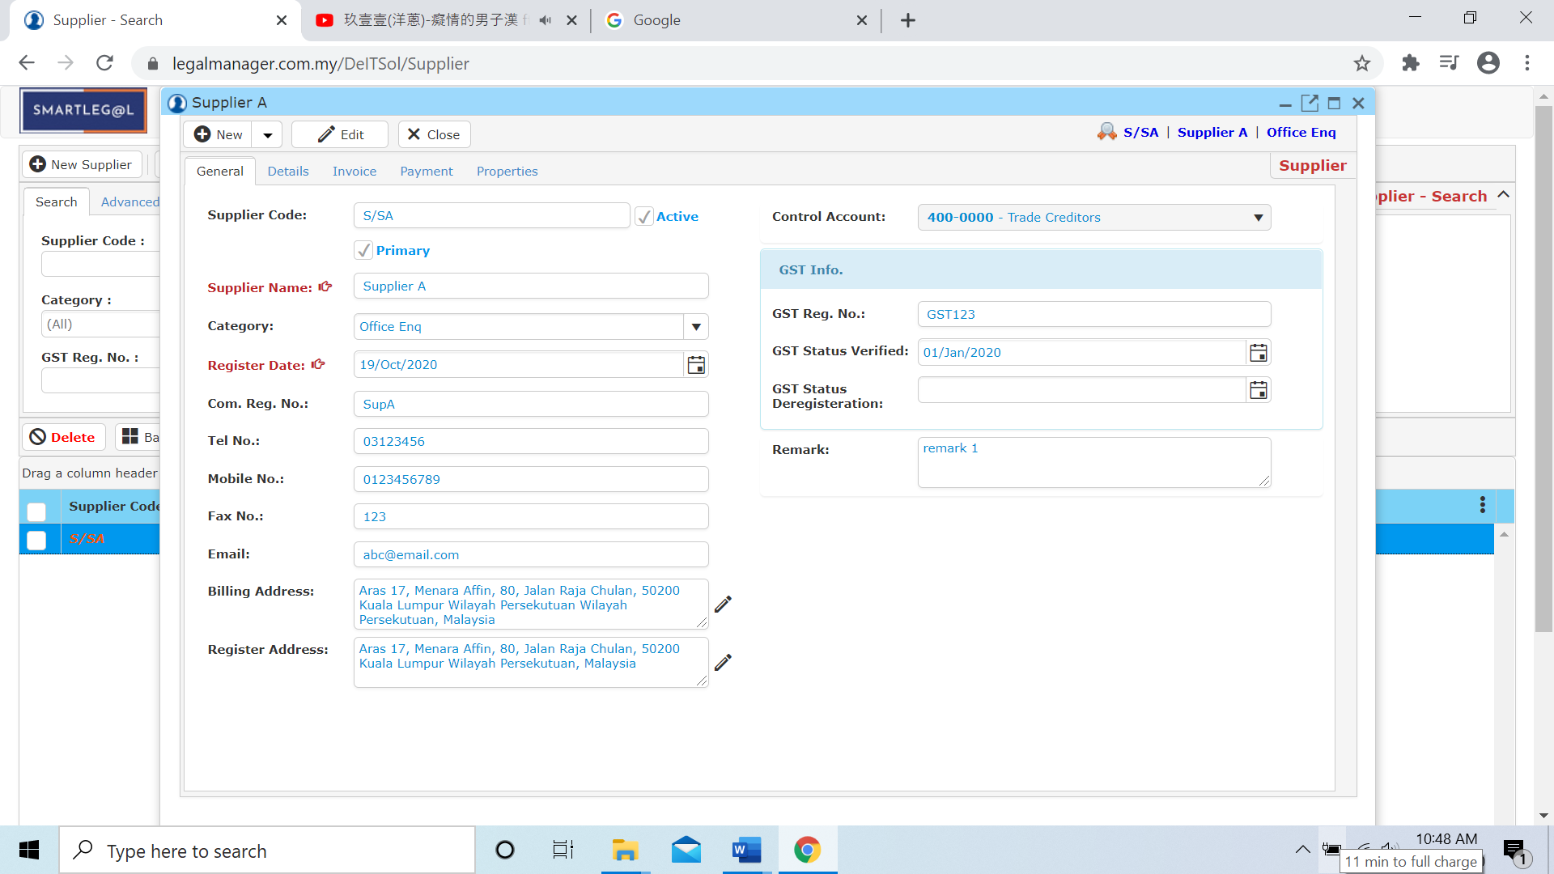

Figure: Manage Supplier – Searched Result, Supplier Info